|  |
| --- |
|  |
|  |



Prepared by Dhruv Dosad

**Business Report**

**Finance and Risk Analytics**



**Table of Contents**

|  |  |
| --- | --- |
| Table of Contents | 2 |
| List of Figures | 3 |
| List of Tables | 4 |
| **PART A: Companies Credit Risk** | **6-55** |
| Outlier Treatment | 13 |
| Missing Value Treatment | 16 |
| Univariate & Bivariate analysis with proper interpretation. | 24 |
| Train Test Split | 34 |
| Build Logistic Regression Model (using statsmodels library) on most important variables on train dataset and choose the optimum cut-off. Also showcase your model building approach | 34 |
| Validate the Model on Test Dataset and state the performance metrics. Also state interpretation from the model | 38 |
| Build a Random Forest Model on Train Dataset. Also showcase your model building approach | 45 |
| Validate the Random Forest Model on test Dataset and state the performance metrics. Also state interpretation from the model | 47 |
| Build a LDA Model on Train Dataset. Also showcase your model building approach | 49 |
| Validate the LDA Model on test Dataset and state the performance metrics. Also state interpretation from the model | 50 |
| Compare the performances of Logistic Regression, Random Forest, and LDA models (include ROC curve) | 53 |
| Conclusions and Recommendations | 54 |
| **PART B: Market Risk Analysis** | **56-63** |
| Draw Stock Price Graph(Stock Price vs Time) for any 2 given stocks with inference | 57 |
| Calculate Returns for all stocks with inference | 58 |
| Calculate Stock Means and Standard Deviation for all stocks with inference | 60 |
| Draw a plot of Stock Means vs Standard Deviation and state your inference | 60 |
| Conclusions and Recommendations | 63 |

List Of Tables

|  |  |
| --- | --- |
| Table | Page No |
| Table 1.1 Sample of the dataset | 10 |
| Table 1.2 Information of the dataset | 11 |
| Table 1.3 Descriptive Statistics of the dataset | 12 |
| Table 1.4 Outliers in Each variable | 14 |
| Table 1.5 Sample of scaled variables | 18 |
| Table 1.6 Variables with highest VIF (>5.0) | 19 |
| Table 1.7 Variables with highest VIF - Top 5 | 19 |
| Table 1.8 Variables with highest VIF - Top 5 | 20 |
| Table 1.9 Variables with highest VIF - Top 5 | 20 |
| Table 1.10 Variables with highest VIF - Top 5 | 20 |
| Table 1.11 Variables with highest VIF - Top 5 | 20 |
| Table 1.12 Variables with highest VIF - Top 5 | 20 |
| Table 1.13 Variables with highest VIF - Top 5 | 20 |
| Table 1.14 Variables with highest VIF - Top 5 | 20 |
| Table 1.15 Variables with highest VIF - Top 5 | 21 |
| Table 1.16 Variables with highest VIF - Top 5 | 21 |
| Table 1.17 Variables with highest VIF - Top 5 | 21 |
| Table 1.18 Final Variables after removing VIF > 5 | 22 |
| Table 1.19 RFE Rank of all Variables | 23 |
| Table 1.20 Selected Variables with Rank 1 | 24 |
| Table 1.21 Descriptive Statistics of the Variable | 25 |
| Table 1.22 Descriptive Statistics of the Variable | 25 |
| Table 1.23 Descriptive Statistics of the Variable | 25 |
| Table 1.24 Descriptive Statistics of the Variable | 26 |
| Table 1.25 Descriptive Statistics of the Variable | 26 |
| Table 1.26 Descriptive Statistics of the Variable | 26 |
| Table 1.27 Descriptive Statistics of the Variable | 27 |
| Table 1.28 Descriptive Statistics of the Variable | 27 |
| Table 1.29 Descriptive Statistics of the Variable | 27 |
| Table 1.30 Descriptive Statistics of the Variable | 28 |
| Table 1.31 Descriptive Statistics of the Variable | 28 |
| Table 1.32 Descriptive Statistics of the Variable | 28 |
| Table 1.33 Descriptive Statistics of the Variable | 29 |
| Table 1.34 Descriptive Statistics of the Variable | 29 |
| Table 1.35 Logistic Regression Model Summary | 36 |
| Table 1.36 Logistic Regression Model Summary | 37 |
| Table 1.37 Logistic Regression Model Summary | 37 |
| Table 1.38 Logistic Regression Model Summary | 37 |
| Table 1.39 Logistic Regression Classification report | 38 |
| Table 1.40 Logistic Regression Conclusion | 39 |
| Table 1.41 Logistic Regression Optimal Cutoff Classification report | 40 |
| Table 1.42 Logistic Regression Conclusion | 41 |
| Table 1.43 Logistic Regression SMOTE Model Summary | 42 |
| Table 1.44 Logistic Regression SMOTE Model Summary | 42 |
| Table 1.45 Logistic Regression SMOTE Classification report | 43 |
| Table 1.46 Logistic Regression Conclusion | 44 |
| Table 1.47 Logistic Regression Optimal Cutoff Classification report | 44 |
| Table 1.48 Logistic Regression Conclusion | 45 |
| Table 1.49 Logistic Regression Metric Comparison | 46 |
| Table 1.50 Random Forest Classification report | 47 |
| Table 1.51 Random Forest Conclusion | 48 |
| Table 1.52 LDA Classification report | 50 |
| Table 1.53 LDA Conclusion | 51 |
| Table 2.1 Dataset Information | 56 |
| Table 2.2 Sample of the Dataset | 57 |
| Table 2.3 Descriptive Statistics | 57 |
| Table 2.4 Sample of the Stock Returns | 59 |
| Table 2.5 Sample of the Stock Returns | 59 |
| Table 2.6 Stock Mean and Volatility | 60 |

List Of Figures

|  |  |
| --- | --- |
| Figure | Page No |
| fig 1.1 Outliers in Each variable | 15 |
| fig 1.2 Outliers after Treatment | 16 |
| fig 1.3 Missing Value heatmap | 17 |
| fig 1.4 Missing Values After Treatment | 18 |
| fig 1.5 Multicollinearity between Variables | 24 |
| fig 1.6 Target Variable Overview | 25 |
| fig 1.7 Univariate Analysis of Research_and_development_expense_rate | 25 |
| fig 1.8 Univariate Analysis of Interest_bearing_debt_interest_rate | 25 |
| fig 1.9 Univariate Analysis of Net_Value_Growth_Rate | 26 |
| fig 1.10 Univariate Analysis of Cash_Reinvestment_perc | 26 |
| fig 1.11 Univariate Analysis of Total_debt_to_Total_net_worth | 26 |
| fig 1.12 Univariate Analysis of Total_Asset_Turnover | 27 |
| fig 1.13 Univariate Analysis of Accounts_Receivable_Turnover | 27 |
| fig 1.14 Univariate Analysis of Fixed_Assets_Turnover_Frequency | 27 |
| fig 1.15 Univariate Analysis of Operating_profit_per_person | 28 |
| fig 1.16 Univariate Analysis of Allocation_rate_per_person | 28 |
| fig 1.17 Univariate Analysis of Retained_Earnings_to_Total_Assets | 28 |
| fig 1.18 Univariate Analysis of Total_income_to_Total_expense | 29 |
| fig 1.19 Univariate Analysis of Total_expense_to_Assets | 29 |
| fig 1.20 Univariate Analysis of Equity_to_Liability | 29 |
| fig 1.21 Pairplot | 30 |
| fig 1.22 Correlation Heatmap | 30 |
| fig 1.23 Default against Research and Development Expense Rate | 31 |
| fig 1.24 Default against Interest-bearing Debt Interest Rate: | 31 |
| fig 1.25 Default against Net Value Growth Rate | 31 |
| fig 1.26 Default against Cash Reinvestment Percentage | 31 |
| fig 1.27 Default against Total Debt to Total Net Worth | 32 |
| fig 1.28 Default against Total Asset Turnover | 32 |
| fig 1.29 Default against Accounts Receivable Turnover | 32 |
| fig 1.30 Default against Fixed Assets Turnover Frequency | 32 |
| fig 1.31 Default against Operating Profit per Person | 33 |
| fig 1.32 Default against Retained Earnings to Total Assets | 33 |
| fig 1.33 Default against Retained Earnings to Total Assets | 33 |
| fig 1.34 Default against Total Income to Total Expense | 33 |
| fig 1.35 Default against Total Expense to Assets | 34 |
| fig 1.36 Default against Equity to Liability | 34 |
| fig 1.37 Logistic Regression Explanation | 35 |
| fig 1.38 Confusion Matrix | 35 |
| fig 1.39 ROC - AUC | 36 |
| fig 1.40 Logistic Regression Confusion Matrix | 38 |
| fig 1.41 Logistic Regression ROC curve | 39 |
| fig 1.42 Logistic Regression Optimal Cutoff Confusion Matrix | 40 |
| fig 1.43 Logistic Regression Optimal Cutoff ROC curve | 41 |
| fig 1.44 Logistic Regression SMOTE Confusion Matrix | 43 |
| fig 1.45 Logistic Regression SMOTE ROC curve | 43 |
| fig 1.46 Logistic Regression SMOTE Optimal Cutoff Confusion Matrix | 44 |
| fig 1.47 Logistic Regression SMOTE Optimal ROC curve | 45 |
| fig 1.48 Random Forrest Explanation | 46 |
| fig 1.49 RandomForest Confusion Matrix | 47 |
| fig 1.50 RandomForest ROC curve | 48 |
| fig 1.51 RandomForest Feature Importance | 48 |
| fig 1.52 LDA Explaination | 49 |
| fig 1.53 LDA Confusion Matrix | 50 |
| fig 1.54 LDA ROC curve | 51 |
| fig 1.55 LDA Feature Importance | 51 |
| fig 1.56 All Model Comparison Metrics | 52 |
| fig 1.57 All Model Comparison Confusion Matrix | 53 |
| fig 1.58 All Model Comparison ROC curve | 54 |
| Fig 2.1 Stock Price vs Time Graph for Shree Cement | 58 |
| Fig 2.2 Stock Price vs Time Graph for Idea-Vodafone | 58 |
| Fig 2.3 Stock Returns & Price Trend | 59 |
| Fig 2.4 Stock Means vs Standard Deviation | 61 |
| Fig 2.5 Stock Means vs Standard Deviation with Stock Names | 61 |

**PART A: Company Credit Risk**

**Problem Statement:**

Businesses or companies can fall prey to default if they are not able to keep up their debt obligations. Defaults will lead to a lower credit rating for the company which in turn reduces its chances of getting credit in the future and may have to pay higher interest on existing debts as well as any new obligations. From an investor's point of view, he would want to invest in a company if it is capable of handling its financial obligations, can grow quickly, and is able to manage the growth scale.

A balance sheet is a financial statement of a company that provides a snapshot of what a company owns, owes, and the amount invested by the shareholders. Thus, it is an important tool that helps evaluate the performance of a business.

Data that is available includes information from the financial statement of the companies for the previous year.

**Dependent variable** - No need to create any new variable, as the 'Default' variable is already provided in the dataset, which can be considered as the dependent variable.

**Test Train Split** - Split the data into train and test datasets in the ratio of 67:33 and use a random state of 42 (*random_state=42*). Model building is to be done on the train dataset and model validation is to be done on the test dataset.

**Data Dictionary:**

|  |  |  |
| --- | --- | --- |
| **Sl. No** | **Column Name** | **Description** |
| 1 | Co_Code | Company Code |
| 2 | Co_Name | Company Name |
| 3 | _Operating_Expense_Rate | Operating Expense Rate: Operating Expenses/Net Sales. The operating expense ratio (OER) is the cost to operate a piece of property compared to the income the property brings in. |
| 4 | _Research_and_development_expense_rate | Research and development expense rate: (Research and Development Expenses)/Net Sales. Research and development (R&D) expenses are direct expenditures relating to a company's efforts to develop, design, and enhance its products, services, technologies, or processes. |
| 5 | _Cash_flow_rate | Cash flow rate: Cash Flow from Operating/Current Liabilities. Cash flow is a measure of how much cash a business brought in or spent in total over a period of time. |
| 6 | _Interest_bearing_debt_interest_rate | Interest-bearing debt interest rate: Interest-bearing Debt/Equity |
| 7 | _Tax_rate_A | Tax rate (A): Effective Tax Rate. Effective tax rate represents the percentage of their taxable income that individuals pay in taxes. For corporations, the effective corporate tax rate is the rate they pay on their pre-tax profits. |
| 8 | _Cash_Flow_Per_Share | Cash Flow Per Share. It is the after-tax earnings plus depreciation on a per-share basis that functions as a measure of a firm's financial strength |
| 9 | _Per_Share_Net_profit_before_tax_Yuan_ | Per Share Net profit before tax (Yuan ¥): Pretax Income Per Share. Pretax income, also known as earnings before tax or pretax earnings, is the net income earned by a business before taxes are subtracted/accounted for. |
| 10 | _Realized_Sales_Gross_Profit_Growth_Rate | Realized Sales Gross Profit Growth Rate. |
| 11 | _Operating_Profit_Growth_Rate | Operating Profit Growth Rate: Operating Income Growth. It is the rate of increase in operating income over the last year. |
| 12 | _Continuous_Net_Profit_Growth_Rate | Continuous Net Profit Growth Rate: Net Income-Excluding Disposal Gain or Loss Growth |
| 13 | _Total_Asset_Growth_Rate | Total Asset Growth Rate: Total Asset Growth. It is the rate at which how quickly the company has been growing its Assets |
| 14 | _Net_Value_Growth_Rate | Net Value Growth Rate: Total Equity Growth |
| 15 | _Total_Asset_Return_Growth_Rate_Ratio | Total Asset Return Growth Rate Ratio: Return on Total Asset Growth |
| 16 | _Cash_Reinvestment_perc | Cash Reinvestment %: Cash Reinvestment Ratio. It is the valuation ratio that is used to measure the percentage of annual cash flow that the company invests back into the business as a new investment. |
| 17 | _Current_Ratio | Current Ratio. The current ratio describes the relationship between a company's assets and liabilities |
| 18 | _Quick_Ratio | Quick Ratio: Acid Test. Acid-test ratio (also known as quick ratio) is a measure of a company's liquidity, which is its ability to pay its short-term obligations using only its most liquid assets. |
| 19 | _Interest_Expense_Ratio | Interest Expense Ratio: Interest Expenses/Total Revenue |
| 20 | _Total_debt_to_Total_net_worth | Total debt/Total net worth: Total Liability/Equity Ratio |
| 21 | _Long_term_fund_suitability_ratio_A | Long-term fund suitability ratio (A): (Long-term Liability+Equity)/Fixed Assets |
| 22 | _Net_profit_before_tax_to_Paid_in_capital | Net profit before tax/Paid-in capital: Pretax Income/Capital |
| 23 | _Total_Asset_Turnover | Total Asset Turnover. Net Sales/Average Total Assets |
| 24 | _Accounts_Receivable_Turnover | Accounts Receivable Turnover. The accounts receivable turnover ratio, or receivables turnover, is used in business accounting to quantify how well companies are managing the credit that they extend to their customers by evaluating how long it takes to collect the outstanding debt throughout the accounting period. |
| 25 | _Average_Collection_Days | Average Collection Days: Days Receivable Outstanding |
| 26 | _Inventory_Turnover_Rate_times | Inventory Turnover Rate (times). The inventory turnover ratio is the number of times a company has sold and replenished its inventory over a specific amount of time. The formula can also be used to calculate the number of days it will take to sell the inventory on hand. |
| 27 | _Fixed_Assets_Turnover_Frequency | Fixed Assets Turnover Frequency. Fixed Asset Turnover (FAT) is an efficiency ratio that indicates how well or efficiently a business uses fixed assets to generate sales. This ratio divides net sales by net fixed assets, calculated over an annual period. |
| 28 | _Net_Worth_Turnover_Rate_times | Net Worth Turnover Rate (times): Equity Turnover. Equity turnover is a ratio that measures the proportion of a company's sales to its stockholders' equity. The intent of the measurement is to determine the efficiency with which management is using equity to generate revenue. |
| 29 | _Operating_profit_per_person | Operating profit per person: Operation Income Per Employee |
| 30 | _Allocation_rate_per_person | Allocation rate per person: Fixed Assets Per Employee |
| 31 | _Quick_Assets_to_Total_Assets | Quick Assets/Total Assets |
| 32 | _Cash_to_Total_Assets | Cash/Total Assets |
| 33 | _Quick_Assets_to_Current_Liability | Quick Assets/Current Liability |
| 34 | _Cash_to_Current_Liability | Cash/Current Liability |
| 35 | _Operating_Funds_to_Liability | Operating Funds to Liability |
| 36 | _Inventory_to_Working_Capital | Inventory/Working Capital |
| 37 | _Inventory_to_Current_Liability | Inventory/Current Liability |
| 38 | _Long_term_Liability_to_Current_Assets | Long-term Liability to Current Assets |
| 39 | _Retained_Earnings_to_Total_Assets | Retained Earnings to Total Assets |
| 40 | _Total_income_to_Total_expense | Total income/Total expense |
| 41 | _Total_expense_to_Assets | Total expense/Assets |
| 42 | _Current_Asset_Turnover_Rate | Current Asset Turnover Rate: Current Assets to Sales. The current assets turnover ratio indicates how many times the current assets are turned over in the form of sales within a specific period of time. A higher asset turnover ratio means a better percentage of sales. |
| 43 | _Quick_Asset_Turnover_Rate | Quick Asset Turnover Rate: Quick Assets to Sales. The asset turnover ratio measures the efficiency of a company's assets in generating revenue or sales. |
| 44 | _Cash_Turnover_Rate | Cash Turnover Rate: Cash to Sales. The cash turnover ratio is an efficiency ratio that reveals the number of times that cash is turned over in an accounting period. |
| 45 | _Fixed_Assets_to_Assets | Fixed Assets to Assets. Fixed assets are also known as non-current assets—assets that can't be easily converted into cash. |
| 46 | _Cash_Flow_to_Total_Assets | Cash Flow to Total Assets. This ratio indicates the cash a company can generate in relation to its size. |
| 47 | _Cash_Flow_to_Liability | Cash Flow to Liability. The amount of money available to run business operations and complete transactions. This is calculated as current assets (cash or near-cash assets, like notes receivable) minus current liabilities (liabilities due during the upcoming accounting period) |
| 48 | _CFO_to_Assets | CFO to Assets. Cash flow on total assets is an efficiency ratio that rates cash flows to the company assets without being affected by income recognition or income measurements. |
| 49 | _Cash_Flow_to_Equity | Cash Flow to Equity. cash flow to equity is a measure of how much cash is available to the equity shareholders of a company after all expenses, reinvestment, and debt are paid. |
| 50 | _Current_Liability_to_Current_Assets | Current Liability to Current Assets. Current liabilities are a company's financial commitments that are due and payable within a year, Current assets are projected to be consumed, sold, or converted into cash within a year or within the operational cycle. |
| 51 | _Liability_Assets_Flag | Liability-Assets Flag: 1 if Total Liability exceeds Total Assets, 0 otherwise |
| 52 | _Total_assets_to_GNP_price | Total assets to GNP price. Gross National Product (GNP) is the total value of all finished goods and services produced by a country’s citizens in a given financial year, irrespective of their location. |
| 53 | _No_credit_Interval | No-credit Interval |
| 54 | _Degree_of_Financial_Leverage_DFL | Degree of Financial Leverage (DFL). The degree of financial leverage is a financial ratio that measures the sensitivity in fluctuations of a company's overall profitability to the volatility of its operating income caused by changes in its capital structure. |
| 55 | _Interest_Coverage_Ratio_Interest_expense_to_EBIT | Interest Coverage Ratio (Interest expense to EBIT). The interest coverage ratio is a debt and profitability ratio used to determine how easily a company can pay interest on its outstanding debt. The interest coverage ratio is calculated by dividing a company's earnings before interest and taxes (EBIT) by its interest expense during a given period. |
| 56 | _Net_Income_Flag | Net Income Flag: 1 if Net Income is Negative for the last two years, 0 otherwise |
| 57 | _Equity_to_Liability | Equity to Liability Ratio. |
| 58 | Default | Whether the Company has Default (Bankrupted) or not? 1 - Defaulted, 0 - Not Defaulted. |

**About the data**

**Sample of data**

The sameple is Transposed for the visibility on a single view & exported in table.

|  |  |  |  |  |  |
| --- | --- | --- | --- | --- | --- |
| index | 0 | 1 | 2 | 3 | 4 |
| Co_Code | 16974 | 21214 | 14852 | 2439 | 23505 |
| Co_Name | Hind.Cables | Tata Tele. Mah. | ABG Shipyard | GTL | Bharati Defence |
| Default | 0 | 1 | 0 | 0 | 0 |
| _Accounts_Receivable_Turnover | 0.014003835 | 0.000306372 | 0.001044911 | 0.005411218 | 0.00081361 |
| _Allocation_rate_per_person | 0.13949366 | 0.022804742 | 0.012358345 | 0.009048551 | 0.002069073 |
| _Average_Collection_Days | 0.000451718 | 0.020644957 | 0.006048237 | 0.001169001 | 0.007775695 |
| _CFO_to_Assets | 0.576869319 | 0.55152318 | 0.463045085 | 0.577212195 | 0.594037614 |
| _Cash_Flow_Per_Share | 0.322557827 | 0.315519559 | 0.299851454 | 0.319834477 | 0.325104336 |
| _Cash_Flow_to_Equity | 0.310900603 | 0.314572393 | 0.314776836 | 0.316974404 | 0.317729099 |
| _Cash_Flow_to_Liability | 0.458072673 | 0.459282055 | 0.459700257 | 0.461860245 | 0.461237791 |
| _Cash_Flow_to_Total_Assets | 0.632665988 | 0.642967042 | 0.644485668 | 0.656831595 | 0.656549332 |
| _Cash_Reinvestment_perc | 0.369136768 | 0.37267613 | 0.348859953 | 0.379875936 | 0.38960918 |
| _Cash_Turnover_Rate | 5470000000 | 882000000 | 679000000 | 6020000000 | 5670000000 |
| _Cash_flow_rate | 0.462045075 | 0.460115917 | 0.449893058 | 0.462731184 | 0.463117016 |
| _Cash_to_Current_Liability | 0.000676239 | 0.000216355 | 0.00045779 | 0.002792591 | 0.002375847 |
| _Cash_to_Total_Assets | 0.025625562 | 0.004529484 | 0.008241543 | 0.053510183 | 0.082328432 |
| _Continuous_Net_Profit_Growth_Rate | 0.217590395 | 0.217359818 | 0.217573146 | 0.21766244 | 0.217589117 |
| _Current_Asset_Turnover_Rate | 0.000731942 | 0.000300807 | 0.000127161 | 0.000401223 | 0.000207952 |
| _Current_Liability_to_Current_Assets | 0.034913465 | 0.041652748 | 0.033560129 | 0.016527162 | 0.034497326 |
| _Current_Ratio | 0.008324467 | 0.006938512 | 0.008668928 | 0.017749711 | 0.008427431 |
| _Degree_of_Financial_Leverage_DFL | 0.0269302 | 0.026297476 | 0.027276372 | 0.026987988 | 0.027497703 |
| _Equity_to_Liability | 0.015337823 | 0.029444909 | 0.041718317 | 0.02695599 | 0.019900264 |
| _Fixed_Assets_Turnover_Frequency | 0.000304869 | 8850000000 | 0.00014903 | 0.001826942 | 0.000829878 |
| _Fixed_Assets_to_Assets | 0.094269738 | 0.351894542 | 0.463276072 | 0.0264327 | 0.103302506 |
| _Interest_Coverage_Ratio_Interest_expense_to_EBIT | 0.565744293 | 0.560740561 | 0.566743977 | 0.565949567 | 0.567177433 |
| _Interest_Expense_Ratio | 0.631512924 | 0.628055438 | 0.631687922 | 0.632587567 | 0.632682429 |
| _Interest_bearing_debt_interest_rate | 0.000352035 | 0.000716072 | 0.00049605 | 0.000592059 | 0.000782078 |
| _Inventory_Turnover_Rate_times | 707000000 | 0.000278202 | 0.000169864 | 1340000000 | 0.000134133 |
| _Inventory_to_Current_Liability | 0.017944511 | 0.00127057 | 0.007011756 | 0.039872089 | 0.003341549 |
| _Inventory_to_Working_Capital | 0.278433848 | 0.277221033 | 0.277473023 | 0.277630169 | 0.277235295 |
| _Liability_Assets_Flag | 0 | 0 | 0 | 0 | 0 |
| _Long_term_Liability_to_Current_Assets | 0.00306419 | 0.004813246 | 0 | 0.004471604 | 0 |
| _Long_term_fund_suitability_ratio_A | 0.005766944 | 0.005230461 | 0.005139082 | 0.011960026 | 0.005822005 |
| _Net_Income_Flag | 1 | 1 | 1 | 1 | 1 |
| _Net_Value_Growth_Rate | 0.000441218 | 0.000403288 | 0.000451574 | 0.000448181 | 0.000454494 |
| _Net_Worth_Turnover_Rate_times | 0.02983871 | 0.018387097 | 0.02983871 | 0.028387097 | 0.052258065 |
| _Net_profit_before_tax_to_Paid_in_capital | 0.192858759 | 0.160681698 | 0.171548149 | 0.172158962 | 0.175597617 |
| _No_credit_Interval | 0.620927233 | 0.622513412 | 0.62374948 | 0.622962701 | 0.624418719 |
| _Operating_Expense_Rate | 8820000000 | 9380000000 | 3800000000 | 6440000000 | 3680000000 |
| _Operating_Funds_to_Liability | 0.342391123 | 0.337475735 | 0.306992828 | 0.343499741 | 0.345795846 |
| _Operating_Profit_Growth_Rate | 0.848021065 | 0.839645289 | 0.848196489 | 0.848390958 | 0.847986749 |
| _Operating_profit_per_person | 0.611689017 | 0.386626264 | 0.393263382 | 0.439779743 | 0.39276588 |
| _Per_Share_Net_profit_before_tax_Yuan_ | 0.194471643 | 0.161632899 | 0.172554041 | 0.174738269 | 0.176545906 |
| _Quick_Asset_Turnover_Rate | 0.000142041 | 0.000298559 | 941000000 | 5310000000 | 0.000189202 |
| _Quick_Assets_to_Current_Liability | 0.001509387 | 0.006584496 | 0.006090393 | 0.002437173 | 0.007270916 |
| _Quick_Assets_to_Total_Assets | 0.176437639 | 0.402040088 | 0.318920592 | 0.137092399 | 0.739193107 |
| _Quick_Ratio | 0.000254527 | 0.004787352 | 0.005912136 | 0.001738019 | 0.003967001 |
| _Realized_Sales_Gross_Profit_Growth_Rate | 0.022074133 | 0.021902022 | 0.022186493 | 0.027637697 | 0.022072095 |
| _Research_and_development_expense_rate | 0 | 4230000000 | 815000000 | 0 | 0 |
| _Retained_Earnings_to_Total_Assets | 0.937630313 | 0.92625076 | 0.93315478 | 0.928037417 | 0.934421037 |
| _Tax_rate_A | 0.001417147 | 0 | 0 | 0.009312683 | 0.40024294 |
| _Total_Asset_Growth_Rate | 7500000000 | 6750000000 | 9680000000 | 7520000000 | 7120000000 |
| _Total_Asset_Return_Growth_Rate_Ratio | 0.263901905 | 0.263713857 | 0.264094614 | 0.26476599 | 0.2639664 |
| _Total_Asset_Turnover | 0.053973013 | 0.056971514 | 0.154422789 | 0.101949025 | 0.163418291 |
| _Total_assets_to_GNP_price | 0.028800595 | 0.006190921 | 0.001094543 | 0.003748761 | 0.006594729 |
| _Total_debt_to_Total_net_worth | 0.026006073 | 0.006812026 | 0.004104542 | 0.007846141 | 0.013670561 |
| _Total_expense_to_Assets | 0.007059242 | 0.015440696 | 0.009770697 | 0.013607109 | 0.01049254 |
| _Total_income_to_Total_expense | 0.002687011 | 0.002043933 | 0.002324166 | 0.002333806 | 0.002310273 |

Table 1.1 Sample of the dataset

* Messy column names have been fixed by adding uniformity throughout in the names of the columns (variables).

**Information about the data**

* This dataset contains information on **2,058 companies** and having **58 columns.**
* **Data Type**: It's mainly made up of **numerical data**. Only 1 Object datatype as Company Name.
* **Missing Values**: Some columns have missing values. For example, the "Cash_Flow_Per_Share" column has 1891 non-null values indicating missing. We'll have deeper look at this.
* **Target Column:** **"Default"** which indicates whether a company defaulted (1) or not (0).
* Overall, the dataset contains information about the financial performance and health of different companies.

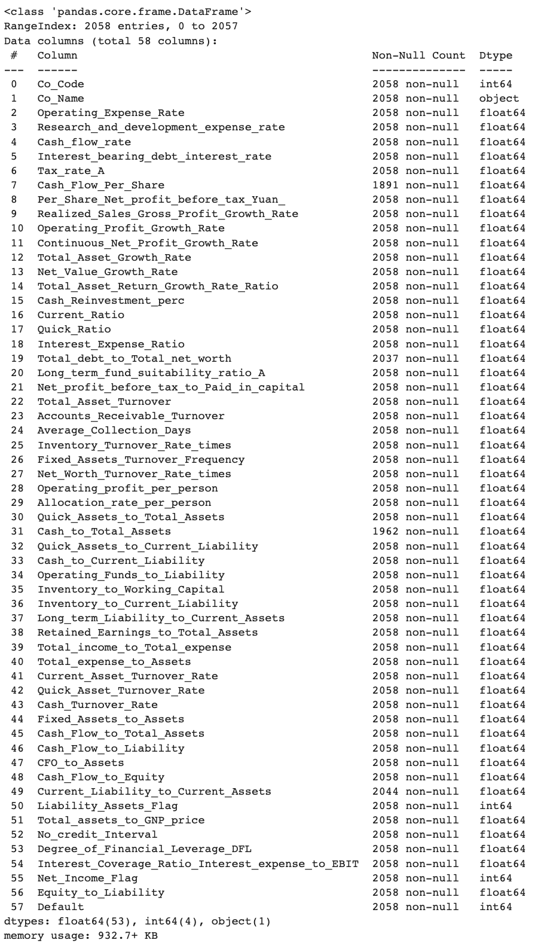

Table 1.2 Information of the dataset

**Statistical Summary of the Dataset:**

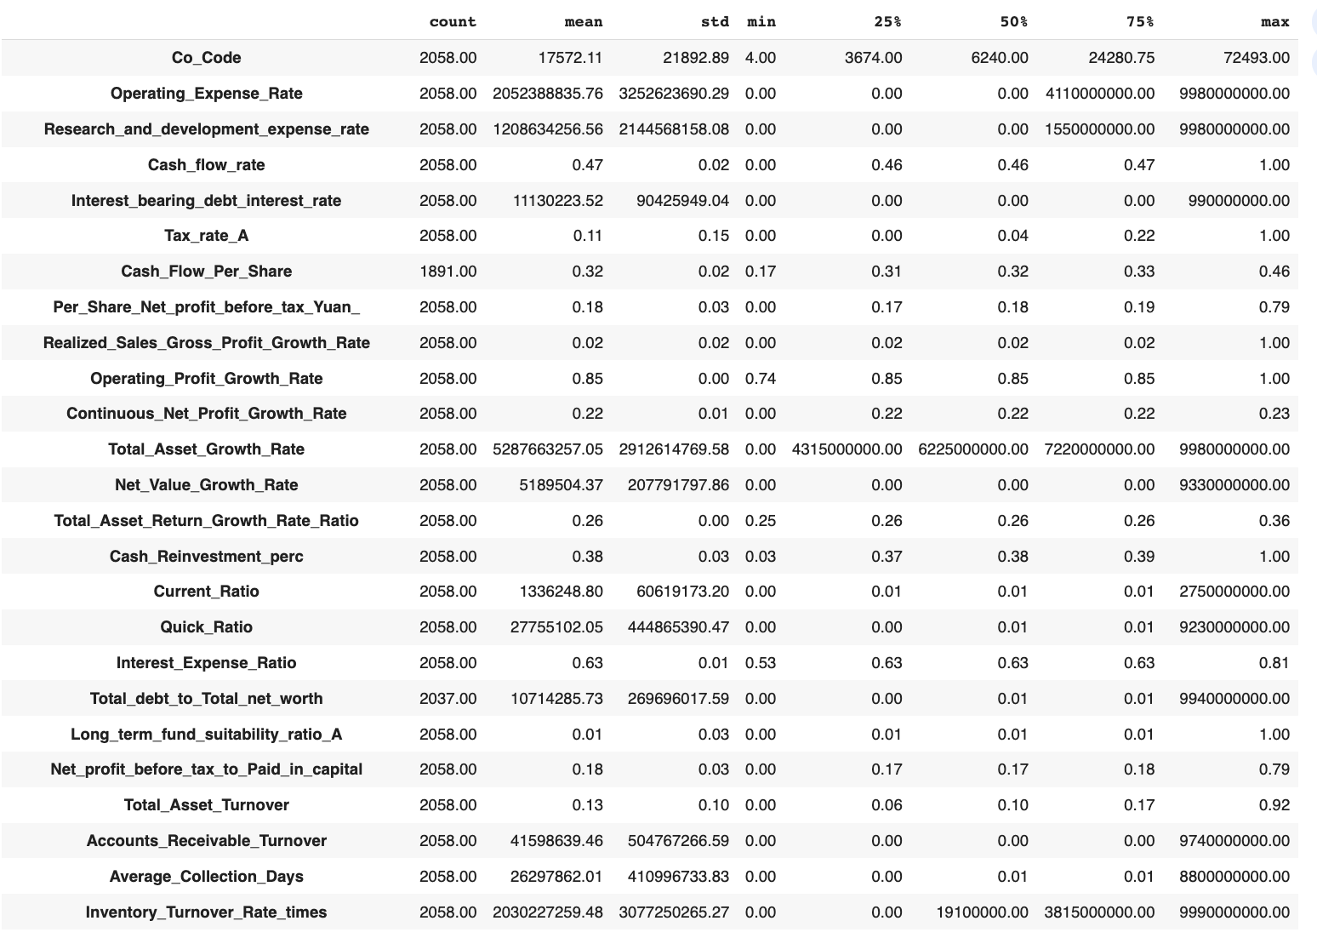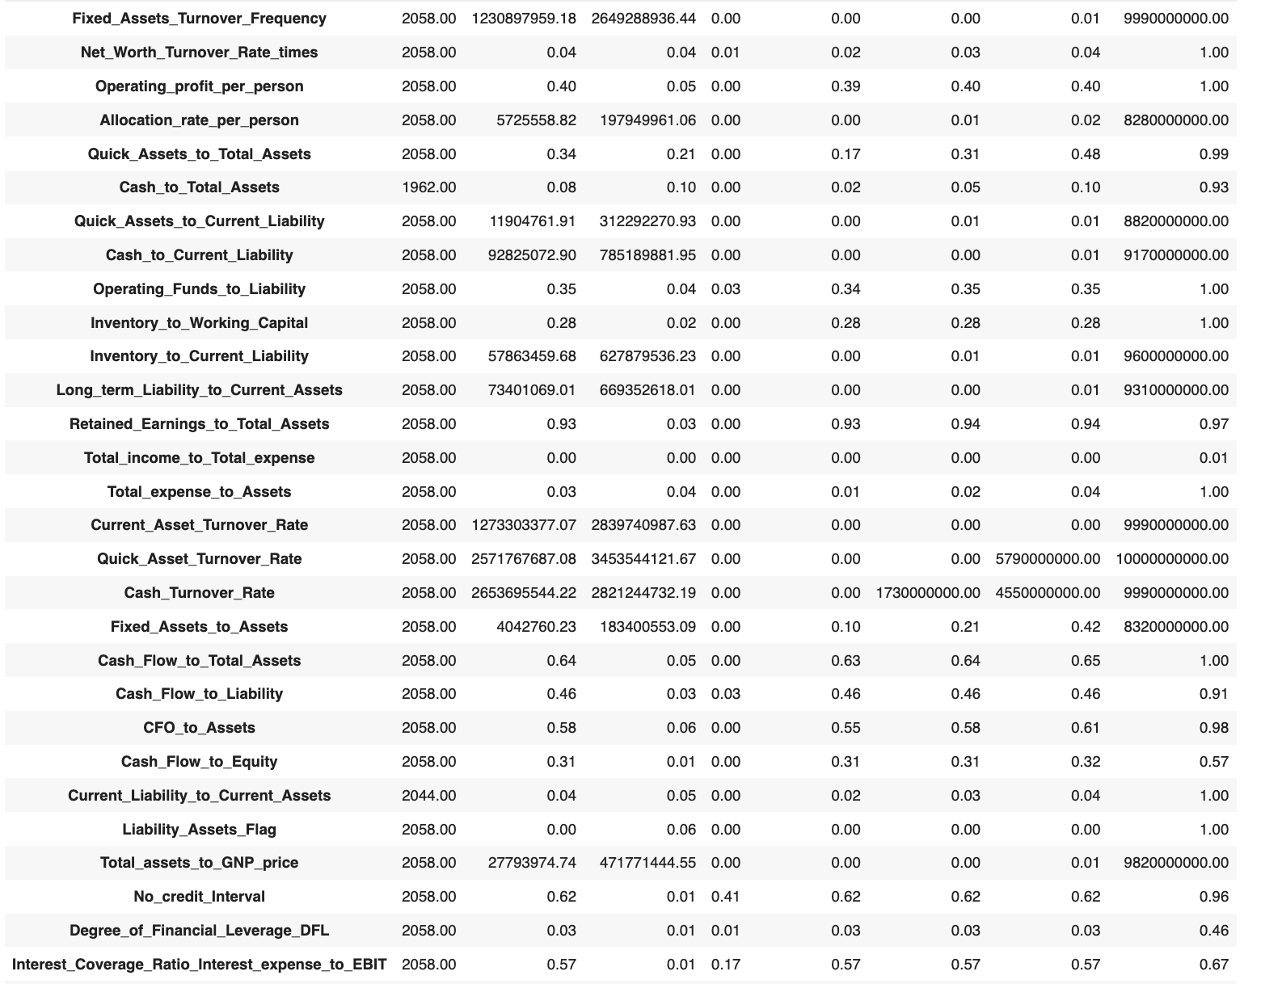

Table 1.3 Descriptive Statistics of the dataset

**Descriptive Statistics**

* **Company information:** The total count of companies in the dataset are 2058.
* **Operating Expenses:** The operating expense rates vary significantly, with values ranging from 0 to approximately 9.98 billion. This column exhibits a very high degree of variability, including extreme outliers towards right.
* **Research and Development Expenses:** Similar to operating expenses, research and development expenses show a wide range, spanning from 0 to approximately 9.98 billion. This column also contains significant variability and potential outliers.
* **Cash Flow and Profitability:** The dataset includes cash flow-related metrics such as cash flow rate and cash flow per share, with values around 0.47 and 0.32, respectively. Per share net profit before tax averages at around 0.18. These metrics appear to have a relatively narrower distribution compared to some other columns.
* **Tax and Financial Ratios:** The tax rate (A) ranges from 0 to 1.0, with a mean of approximately 0.11. Several financial ratios, such as realized sales gross profit growth rate and operating profit growth rate, show moderate variability with means around 0.02 and 0.85, respectively. Other financial ratios also demonstrate variability within their respective ranges.

**Duplicate records:**

* There are no duplicate records in the dataset.

**Outlier Treatment**

Number of Observations Beyond Upper & Lower Limit for Each Column:

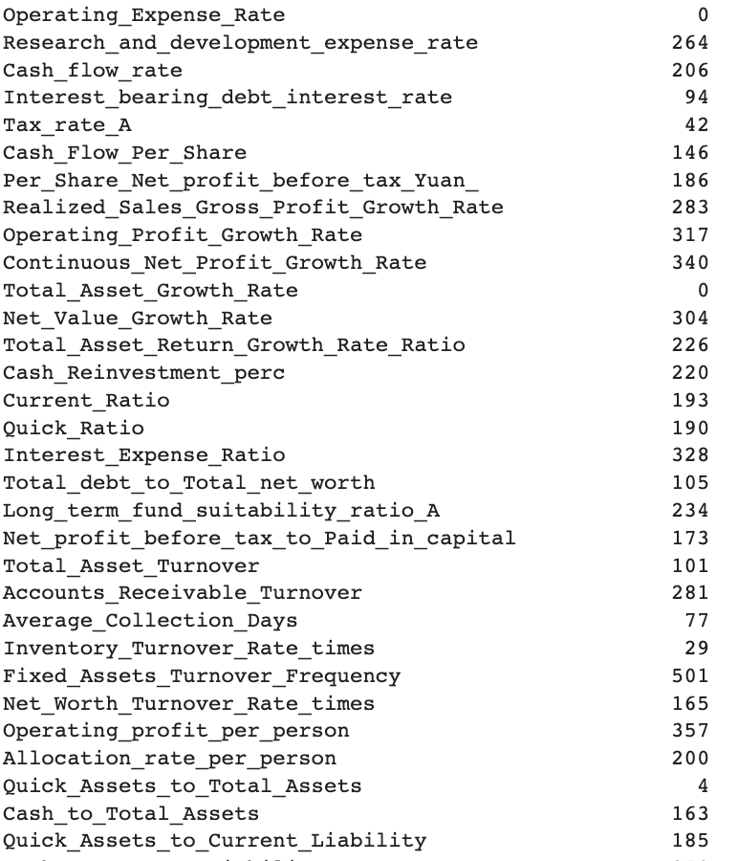

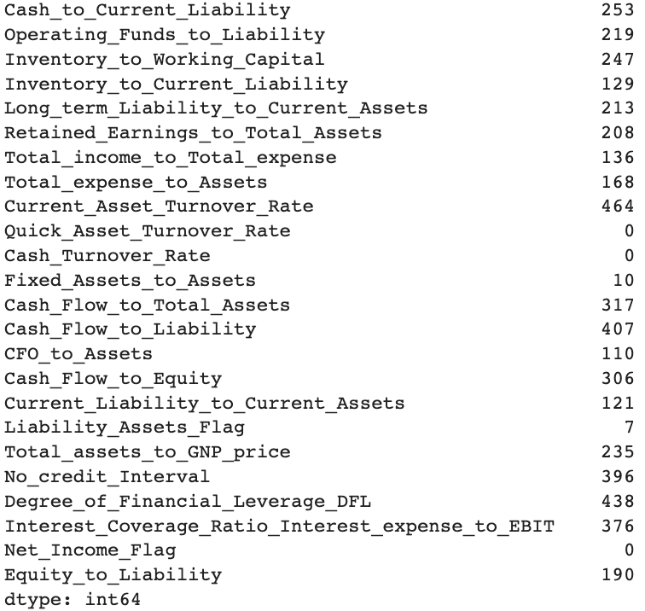

Table 1.4 Outliers in Each variable

**Outliers Visualization**

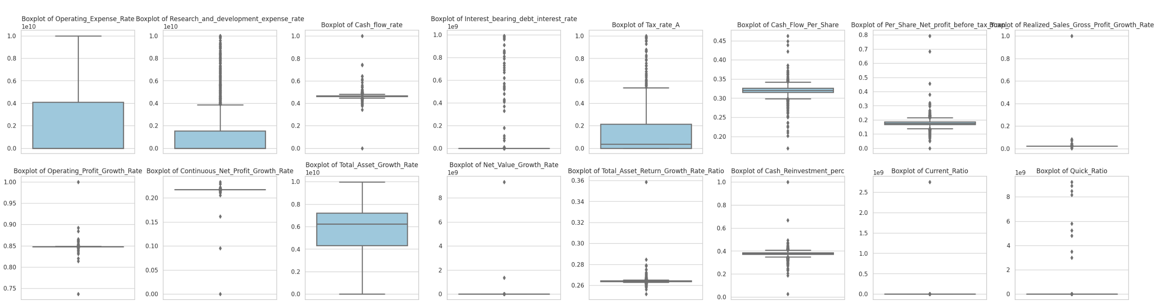

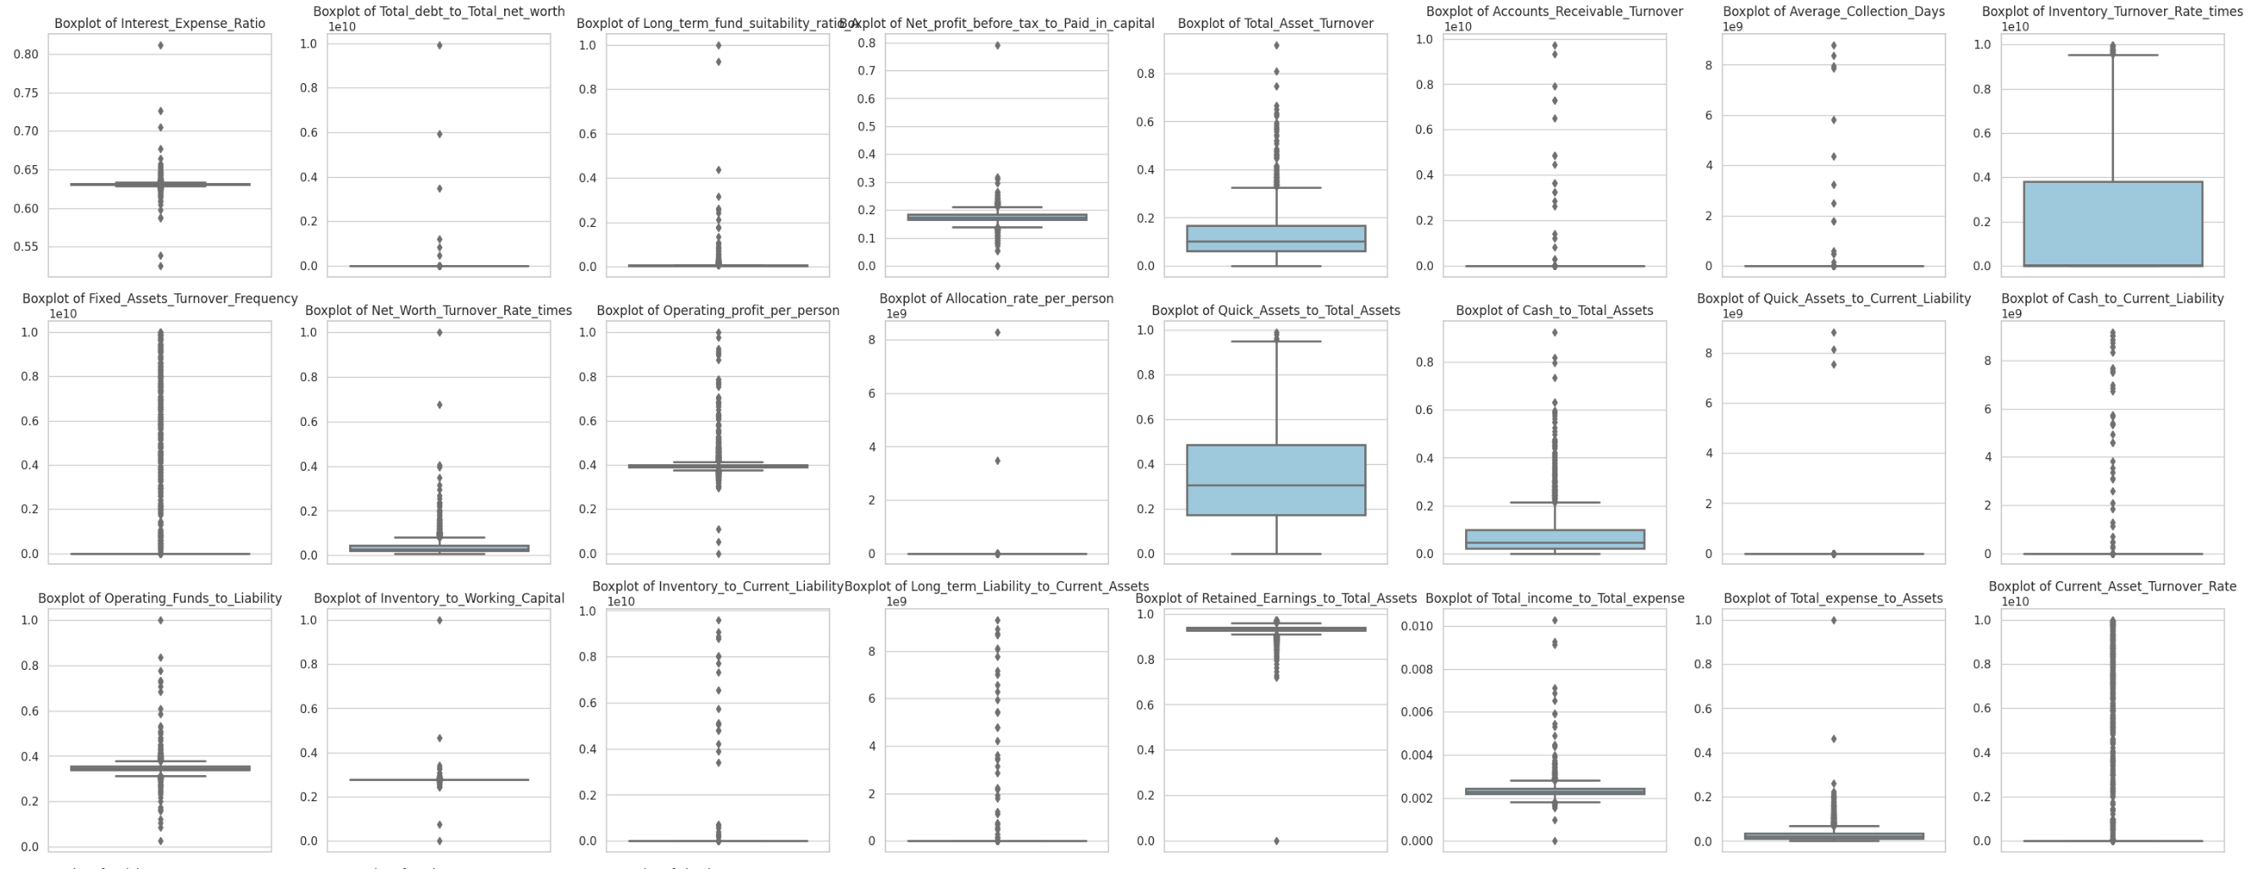

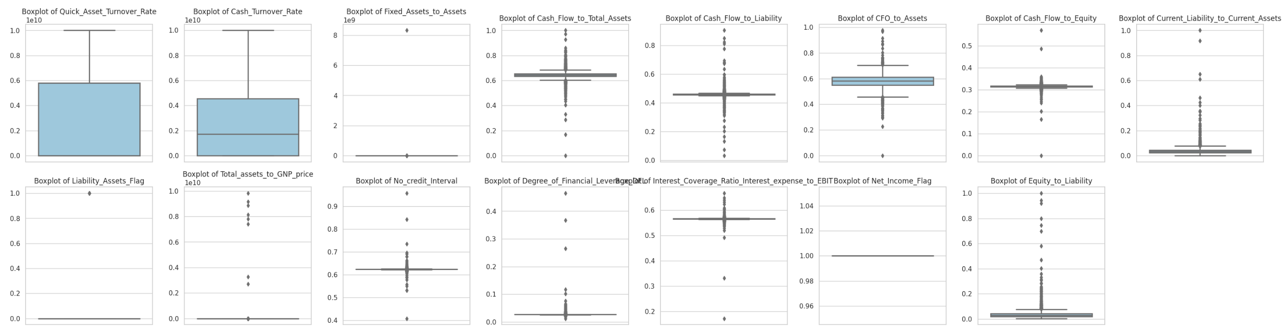

fig 1.1 Outliers in Each variable

**Treatment Approach:**

* The Outliers are Treated by capping them on **Upper Limit** and **Lower limit** for each column.

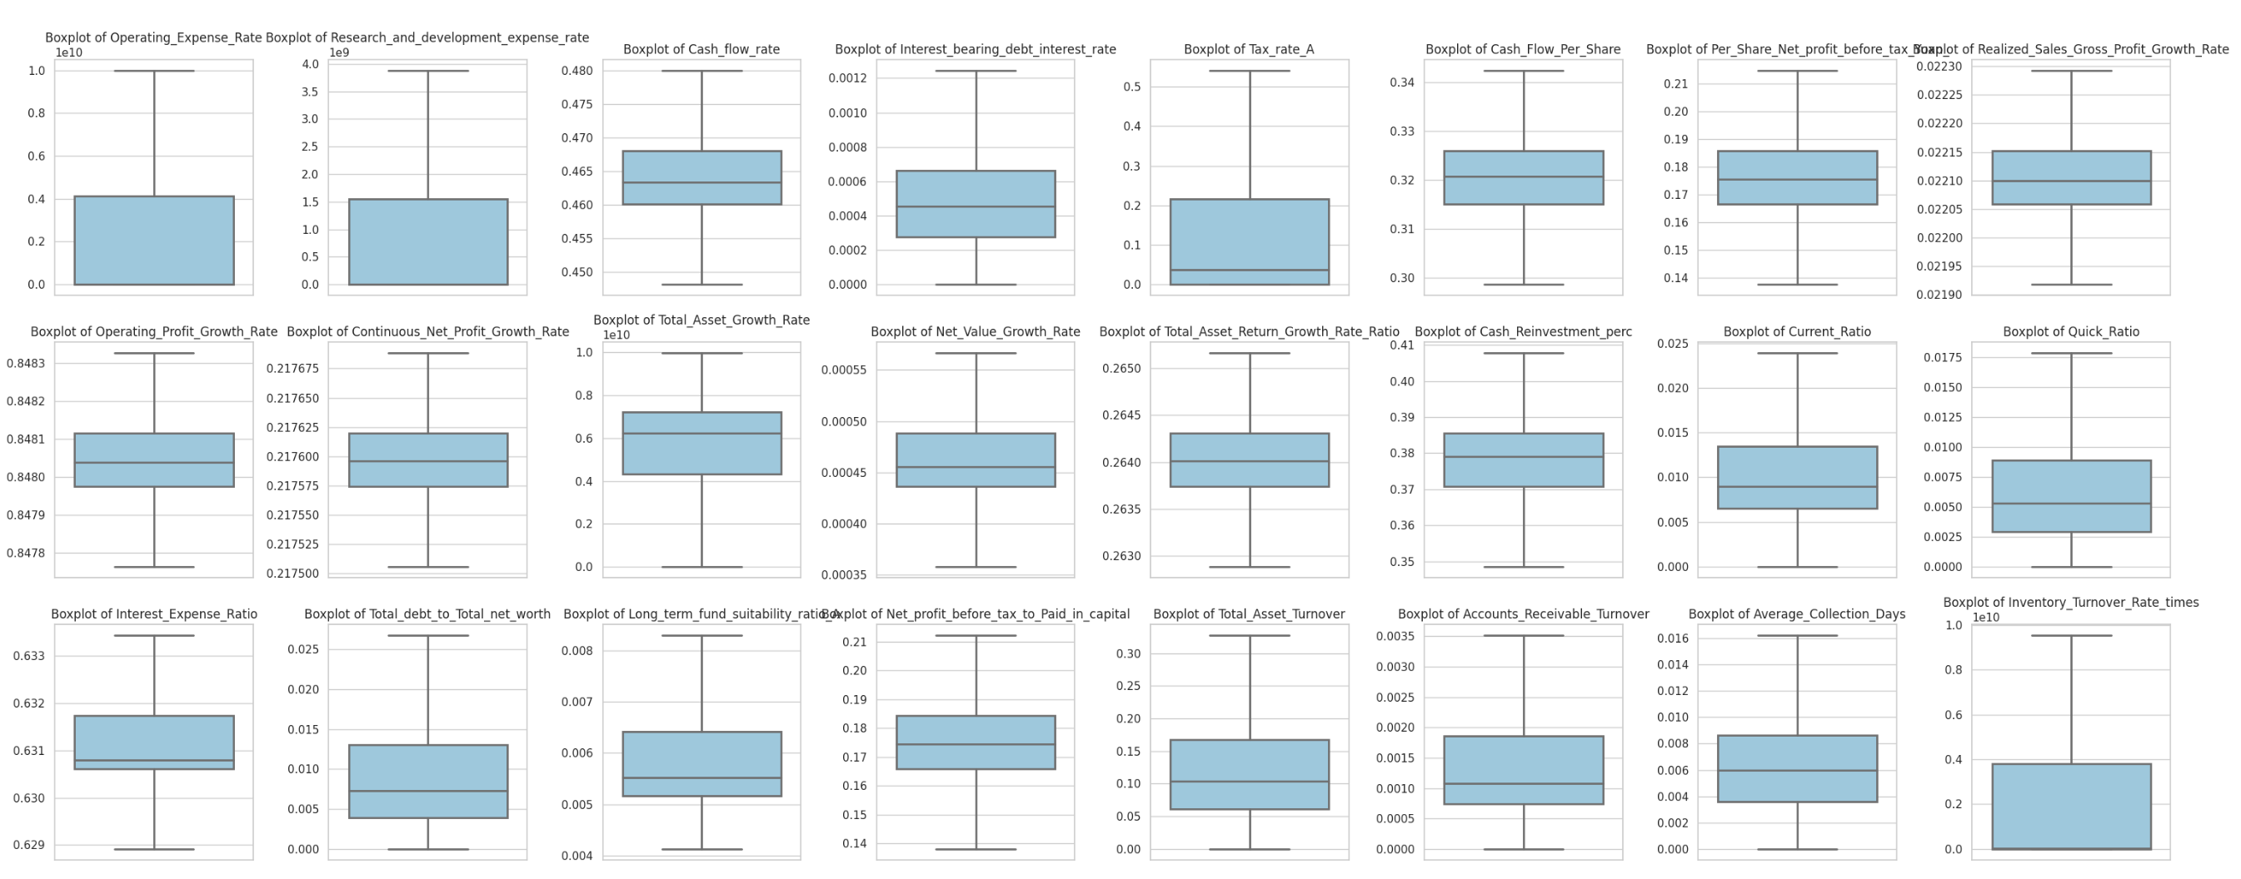

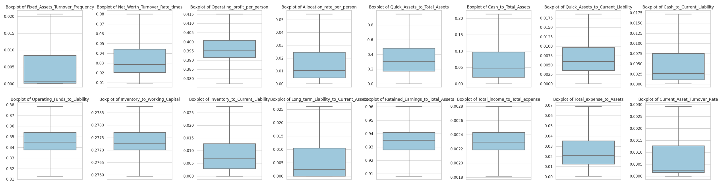

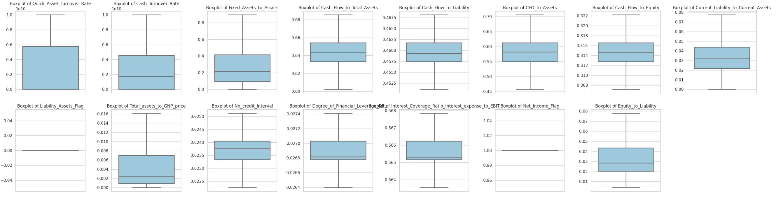

fig 1.2 Outliers after Treatment

**Missing Values**

* **Overall**: The total number of missing values are **298**, which is **0.25%** of total data.

**Column Wise:**

* **Cash_Flow_Per_Share** has **167** missing values, which is **8.11%** of the column.
* **Total_debt_to_Total_net_worth** has **21** missing values, which is **1.02%** of the column.
* **Cash_to_Total_Assets** has **96** missing values, which is **4.66%** of the column.
* **Current_Liability_to_Current_Assets** has **14** missing values, which is **0.68%** of the column.

Missing Value visualization:-

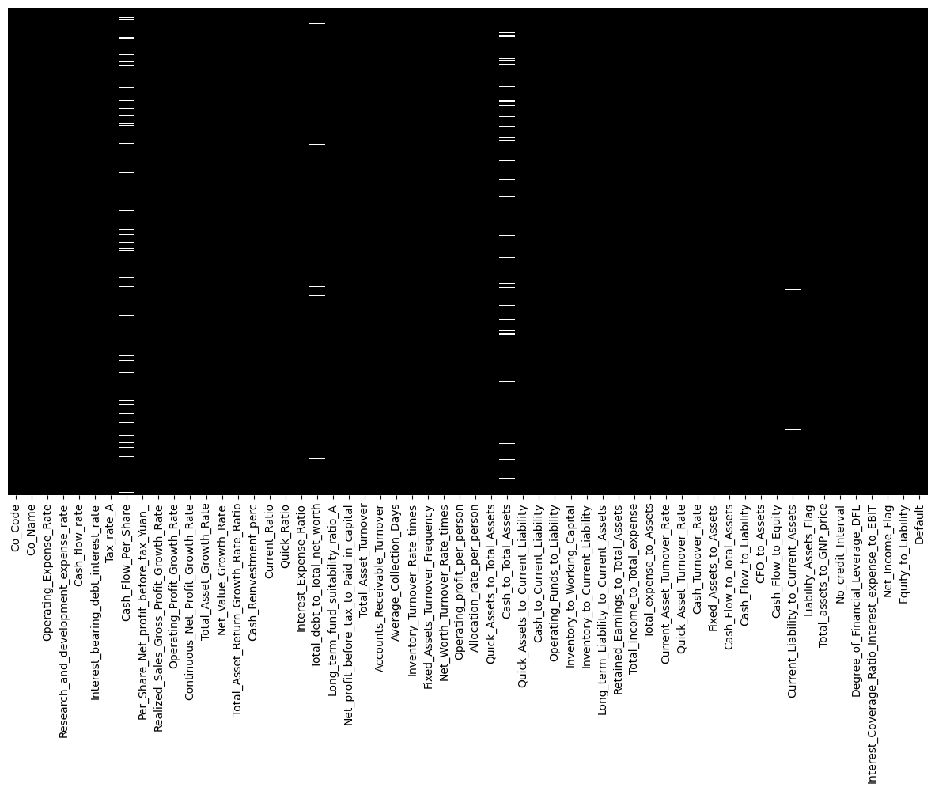

fig 1.3 Missing Value heatmap

**Missing Value Treatment:**

The missing values are Treated using KNN imputer post outlier Treatment.

* Scaling was done on the predictors to make them on same scale
* KNN imputer imputed the missing values using the mean value from the ‘n’ nearest neighbours found in the training set (here, n = 5).
* There are no missing values remaining after imputation using KNN



fig 1.4 Missing Values After Treatment

**Univariate & Bivariate analysis with proper interpretation.**

Before we do Univariate & Bivariate analysis, Let’s do feature selection for the most important features.

**Feature Scaling**

The features are scaled as per the standard scaler(Z score) technique as the standardisation helps in easy & correct interpretation of the coefficients of Logistic Regression & LDA. A snippet of the dataset after scaling is

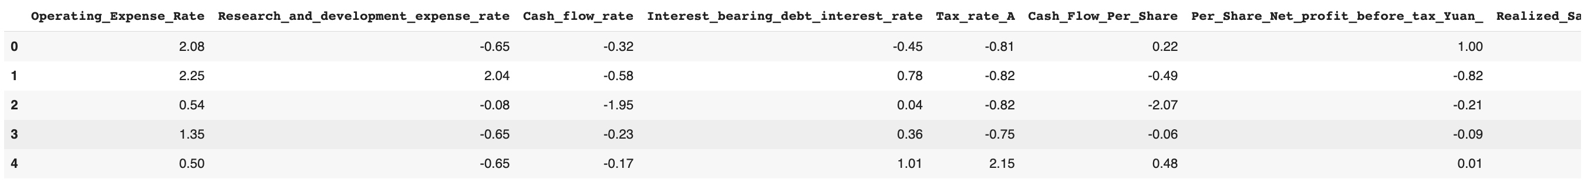

Table 1.5 Sample of scaled variables

Z-score is a technique of scaling that tells us the number of standard deviations a data is away from the mean. After Z-score scaling the features have a mean = 0 and standard deviation = 1

**Multicollinearity**

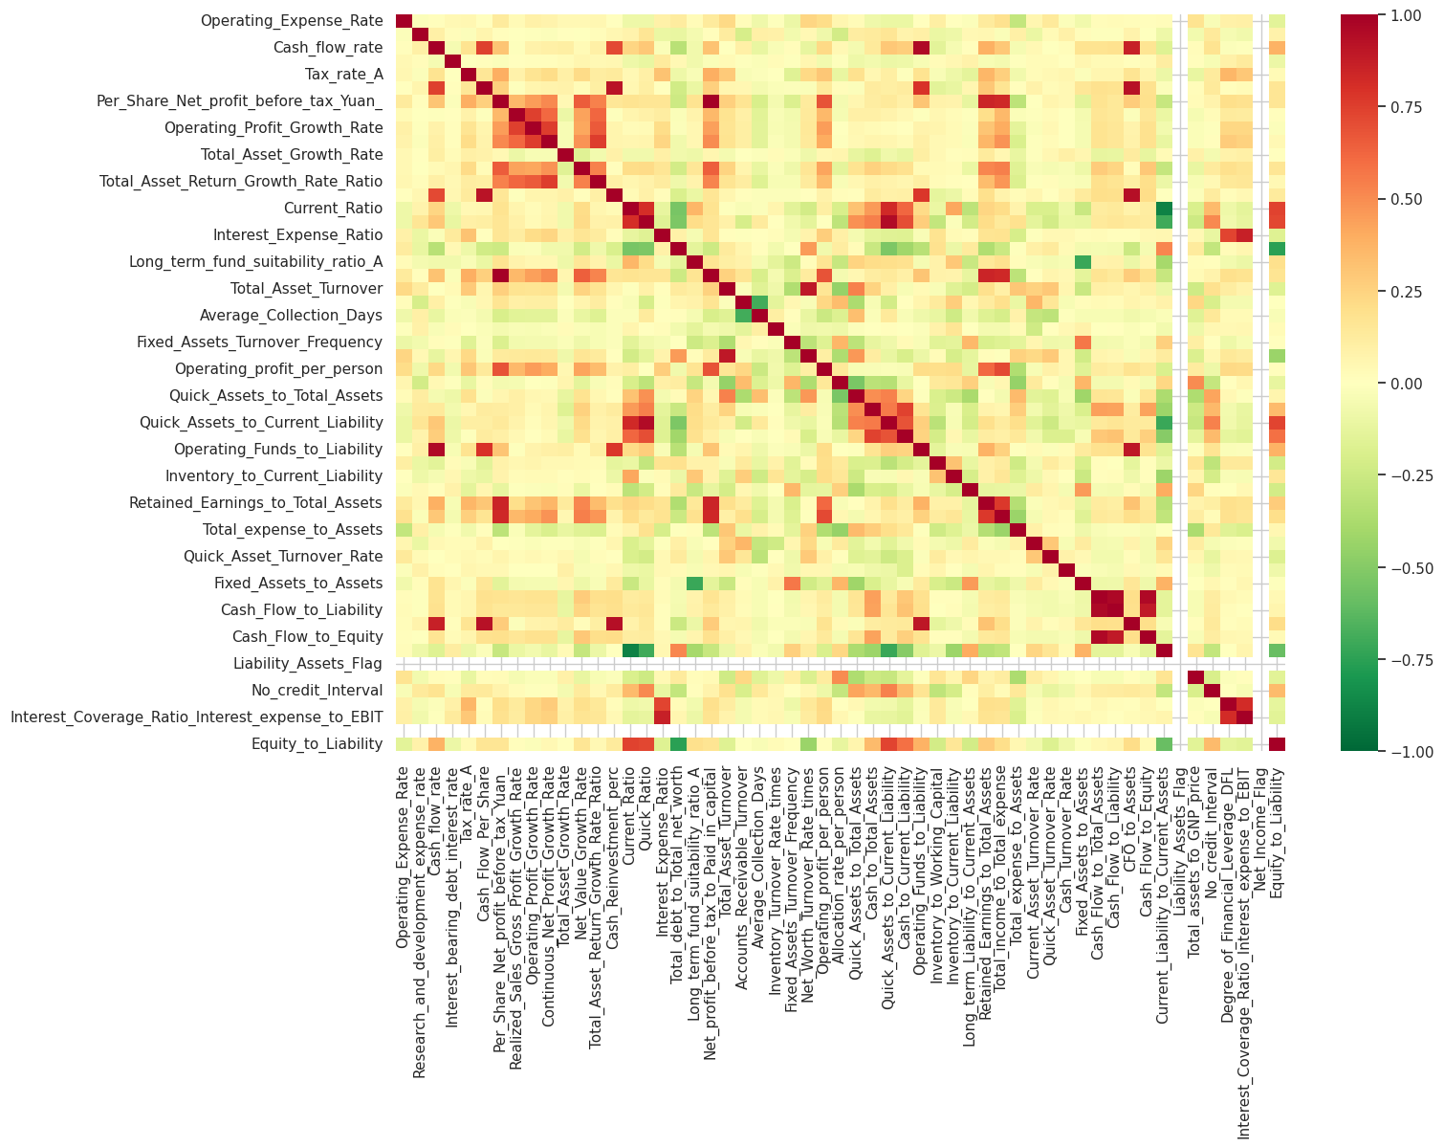

fig 1.5 Multicollinearity between Variables

* Multicollinearity is evident as many features exhibit high correlations with each other, potentially complicating the interpretation of individual feature impacts on the target variable and the stability of model coefficients
* Features such as , such as "Realized_Sales_Gross_Profit_Growth_Rate" and "Operating_Profit_Growth_Rate," exibits strong positive correlation, indicating that they tend to move together positively in financial performance.
* Some pairs of features, like "Total_assets_to_GNP_price" and "Total_expense_to_Assets," show negative correlations, implying an inverse relationship between them.
* **Variables with a high multicollinearity will be removed, i.e., variables with a VIF > 5**

### **Eliminating variables that are highly correlated with one another using VIF:**

* A **variance inflation factor (VIF)** provides a measure of multicollinearity among the independent variables in a multiple regression model.
* Detecting multicollinearity is important because while multicollinearity does not reduce the explanatory power of the model, it does reduce the statistical significance of the independent variables.
* A large VIF on an independent variable indicates a highly collinear relationship to the other variables that should be considered or adjusted for in the structure of the model and selection of independent variables.

**VIF > 5 is not suitable as it is mostly compensated by other IVs. Hence we use VIF to clean the data of redundant variables.** Variables VIF>5 are shown as below without any elimination yet:

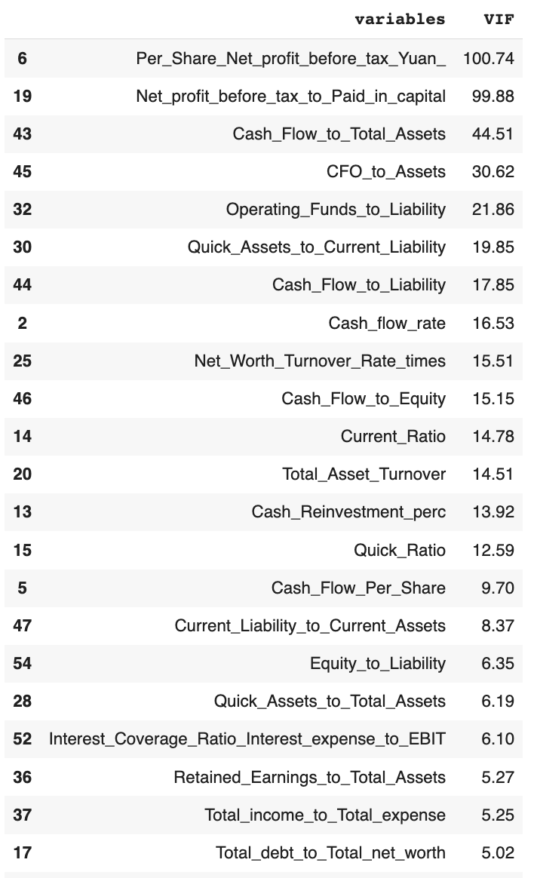

Table 1.6 Variables with highest VIF (>5.0)

**Let’s eliminate the variables one by one.** We will iterate through the values one by one. Starting the first iteration by dropping variable with highest VIF & show updated VIF values (Top 5)

**Iteration 1**: Highest VIF is 100.74 for **Per_Share_Net_profit_before_tax_Yuan**_, dropping it.

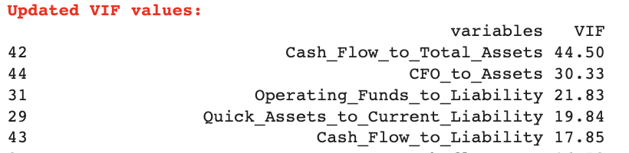

Table 1.7 Variables with highest VIF - Top 5

**Iteration 2**: Highest VIF is 44.5 for **Cash_Flow_to_Total_Assets**, dropping it.

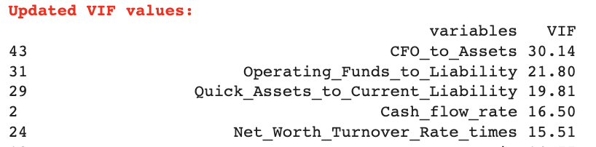

Table 1.8 Variables with highest VIF - Top 5

**Iteration 3:** Highest VIF is 30.14 for **CFO_to_Assets**, dropping it.

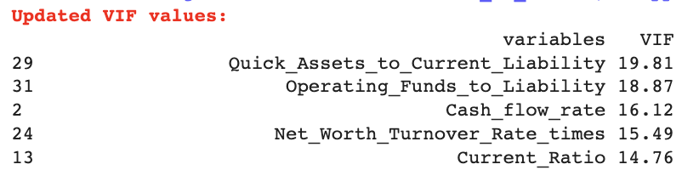

Table 1.9 Variables with highest VIF - Top 5

**Iteration 4**: Highest VIF is 19.81 for **Quick_Assets_to_Current_Liability**, dropping it.

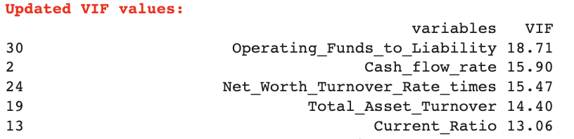

Table 1.10 Variables with highest VIF - Top 5

Iteration 5: Highest VIF is 18.71 for **Operating_Funds_to_Liability**, dropping it.

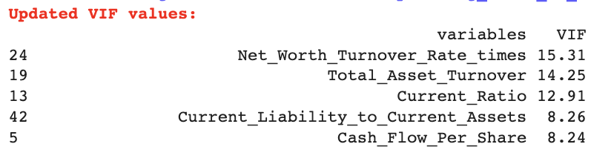

Table 1.11 Variables with highest VIF - Top 5

Iteration 6: Highest VIF is 15.31 for **Net_Worth_Turnover_Rate_times**, dropping it.

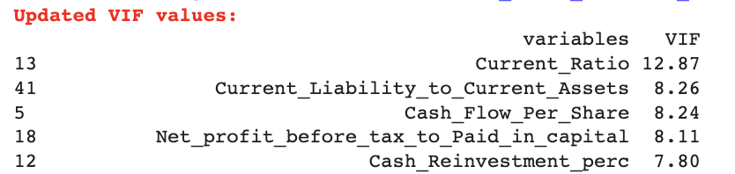

Table 1.12 Variables with highest VIF - Top 5

Iteration 7: Highest VIF is 12.87 for **Current_Ratio**, dropping it.

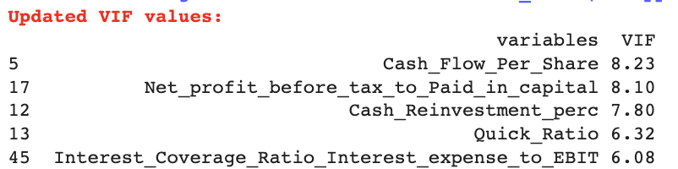

Table 1.13 Variables with highest VIF - Top 5

Iteration 8: Highest VIF is 8.23 for **Cash_Flow_Per_Share**, dropping it.

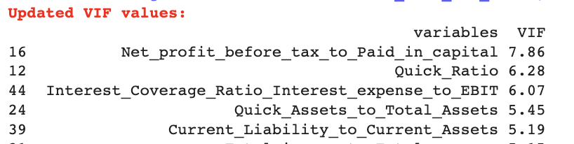

Table 1.14 Variables with highest VIF - Top 5

Iteration 9: Highest VIF is 7.86 for **Net_profit_before_tax_to_Paid_in_capital**, dropping it.

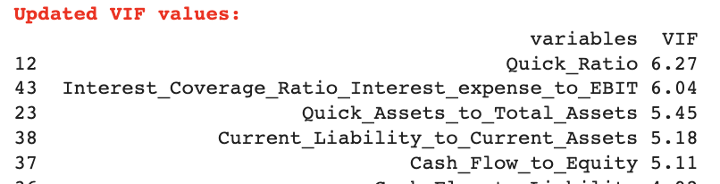

Table 1.15 Variables with highest VIF - Top 5

Iteration 10: Highest VIF is 6.27 for **Quick_Ratio**, dropping it.

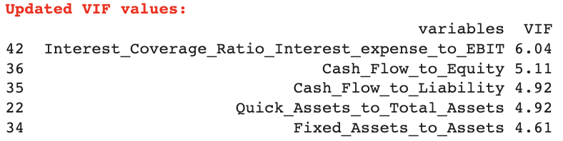

Table 1.16 Variables with highest VIF - Top 5

Iteration 11: Highest VIF is 6.04 for **Interest_Coverage_Ratio_Interest_expense_to_EBIT**, dropping it.

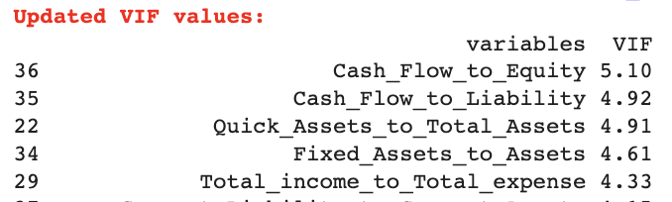

Table 1.17 Variables with highest VIF - Top 5

Iteration 12: Highest VIF is 5.1 for **Cash_Flow_to_Equity,** dropping it.

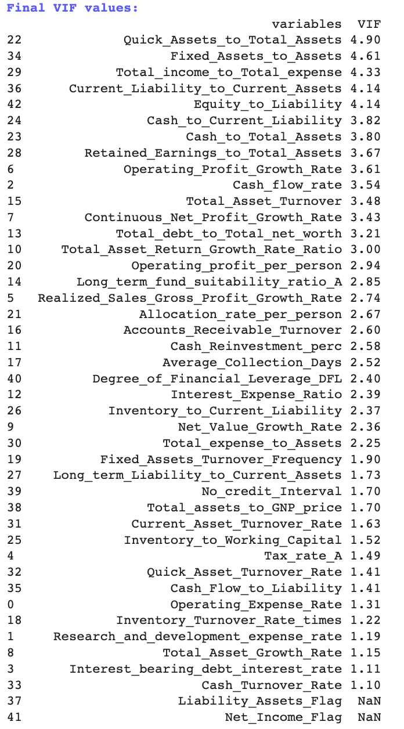

Table 1.18 Final Variables after removing VIF > 5

We can see that we do not have any variable now having VIF>5. We have dropped 12 Variables & left with 43.

We see there are 2 variables **Liability_Assets_Flag', 'Net_Income_Flag'** having only one type of values which are not significant, hence, we chose to drop them as well.

**After dropping** all columns with **VIF > 5 & 2 constant value variables,** we are left with **41 Variables.**

**Recursive Feature Elimination:**

**Recursive feature elimination (RFE)** is a feature selection method that fits a model and removes the weakest feature (or features) until the specified number of features is reached.

* Once the feature importance has been determined, it then removes the less important features one by one in each iteration.
* We use the **Logistic Regression algorithm** of sci-kit learn to determine the most important features.
* Since there are still a lot of variables (41) remaining in the dataset, we use recursive feature elimination to select the most important features. As per the thumb rule, we select 1/3rd of the features (14) that will be critical in the model development.

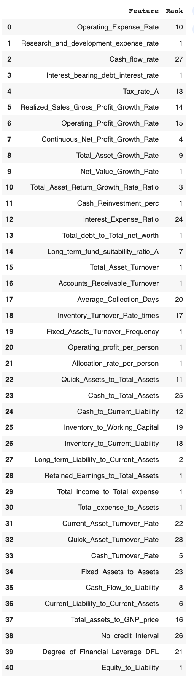

Table 1.19 RFE Rank of all Variables

The ranks of the **most important features are 1 and** the rest follow it. Below given is the list of the **14 most important features** that will be used in model building

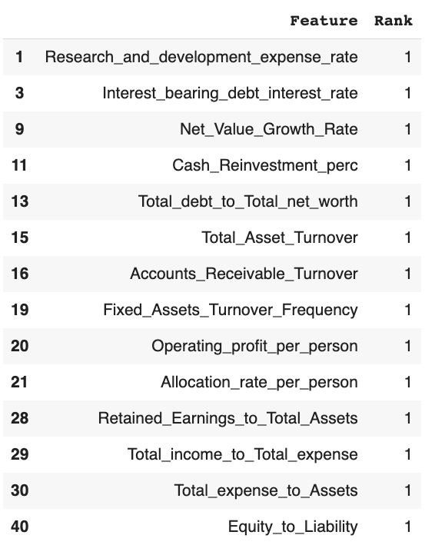

Table 1.20 Selected Variables with Rank 1

**Univariate Analysis**

We will now take a look at only the most important variables for univariate & bivariate analysis.

**Note: The Univariate & bivariate Analysis is done on the original data, not the treated**

**Target Variable:**

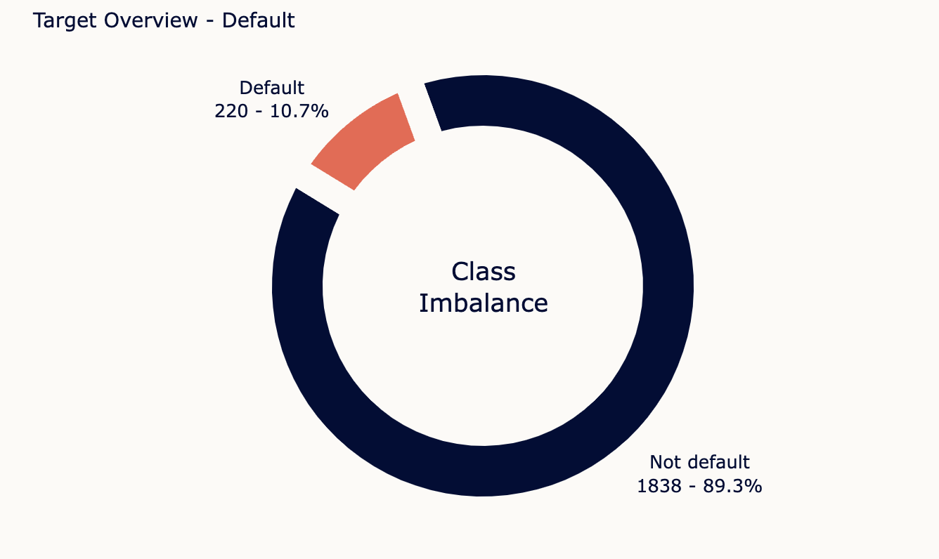

fig 1.6 Target Variable Overview

* The default class of the “Default “ variable is imbalanced as observed earlier as well with 10.7% data in the underrepresented class.
* We will try to oversample the default class using SMOTE to see if it improves our model performance.

**Distribution of each Variable**

**Research_and_development_expense_rate**

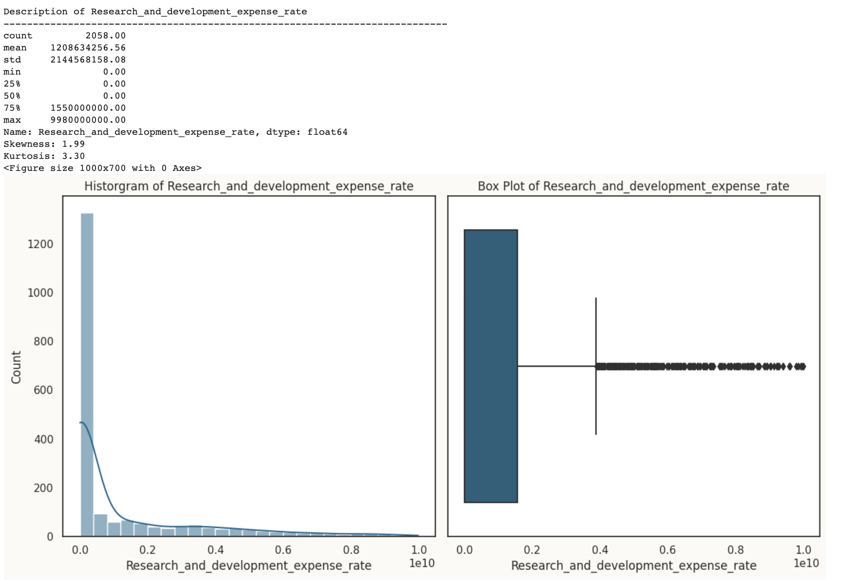



Table 1.21 Descriptive Statistics of the Variable

- The mean value is 1.21Bil. but it has a wide range from 0 to 9.98Bil, indicating a high variation in this feature.

- The data is positively skewed (1.99) and has positive kurtosis 3.30), suggesting that it is not normally distributed and has a heavy right tail.

fig 1.7 Univariate Analysis of Research_and_development_expense_rate

**Interest_bearing_debt_interest_rate**

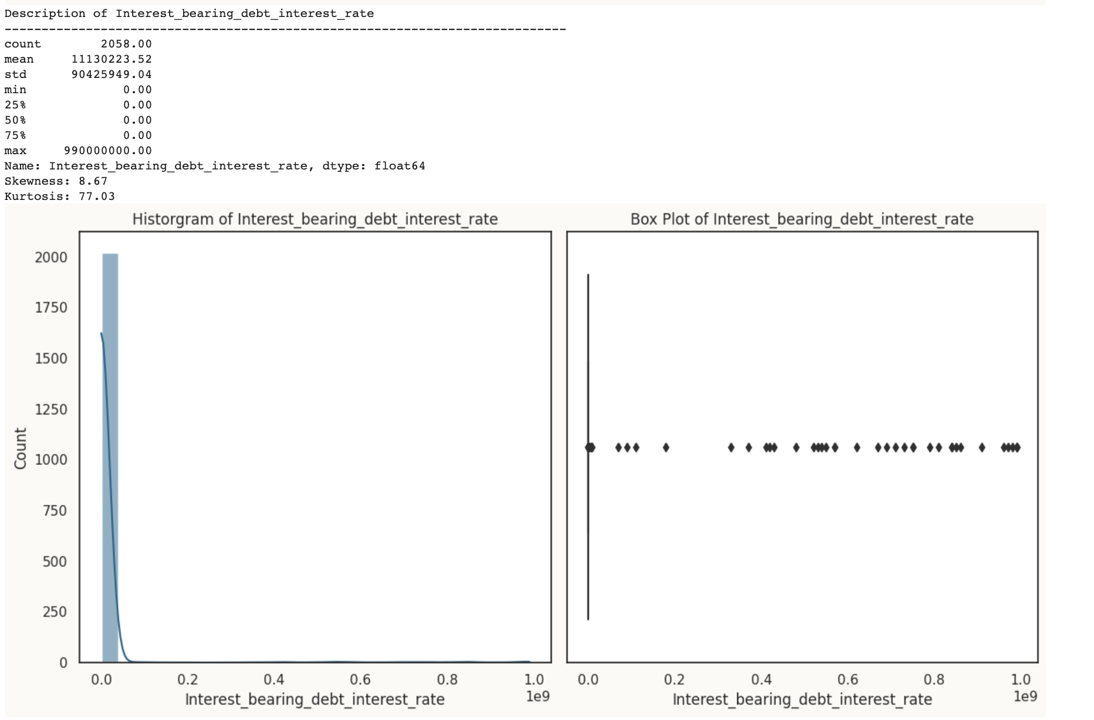



Table 1.22 Descriptive Statistics of the Variable

- The mean value is 11130223.52, but it has a wide range from 0 to 990000000.00, indicating significant variation.

- This feature is highly positively skewed (Skewness: 8.67) and has extremely high kurtosis (Kurtosis: 77.03), indicating a non-normal distribution with a long right tail.

fig 1.8 Univariate Analysis of Interest_bearing_debt_interest_rate

**Net_Value_Growth_Rate**

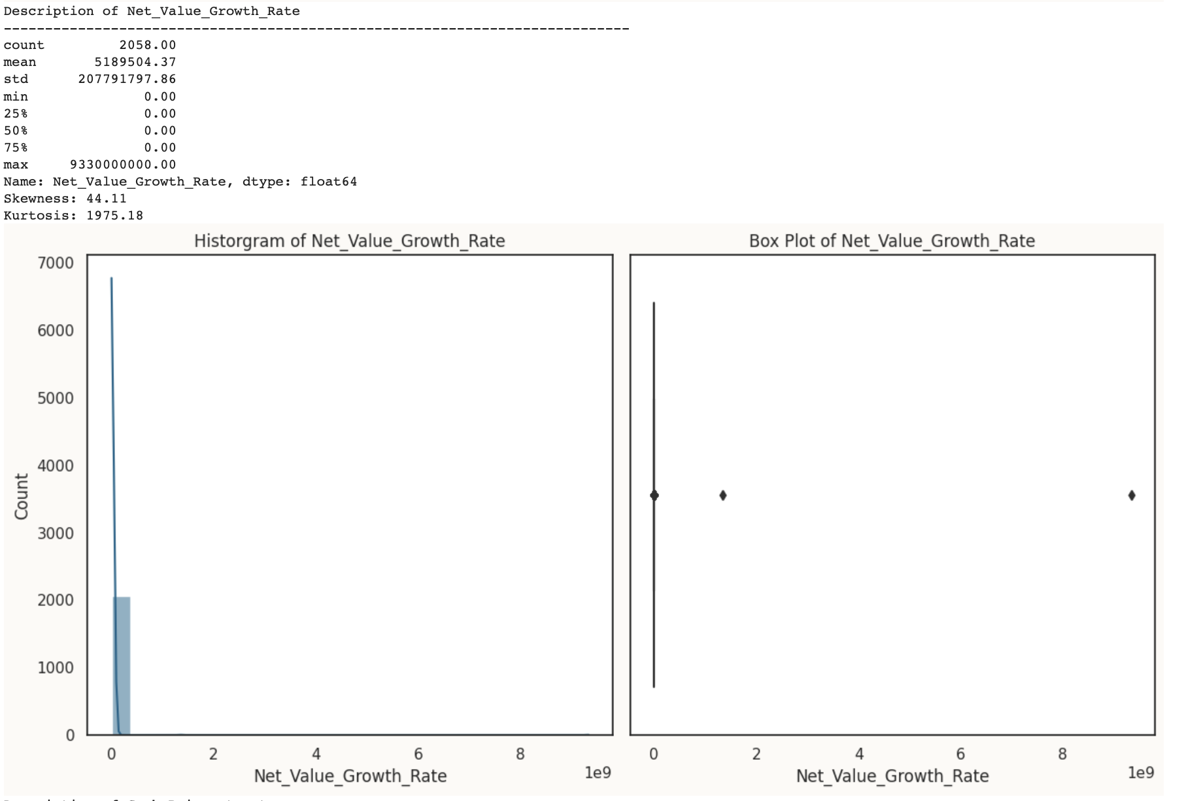



Table 1.23 Descriptive Statistics of the Variable

- The mean value is 5189504.37, a wide range from 0 to 9.33B, indicating a large variation.

- This feature is extremely positively skewed (Skewness: 44.11) and has very high kurtosis (Kurtosis: 1975.18), indicating a highly non-normal distribution with a heavy right tail.

fig 1.9 Univariate Analysis of Net_Value_Growth_Rate

**Cash_Reinvestment_perc**

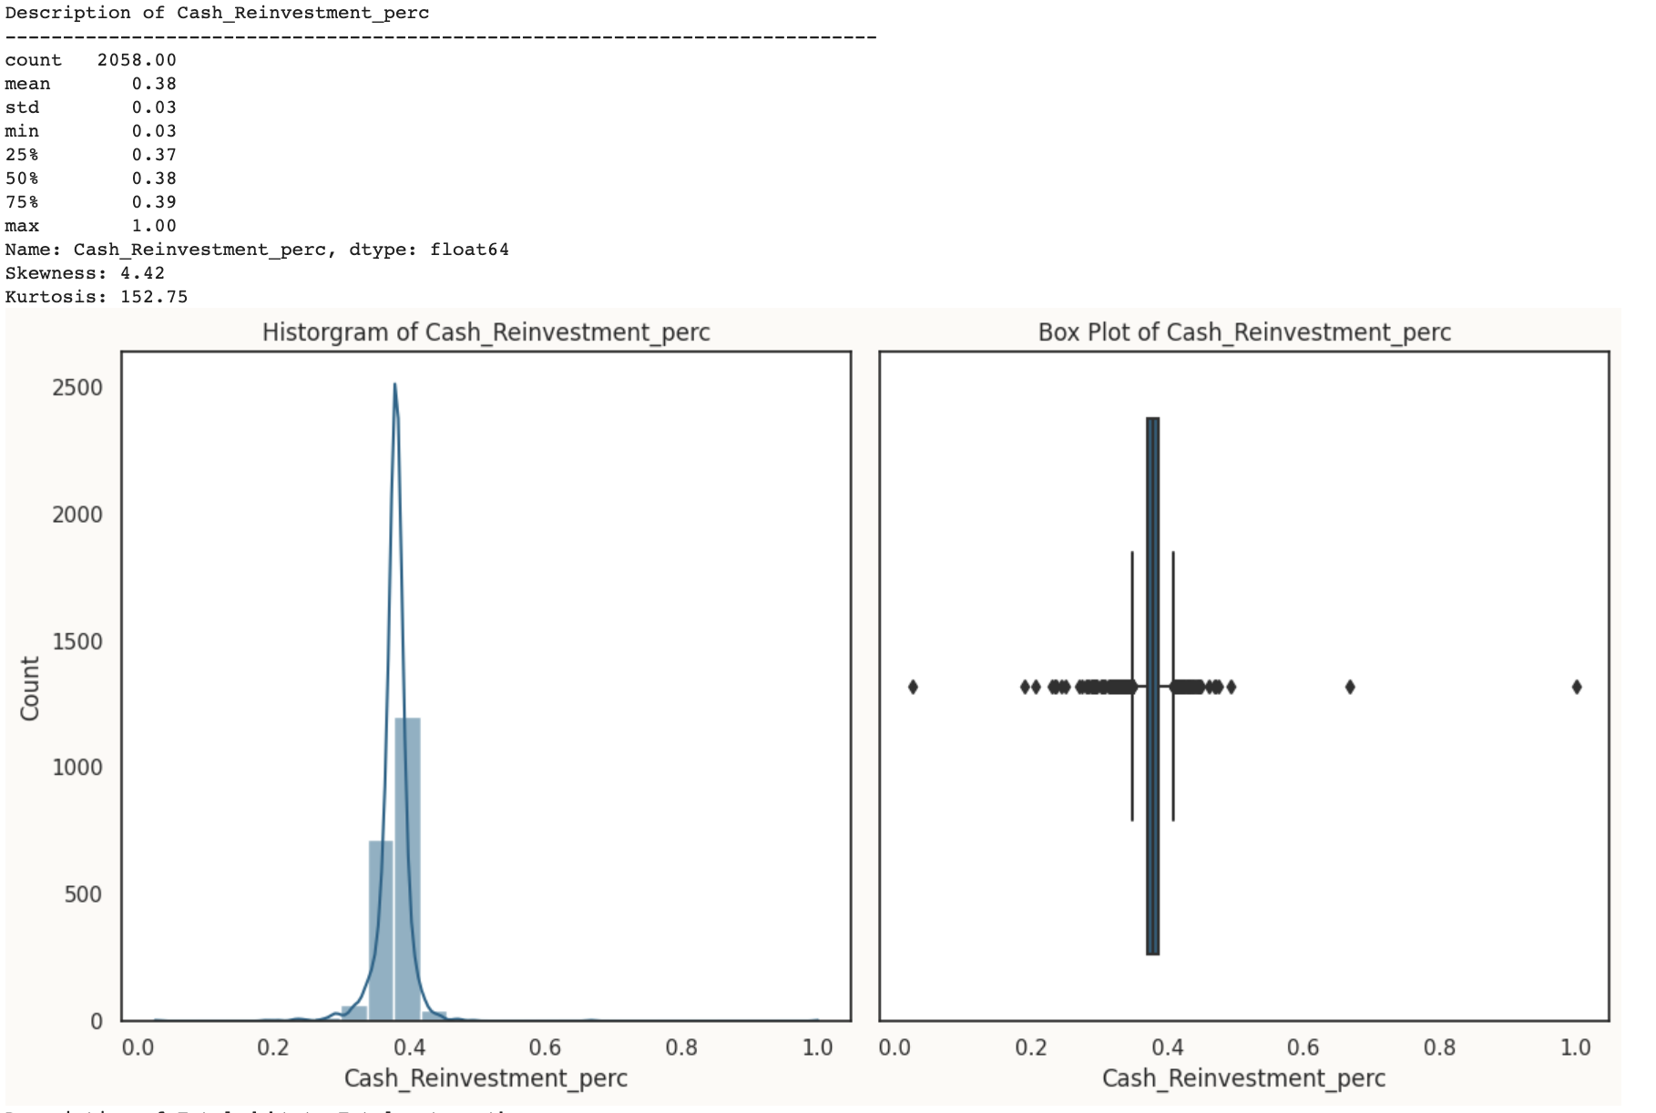



Table 1.24 Descriptive Statistics of the Variable

- The data has a relatively low standard deviation (0.03) compared to the mean (0.38), suggesting low variability.

- The skewness (Skewness: 4.42) and kurtosis (Kurtosis: 152.75) values indicate that this feature is positively skewed and has a heavy right tail.

fig 1.10 Univariate Analysis of Cash_Reinvestment_perc

**Total_debt_to_Total_net_worth**

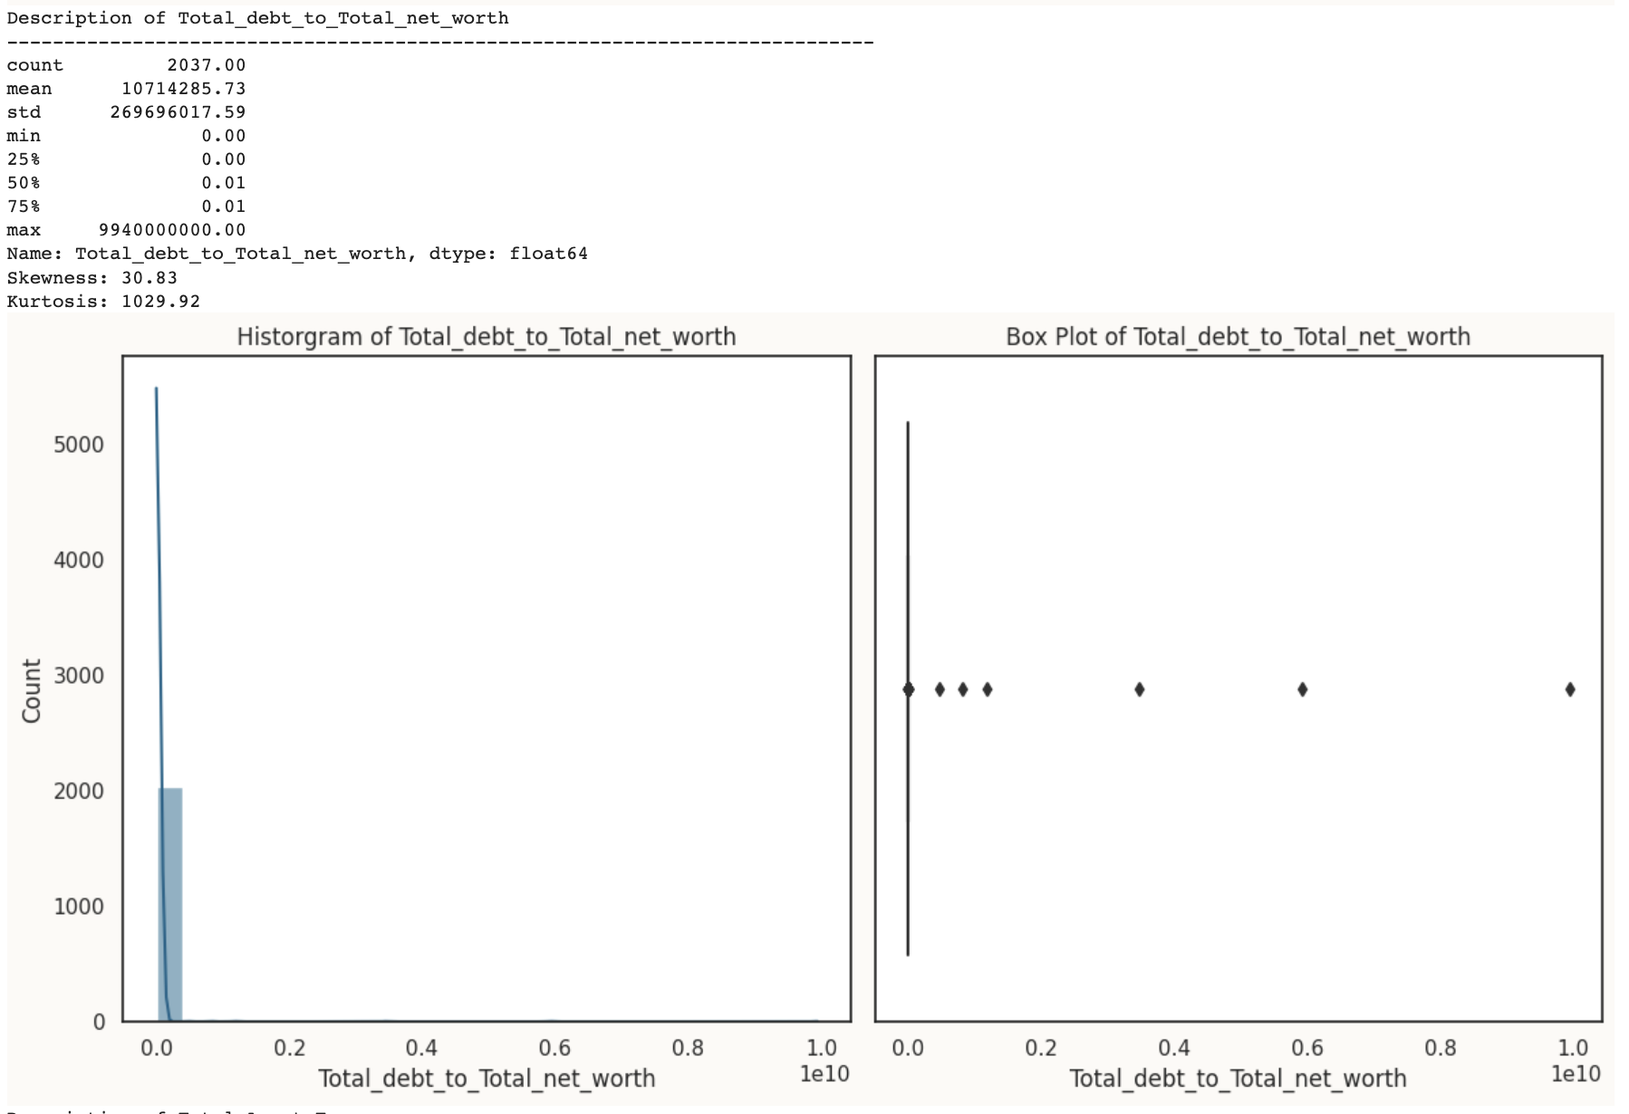



Table 1.25 Descriptive Statistics of the Variable

- The mean value is 10714285.73, with a wide range from 0 to 9940000000.00.

- The feature is highly positively skewed (Skewness: 30.83) and has extremely high kurtosis (Kurtosis: 1029.92), indicating a non-normal distribution with a heavy right tail.

fig 1.11 Univariate Analysis of Total_debt_to_Total_net_worth

**Total_Asset_Turnover**

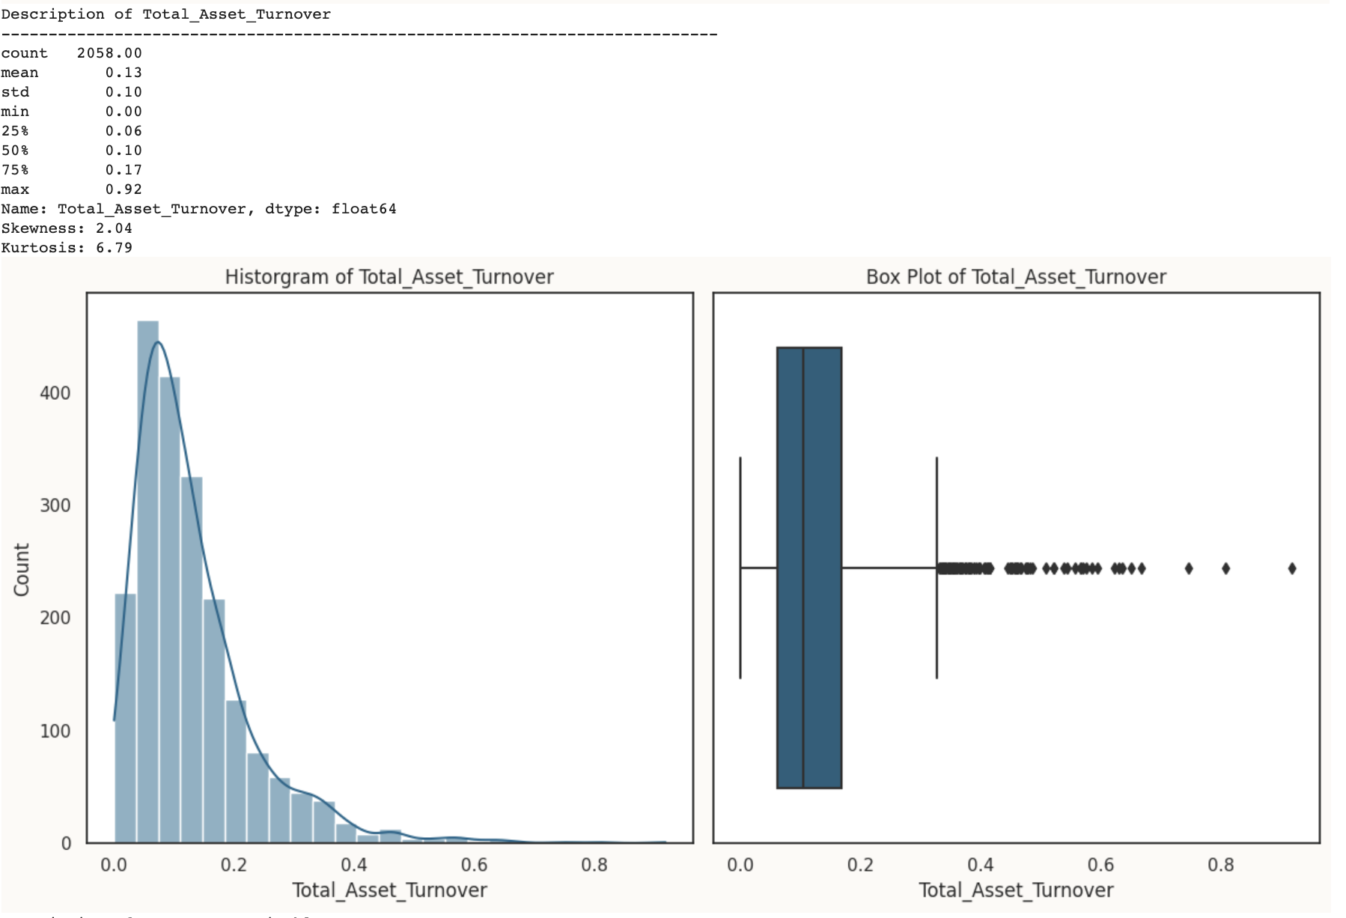



Table 1.26 Descriptive Statistics of the Variable

- The mean value is 0.13, indicating the average asset turnover rate.

- The data is moderately positively skewed (Skewness: 2.04) and has moderate kurtosis (Kurtosis: 6.79), suggesting a somewhat non-normal distribution.

fig 1.12 Univariate Analysis of Total_Asset_Turnover

**Accounts_Receivable_Turnover**

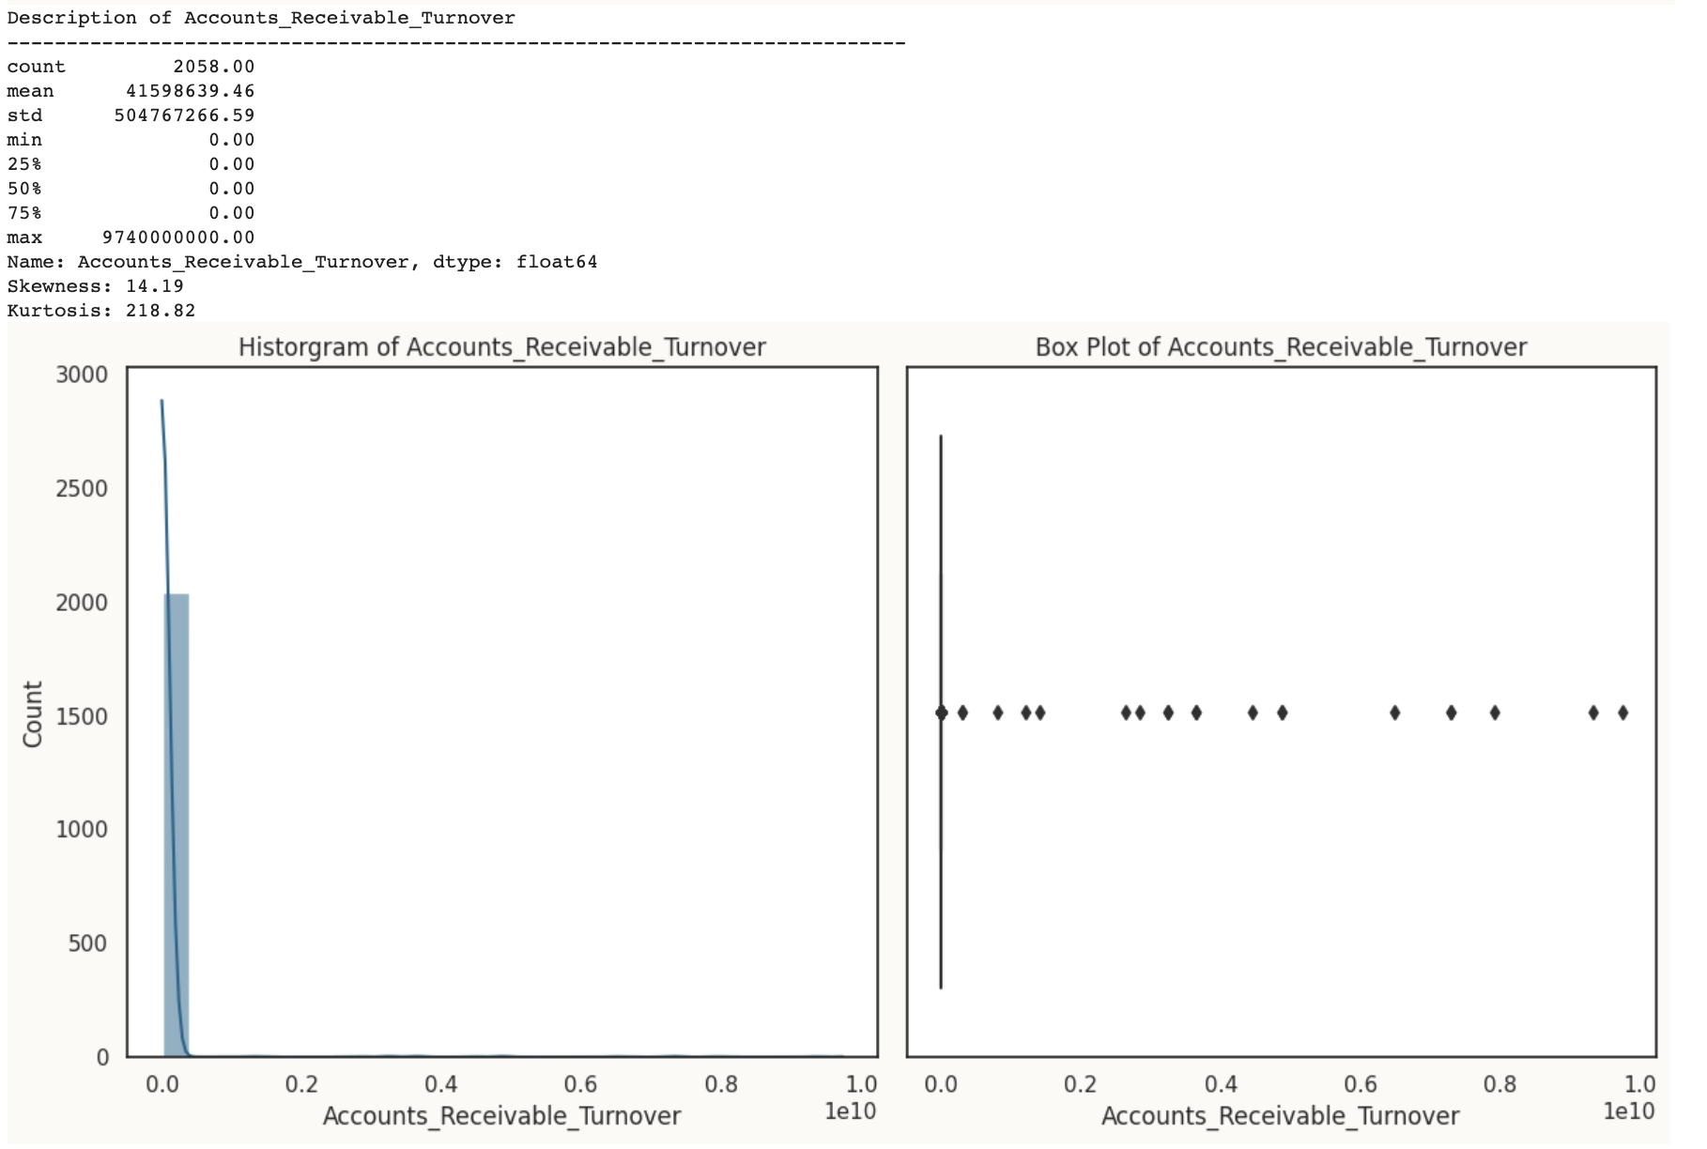



Table 1.27 Descriptive Statistics of the Variable

- The mean value is 41598639.46, but it has a wide range from 0 to 9740000000.00.

- This feature is highly positively skewed (Skewness: 14.19) and has extremely high kurtosis (Kurtosis: 218.82), indicating a non-normal distribution with a heavy right tail.

fig 1.13 Univariate Analysis of Accounts_Receivable_Turnover

**Fixed_Assets_Turnover_Frequency**

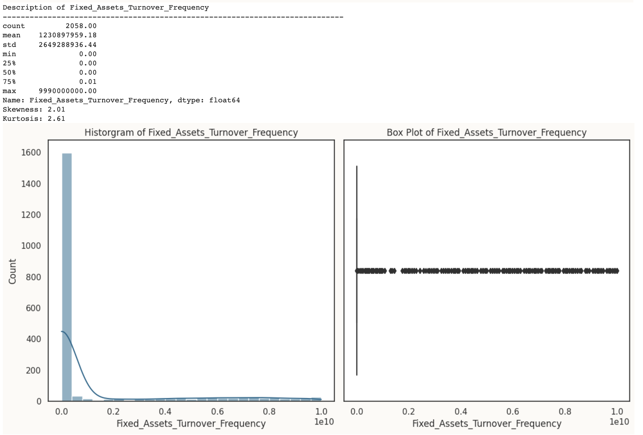



Table 1.28 Descriptive Statistics of the Variable

- The mean value is 1230897959.18, but it has a wide range from 0 to 9990000000.00.

- The data is moderately positively skewed (Skewness: 2.01) and has moderate kurtosis (Kurtosis: 2.61), suggesting a somewhat non-normal distribution.

fig 1.14 Univariate Analysis of Fixed_Assets_Turnover_Frequency

**Operating_profit_per_person**

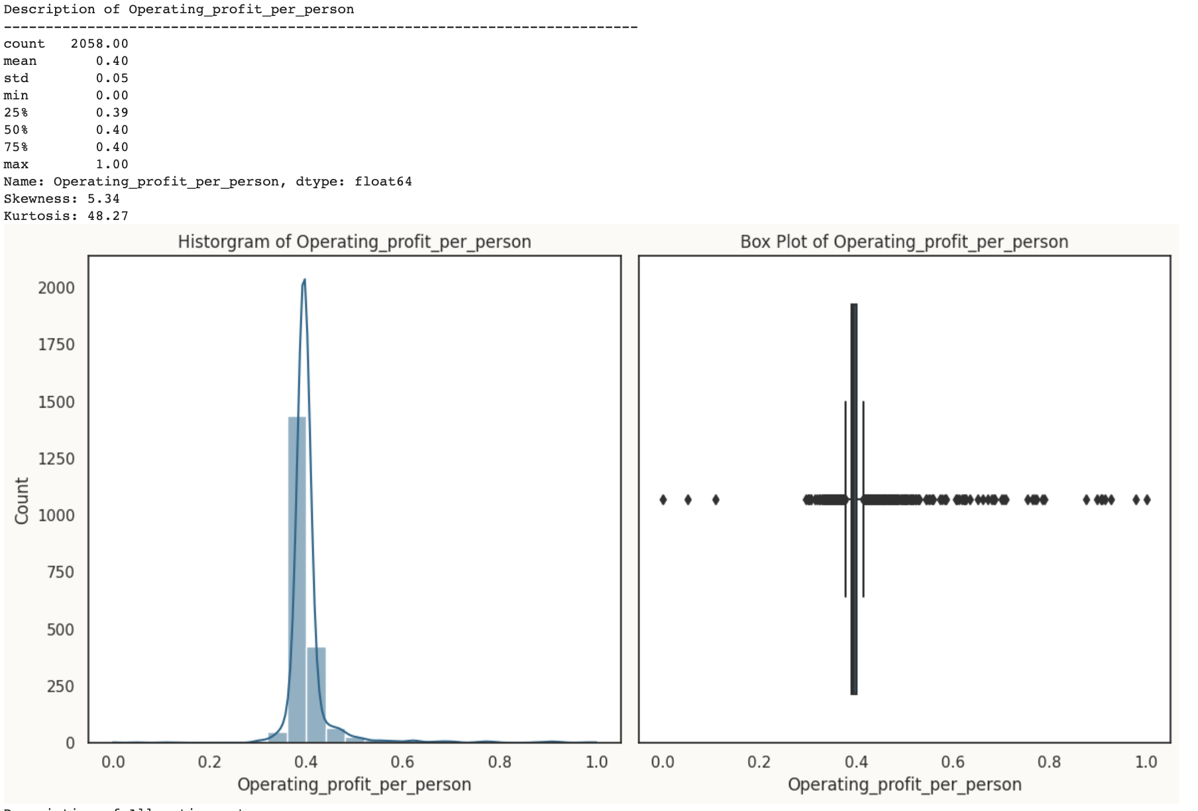



Table 1.29 Descriptive Statistics of the Variable

- The data has a relatively low standard deviation (0.05) compared to the mean (0.40), suggesting low variability.

- This feature is highly positively skewed (Skewness: 5.34) and has high kurtosis (Kurtosis: 48.27), indicating a non-normal distribution with a heavy right tail.

fig 1.15 Univariate Analysis of Operating_profit_per_person

**Allocation_rate_per_person**

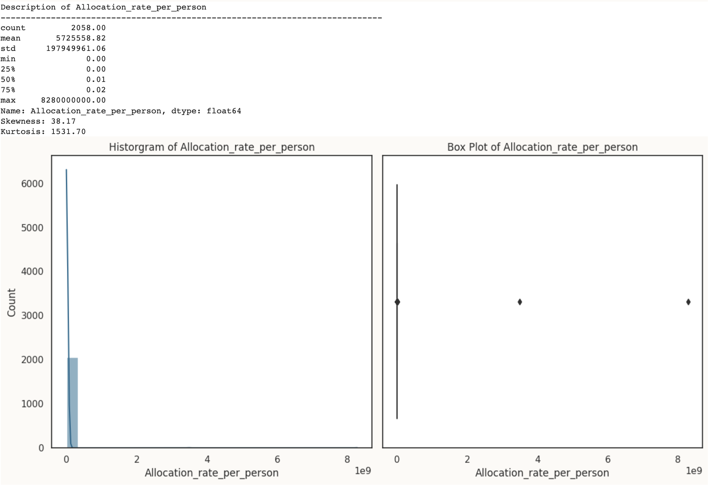



Table 1.30 Descriptive Statistics of the Variable

- The mean value is 5725558.82, with a wide range from 0 to 8280000000.00.

- The feature is highly positively skewed (Skewness: 38.17) and has extremely high kurtosis (Kurtosis: 1531.70), indicating a non-normal distribution with a heavy right tail.

fig 1.16 Univariate Analysis of Allocation_rate_per_person

**Retained_Earnings_to_Total_Assets**

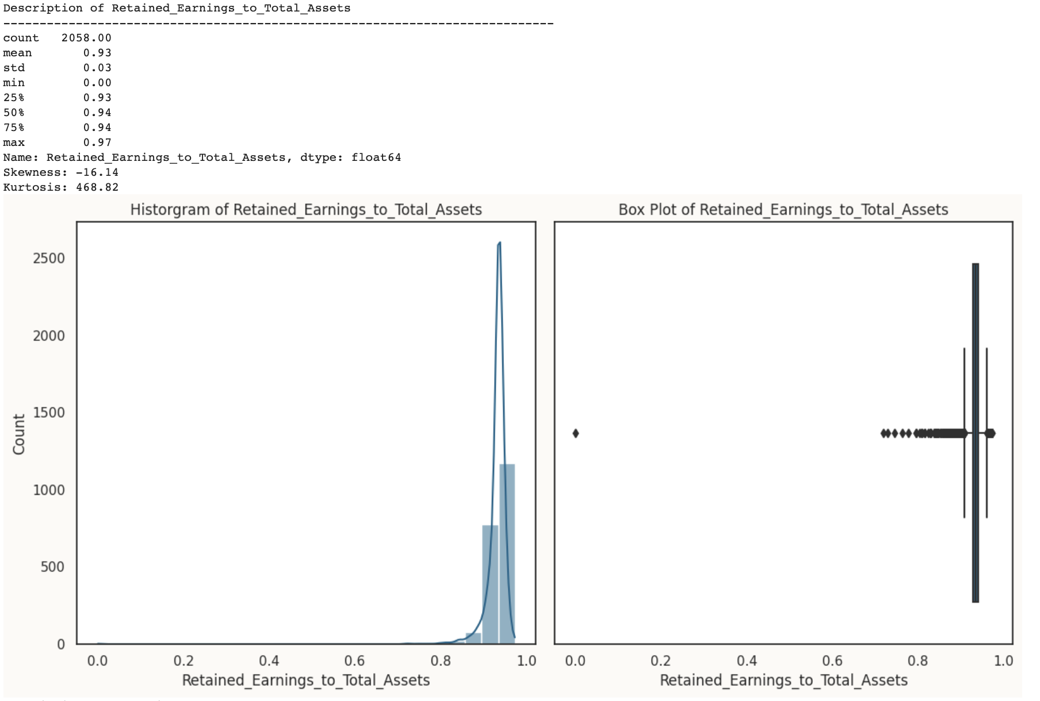



Table 1.31 Descriptive Statistics of the Variable

- The mean value is 0.93, suggesting a high proportion of retained earnings to total assets on average.

- The feature is highly negatively skewed (Skewness: -16.14) and has high kurtosis (Kurtosis: 468.82), indicating a non-normal distribution with a heavy left tail.

fig 1.17 Univariate Analysis of Retained_Earnings_to_Total_Assets

**Total_income_to_Total_expense**

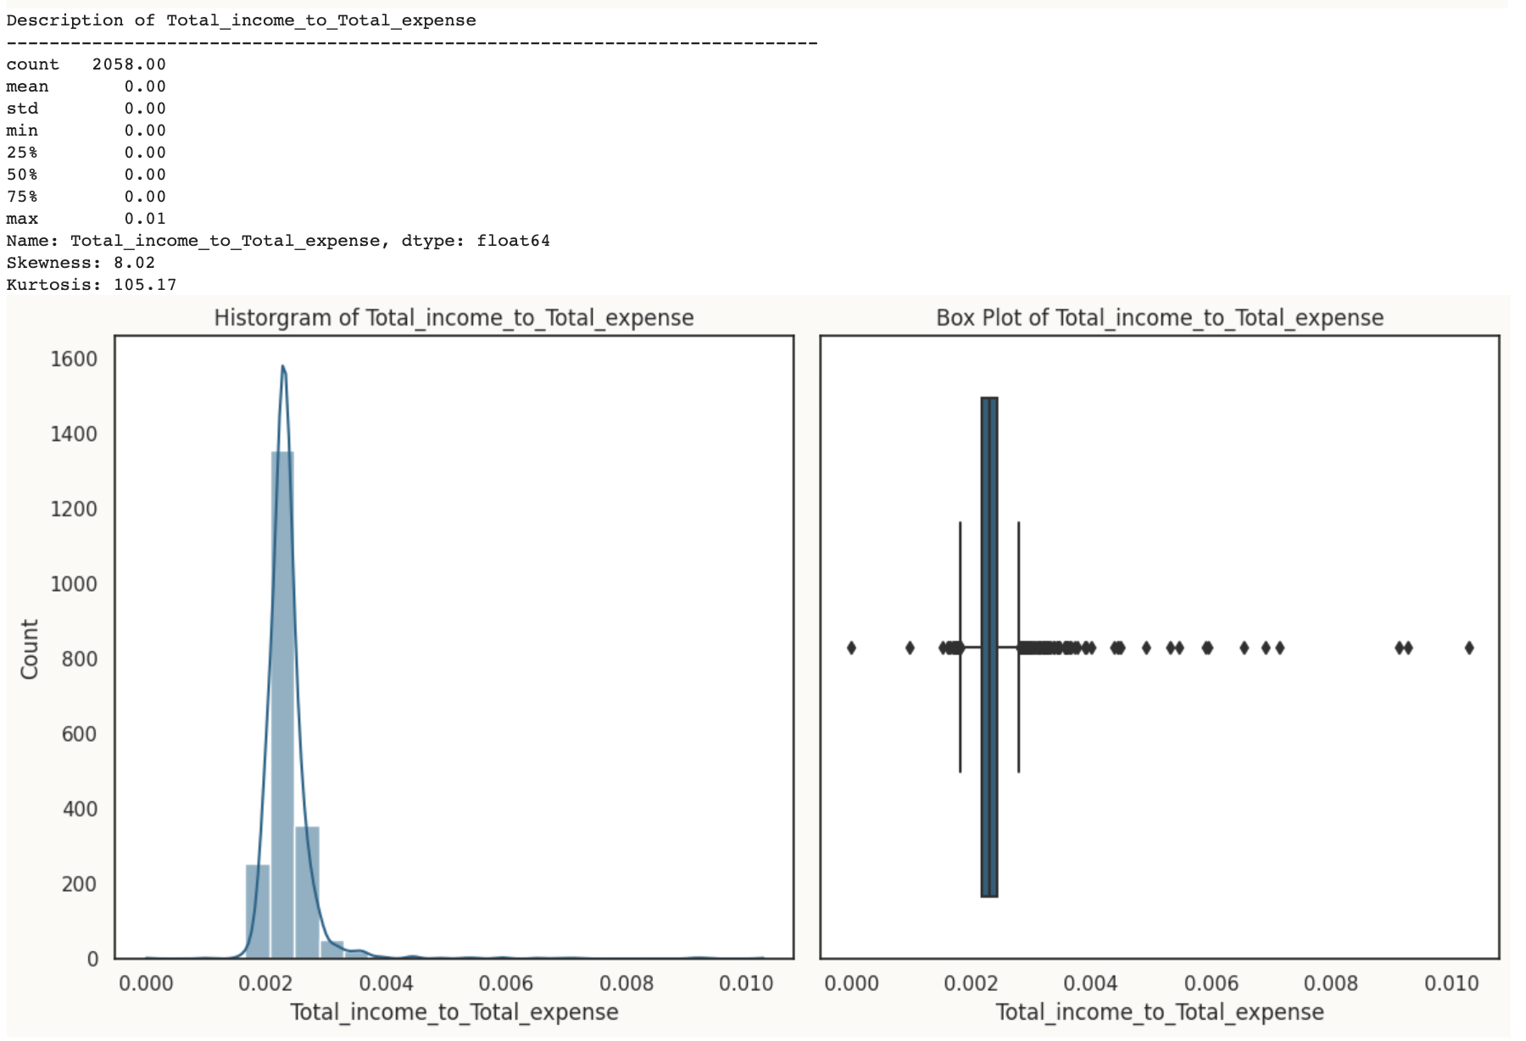



Table 1.32 Descriptive Statistics of the Variable

- Mean of 0.0, indicating that total income is very close to total expenses on average.

- This feature is highly positively skewed (Skewness: 8.02) and has high kurtosis( 105.17), indicating a non-normal distribution with a heavy right tail.

fig 1.18 Univariate Analysis of Total_income_to_Total_expense

**Total_expense_to_Assets**

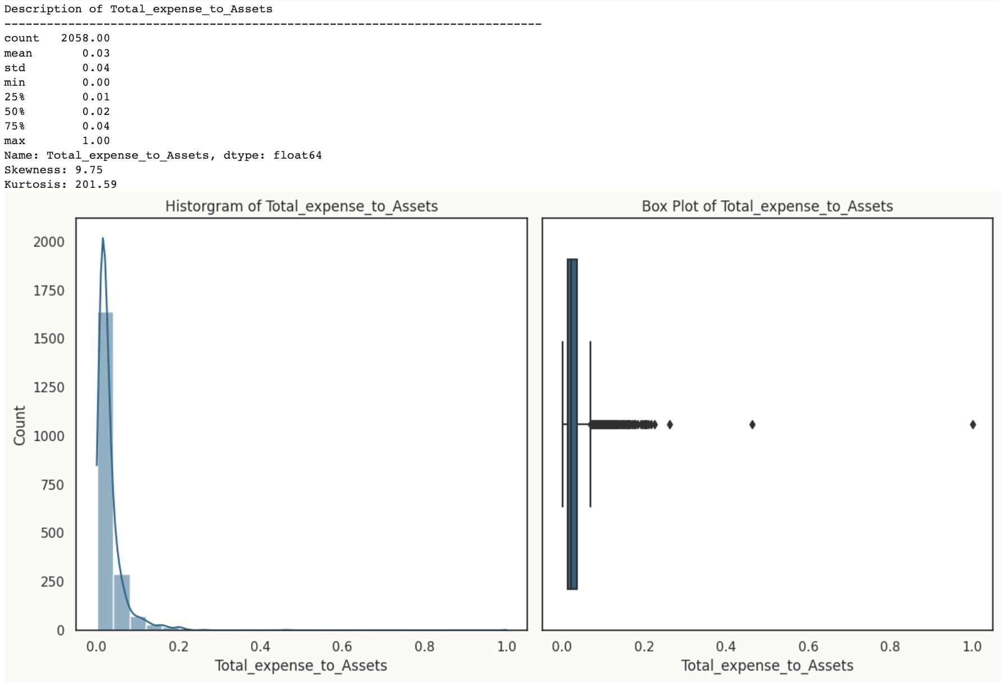



Table 1.33 Descriptive Statistics of the Variable

- The data has a mean of 0.03, suggesting that total expenses are a small proportion of total assets on average.

- This feature is highly positively skewed (Skewness: 9.75) and has high kurtosis (Kurtosis: 201.59), indicating a non-normal distribution with a heavy right tail.

fig 1.19 Univariate Analysis of Total_expense_to_Assets

**Equity_to_Liability**

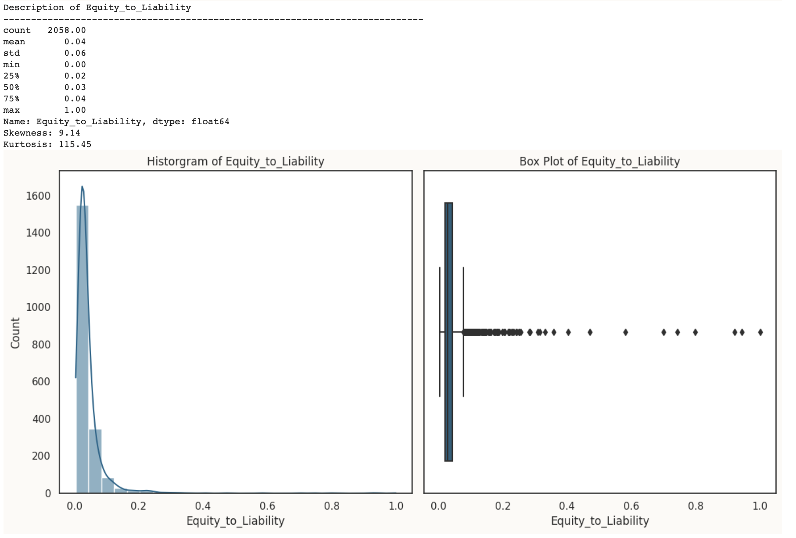



Table 1.34 Descriptive Statistics of the Variable

- The mean value is 0.04, suggesting that equity is a small proportion of liabilities on average.

- This feature is highly positively skewed (Skewness: 9.14) and has high kurtosis (Kurtosis: 115.45), indicating a non-normal distribution with a heavy right tail.

fig 1.20 Univariate Analysis of Equity_to_Liability

**Bivariate Analysis**

In Bivariate Analysis, we will check how the features are related with each other, correlation between them.

Additionally we will explore how the important features are related to the target “Default”

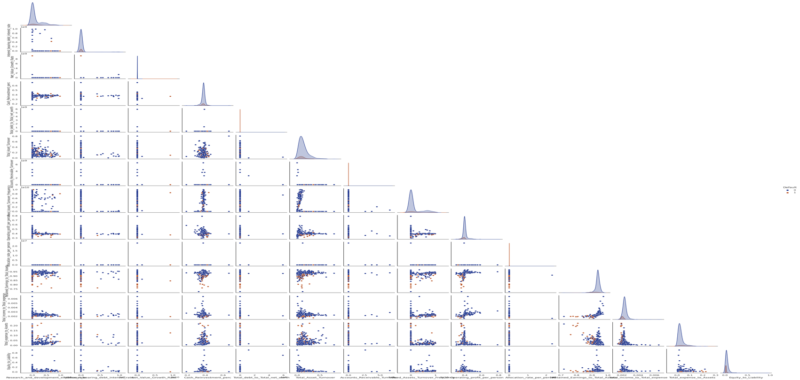

fig 1.21 Pairplot

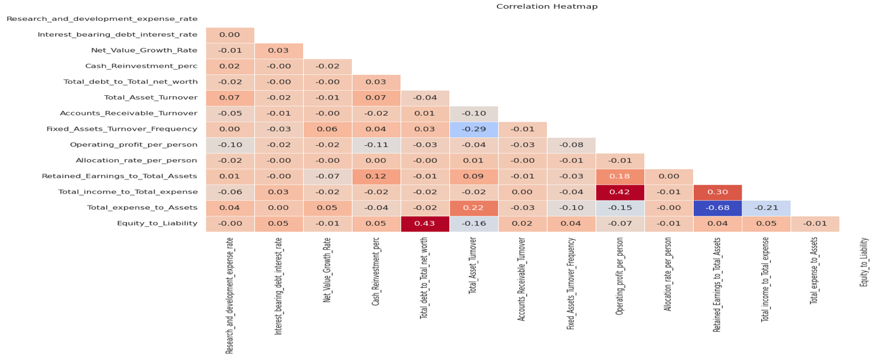

fig 1.22 Correlation Heatmap

* **Operating Profit per Person** and **Total Income to Total Expense** show **strong positive correlations**, indicating a close relationship between these variables.
* **Total Debt to Total Net Worth** has a moderate **positive correlation** with **Equity to Liability**, suggesting a strong financial structure.
* **Retained Earnings to Total Assets** has a **strong positive** **correlation** with **Total Income to Total Expense**, indicating healthy financial management.
* **Several variables show weak or no significant correlations**, indicating their **independence from other factors** in the dataset.

**Default against most important variables:**

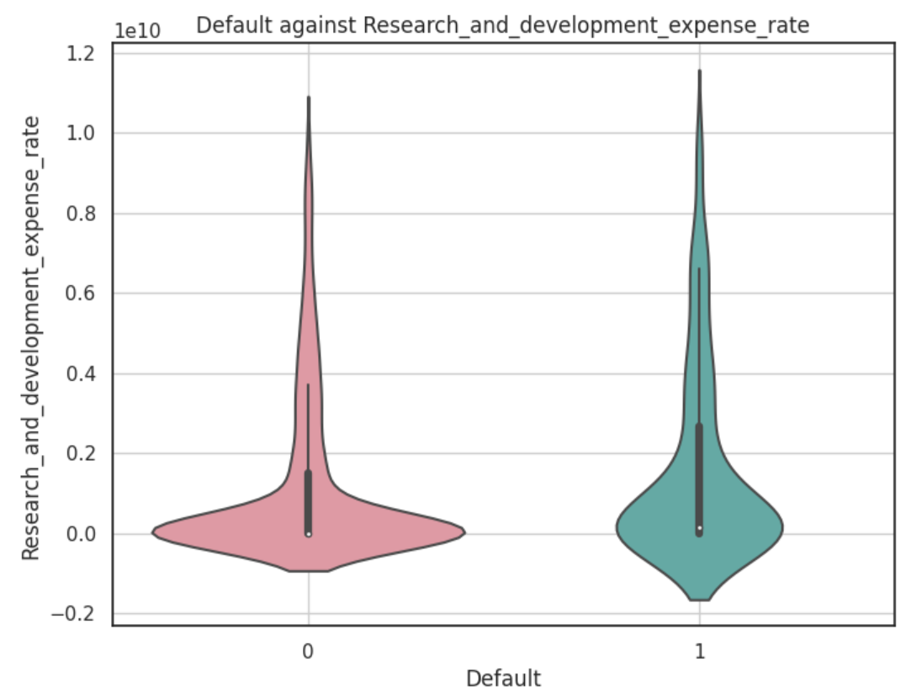

- The 'Default' 1 class tends to have higher research and development expenses compared to 'Default' 0.

- There is a wide range of variation in research and development expenses within both classes.

fig 1.23 Default against Research and Development Expense Rate

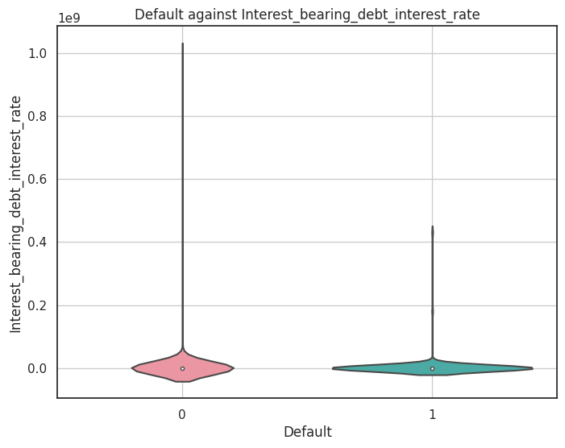

- 'Default' 0 has a wider distribution of interest rates, while 'Default' 1 has relatively lower interest rates.

- Most observations in both classes have low or zero interest rates.

fig 1.24 Default against Interest-bearing Debt Interest Rate:

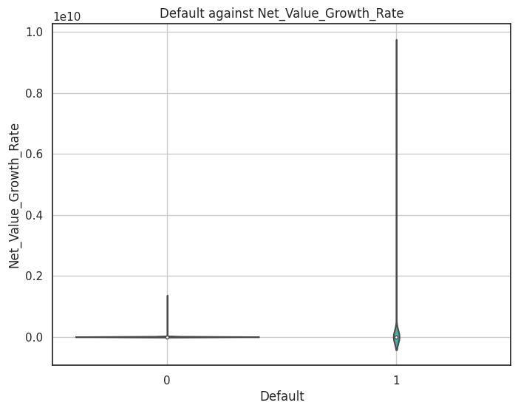

- The growth rate is significantly higher for 'Default' 1 compared to 'Default' 0.

- There is a wide range of variation in growth rates within both classes.

fig 1.25 Default against Net Value Growth Rate

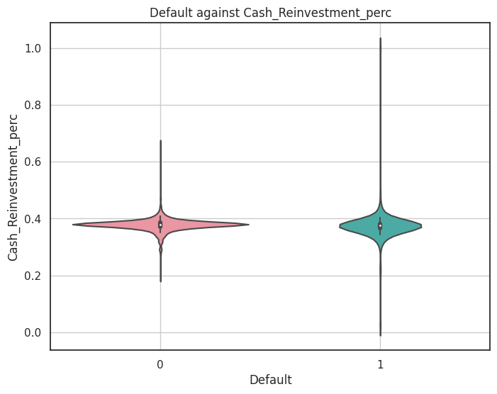

- Both classes have similar mean cash reinvestment percentages, but 'Default' 1 has a wider distribution.

- 'Default' 1 has some extreme values with very low or very high reinvestment percentages.

fig 1.26 Default against Cash Reinvestment Percentage

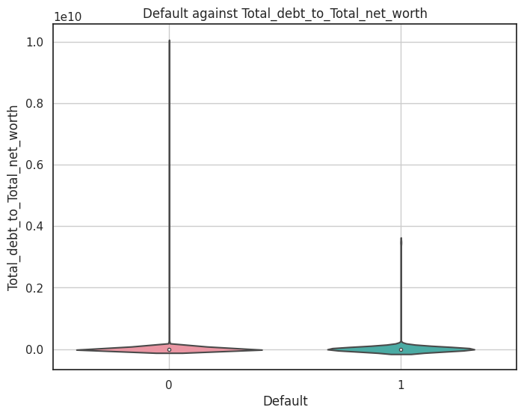

- 'Default' 1 has a slightly higher mean total debt-to-net-worth ratio compared to 'Default' 0.

- Both classes have a significant number of observations with low ratios.

fig 1.27 Default against Total Debt to Total Net Worth

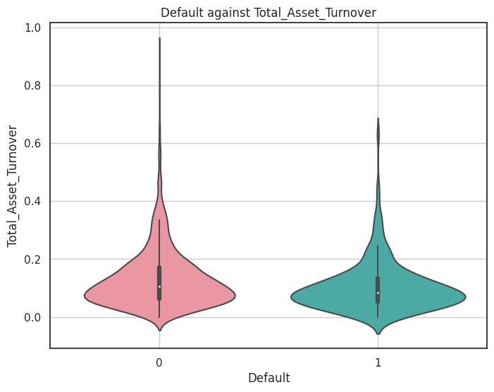

- 'Default' 0 tends to have a higher total asset turnover rate compared to 'Default' 1.

- There is a wide distribution of turnover rates in both classes.

fig 1.28 Default against Total Asset Turnover

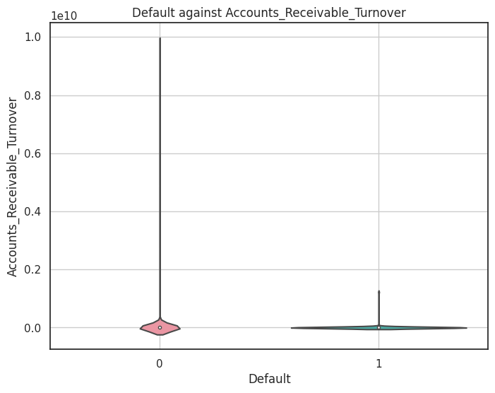

- 'Default' 1 has a lower mean accounts receivable turnover compared to 'Default' 0.

- Both classes have a majority of observations with zero or low turnover.

fig 1.29 Default against Accounts Receivable Turnover

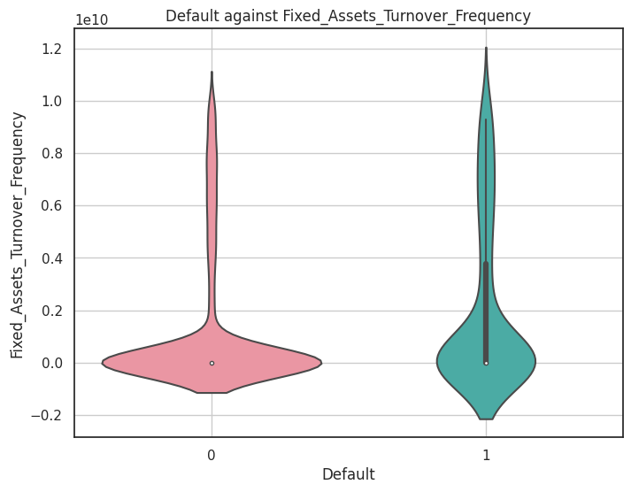

- 'Default' 1 has a wider distribution of turnover frequency, with some extreme values.

- 'Default' 0 has a narrower distribution with lower frequencies.

fig 1.30 Default against Fixed Assets Turnover Frequency

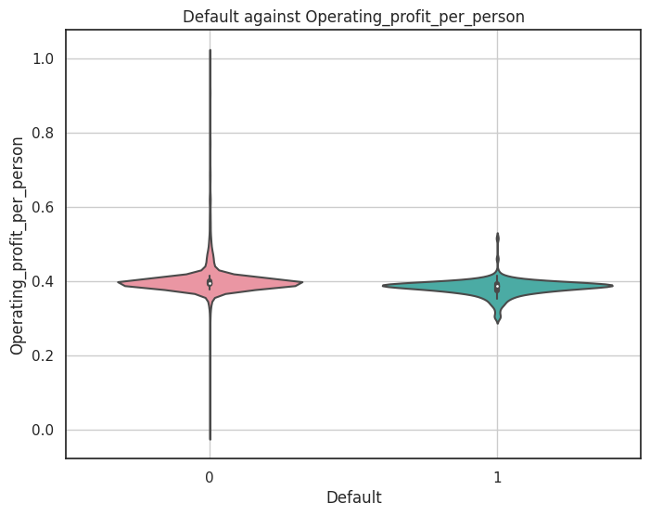

- 'Default' 0 has a slightly higher mean operating profit per person compared to 'Default' 1.

- Both classes have observations with relatively high profit per person.

fig 1.31 Default against Operating Profit per Person

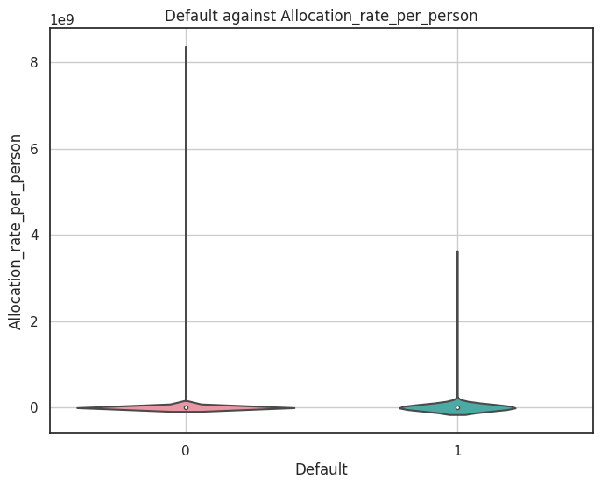

- 'Default' 1 has a higher mean allocation rate per person compared to 'Default' 0.

- Both classes have observations with a wide range of allocation rates

fig 1.32 Default against Retained Earnings to Total Assets

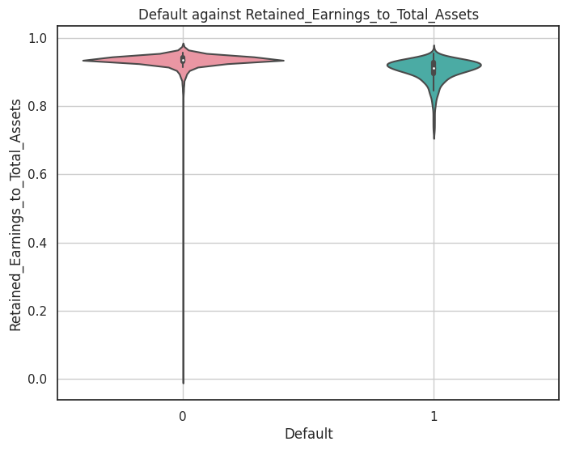

- 'Default' 0 has a slightly higher mean ratio of retained earnings to total assets compared to 'Default' 1.

- Both classes have a majority of observations with high ratios.

fig 1.33 Default against Retained Earnings to Total Assets

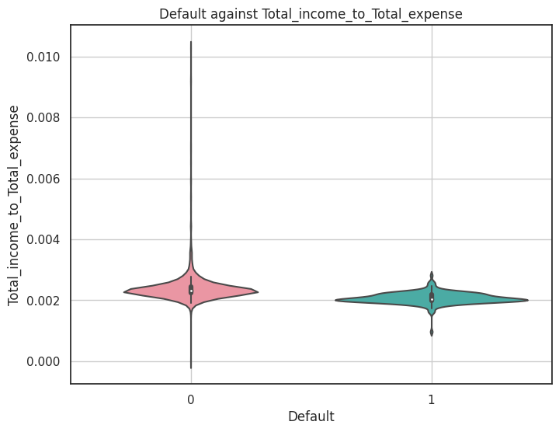

- Both classes have very low mean ratios of total income to total expense, indicating low profitability.

- The majority of observations in both classes have low ratios.

fig 1.34 Default against Total Income to Total Expense

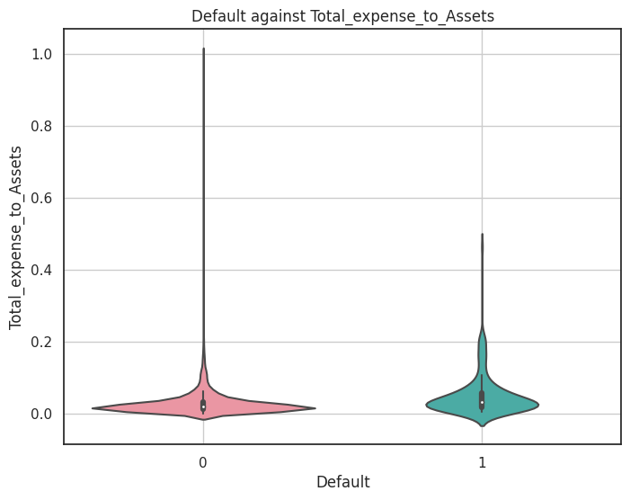

- 'Default' 1 has a higher mean ratio of total expenses to assets compared to 'Default' 0.

- Both classes have observations with a wide range of expense ratios.

fig 1.35 Default against Total Expense to Assets

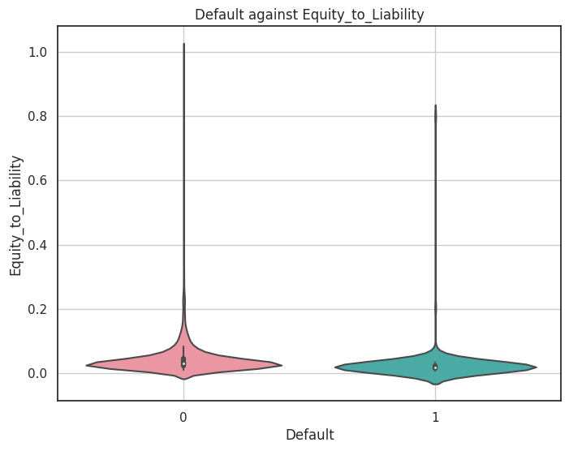

- 'Default' 0 has a higher mean equity-to-liability ratio compared to 'Default' 1.

- Both classes have observations with a wide range of equity ratios.

fig 1.36 Default against Equity to Liability

**Train Test Split**

We Split the data into train and test datasets in the ratio of 67:33 and used a random state of 42 (random_state=42).

Train set has 1378 records whereas the test set has 680 records.

However, for the logistic regression model using Statsmodels we do not need to segregate the X & the Y separately. Hence, for the purpose of Logistic Regression we concatenate the X & Y for both train & test set.

**Build Logistic Regression Model (using statsmodels library) on most important variables on train dataset and choose the optimum cut-off. Also showcase your model building approach.**

**Validate the Model on Test Dataset and state the performance metrics. Also state interpretation from the model**

**Logistic Regression Model (using Statsmodels library)**

**Logistic Regression** is a supervised learning for classification. Logistic regression is the type of regression analysis used to find the probability of a certain event occurring. It is the best suited type of regression for cases where we have a categorical dependent variable which can take only discrete values.

We will build a logistic regression model using the statsmodels library. Statsmodels is a Python module that provides various functions for estimating different statistical models and performing statistical tests

First, we define the set of dependent(y) and independent(X) variables. Statsmodels provides a Logit() function for performing logistic regression. The Logit() function accepts y and X as parameters and returns the Logit object. The model is then fitted to the data.

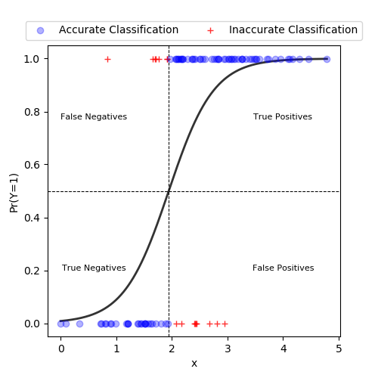

fig 1.37 Logistic Regression Explanation

**Performance Metrices.**

Since the dataset is skewed and type – II error is costly, i.e., **actually the company defaults when it is predicted as not going to default, we give priority to the recall score** of the default class over the accuracy to adjudge the model performance as incorrect prediction of default will lead to incorrect assessment of the company and a credit line may be

extended to the defaulting company which will lead to huge losses to the business.

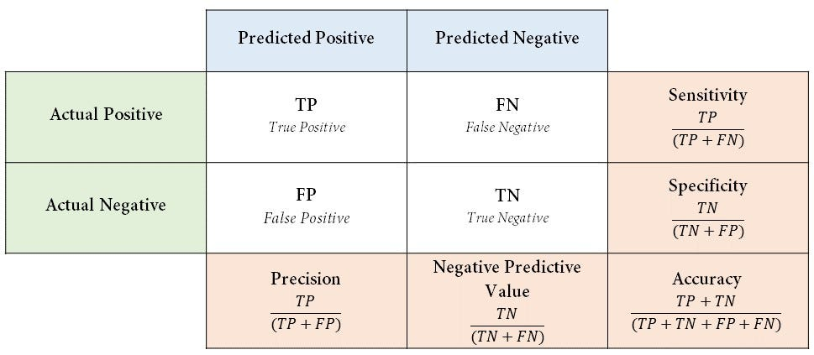

fig 1.38 Confusion Matrix

**Confusion Matrix:**

* **Actual 0, Predicted 0 (TN - True Negative)**: This represents cases where the actual class is 0 (negative) and the model correctly predicts it as 0.
* **Actual 1, Predicted 1 (TP - True Positive)**: This represents cases where the actual class is 1 (positive) and the model correctly predicts it as 1.
* **Actual 0, Predicted 1 (FP - False Positive)**: This represents cases where the actual class is 0 (negative) but the model incorrectly predicts it as 1 (positive). It's also known as a Type I error or a false alarm.
* **Actual 1, Predicted 0 (FN - False Negative)**: This represents cases where the actual class is 1 (positive) but the model incorrectly predicts it as 0 (negative). It's also known as a Type II error or a missed detection.
* **Recall (Sensitivity)**: This is all about how well the model can spot the actual credit defaults. If it has high recall, it's good at catching most of the real defaults. That's a plus because it means fewer cases of missing out on potential defaulters (those false negatives), and that's something lenders want to avoid because it can lead to losses.
* **Precision**: Precision looks at the proportion of cases the model predicts as defaults that actually turn out to be true credit defaults. If precision is a bit lower, it means there might be more cases where the model predicts defaults that don't really happen (false positives). This cautious approach helps minimize the risk of lending to people who might not actually default.

**The ROC (Receiver Operating Characteristic) curve** evaluates a classification model's performance by plotting the trade-off between true positive rate (sensitivity) and false positive rate (1 - specificity) as the classification distinguishes positive and negative instances.

AUC (Area Under the Curve) summarizes overall performance, with higher values indicating better model performance threshold varies. It helps visualize how well the model

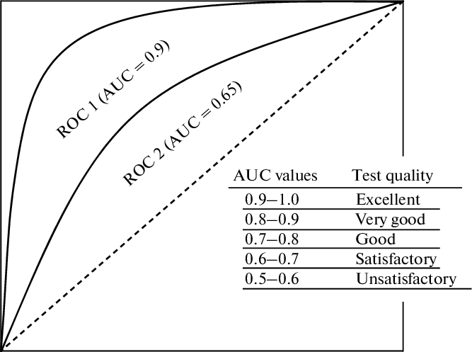

fig 1.39 ROC-AUC

**Model Building**

**Model 1 :**

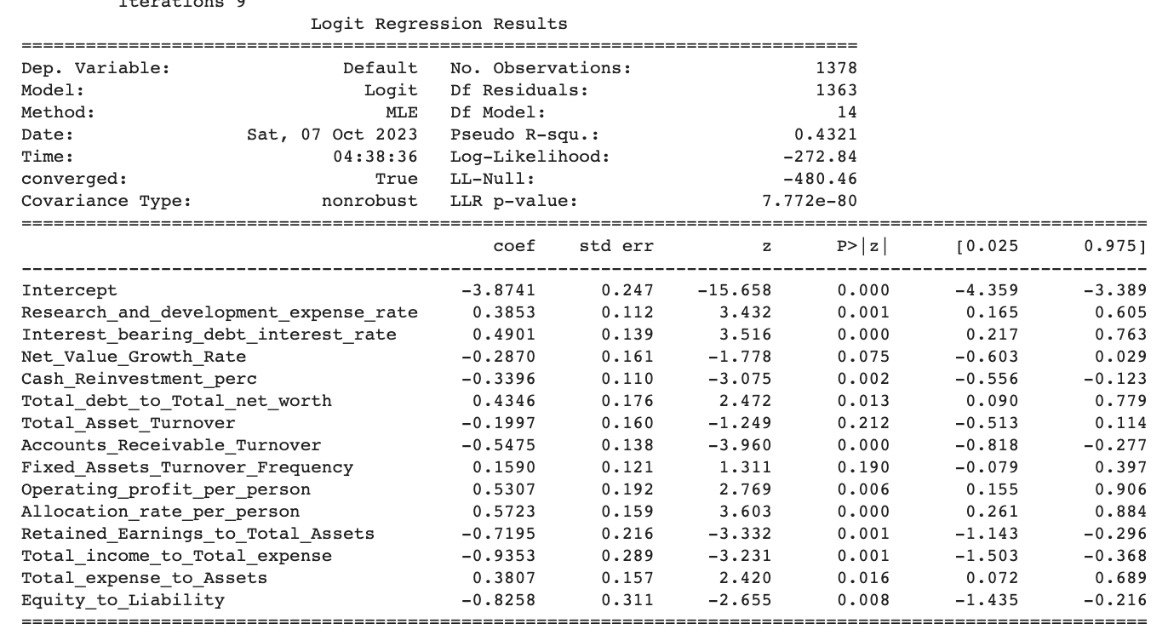

Table 1.35 Logistic Regression Model Summary

We Observe that there is presence of **Insignificant predictors like "Total_Asset_Turnover", "Fixed_Assets_Turnover_Frequency" etc having p-value > 0.05 need to be removed**. We will remove all features one by one, till we have any features with p-value>0.05

**Model 2:** Removed ' **Total_Asset_Turnover'** since p-value is 0.212 > 0.05

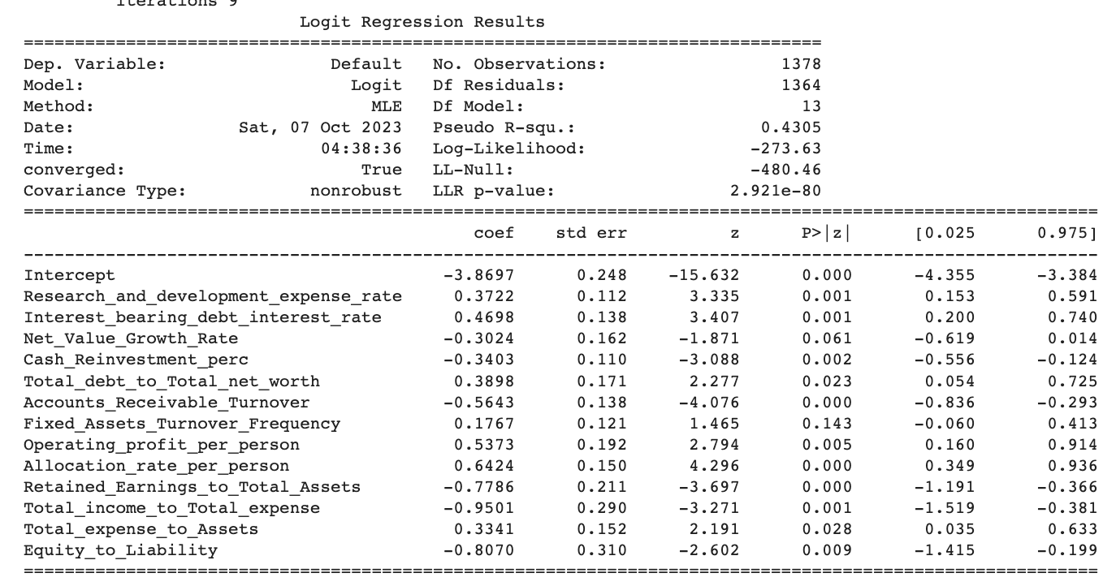

Table 1.36 Logistic Regression Model Summary

**Model 3:** Removed ' **Fixed_Assets_Turnover_Frequency'** since p-value is 0.143 > 0.05

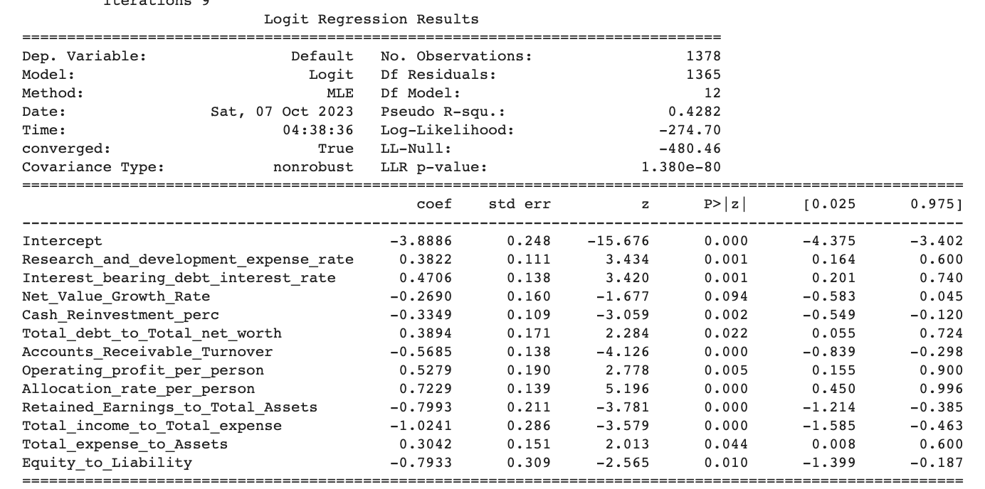

Table 1.37 Logistic Regression Model Summary

**Model 4:** Removed ' **Net_Value_Growth_Rate'** since p-value is 0.094 > 0.05

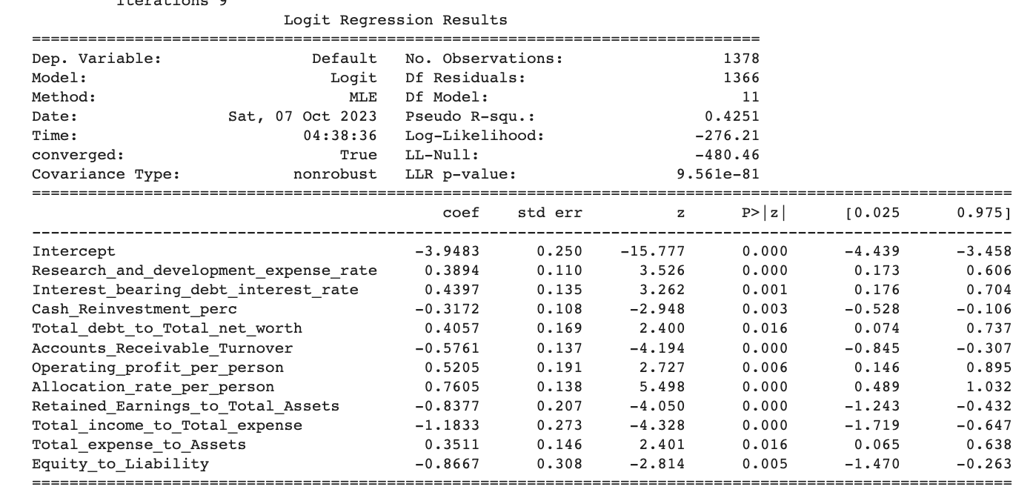

Table 1.38 Logistic Regression Model Summary

After removing non-significant features, the **model 4** is the Optimized model with **12 features.**

**Logit Score Equation**: = -3.9483 + 0.3894 * Research_and_development_expense_rate

+ 0.4397 * Interest_bearing_debt_interest_rate - 0.3172 * Cash_Reinvestment_perc

+ 0.4057 * Total_debt_to_Total_net_worth - 0.5761 * Accounts_Receivable_Turnover

+ 0.5205 * Operating_profit_per_person + 0.7605 * Allocation_rate_per_person

- 0.8377 * Retained_Earnings_to_Total_Assets

- 1.1833 * Total_income_to_Total_expense

+ 0.3511 * Total_expense_to_Assets - 0.8667 * Equity_to_Liability

The logit score equation assesses financial risk, with positive coefficients increasing Default likelihood, and negative coefficients decreasing it. For example, keeping others constant for each one-unit increase in the "Research and Development Expense Rate," the log-odds of Default increase by 0.3894 units. Conversely, for each one-unit increase in the " Total_income_to_Total_expense ," the log-odds of Default decrease by 1.1833 units.

**Model Performance Evaluation**

**Classification Report on Train & Test data:-**

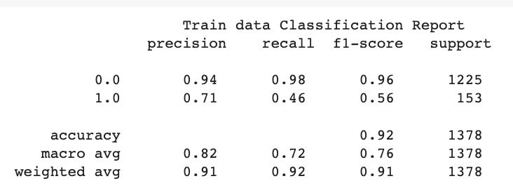 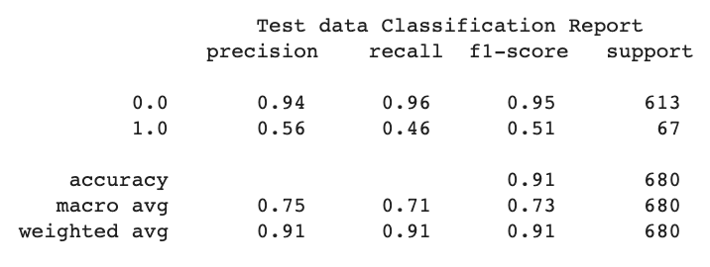

Table 1.39 Logistic Regression Classification report

**Confusion Matrix:-**

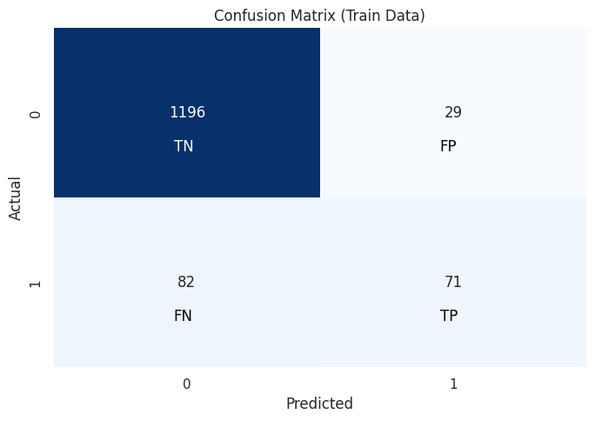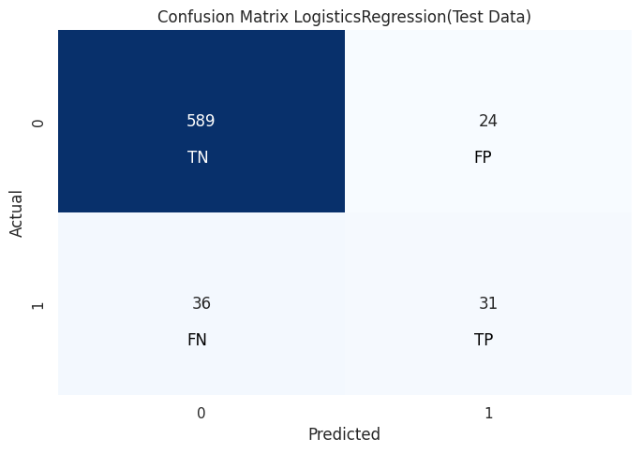

fig 1.40 Logistic Regression Confusion Matrix

**ROC Curve**

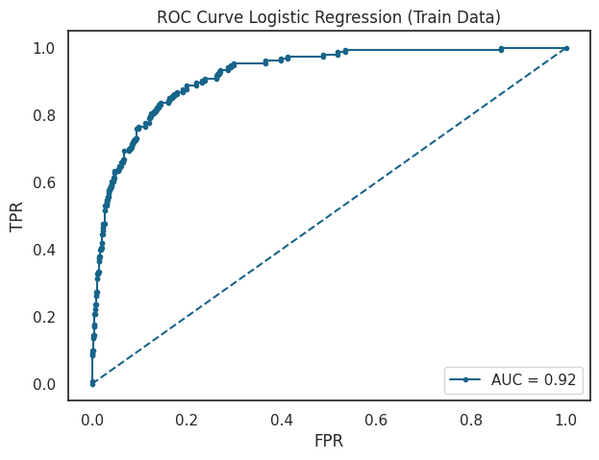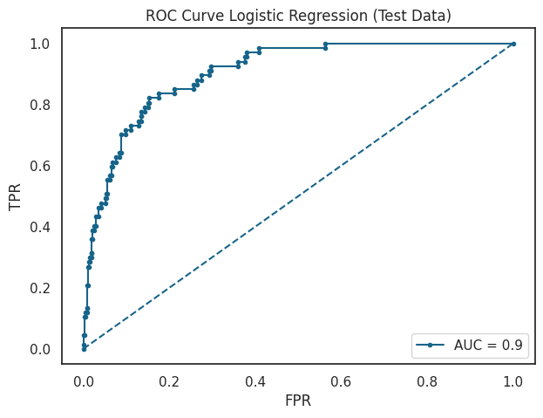

fig 1.41 Logistic Regression ROC curve

**Logistic Regression Conclusion**

|  |  |  |
| --- | --- | --- |
| Metrics | Train | Test |
| True Negative | 1196 | 589 |
| True Positive | 71 | 31 |
| False Negative | 82 | 36 |
| False Positive | 29 | 24 |
| AUC | 92% | 90% |
| Accuracy | 92% | 91% |
| Precision | 71% | 56% |
| Recall | 46% | 46% |
| f1-score | 56% | 51% |

Table 1.40 Logistic Regression Conclusion

**Insights**

The Logistic Regression model demonstrates good predictive capabilities for identifying default and non-default cases. When analyzing its performance on both the training and test datasets, several key findings emerge:

* **True Positives and True Negatives:** The model successfully identifies more true positives (default cases) in the test dataset, while maintaining a high accuracy in predicting true negatives (non-default cases) in the training dataset.
* **False Positives and False Negatives:** The model exhibits a lower rate of false positives (incorrectly predicted default cases) on the test dataset, indicating its ability to avoid erroneous classifications. Additionally, the test data shows fewer false negatives (missed default cases) compared to the training data.
* **AUC (Area Under the ROC Curve):** Although the AUC is slightly higher on the training data, both datasets display high AUC values, suggesting excellent discrimination between classes. This indicates the model's robustness in distinguishing between default and non-default cases.
* **Accuracy:** The model maintains a remarkably high level of accuracy on both the training and test datasets. Despite a slight drop in accuracy on the test data, the model's overall accuracy remains impressive.
* **Precision and Recall:** Precision, which measures the ability to avoid false positives, demonstrates a minor decrease on the test data but remains relatively high. Recall, which measures the ability to capture true positives, remains consistent between the two datasets.
* **F1-Score:** The F1-score, which balances precision and recall, experiences a slight decrease on the test data but remains at a satisfactory level.

Since, Recall is important in Financial Risks, the recall from above model was very less. We'll find optimum cut-off to improve Recall

**Adjusting Optimal Cutoff**

**We adjust the threshold to find the optimum cut-off value that will improve the recall of the model. The optimum cut-off value comes out to be 0.128.**

**Let’s see the evaluation Metrices:**

**Classification Report on Train & Test data:-**

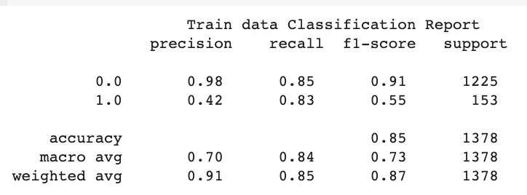 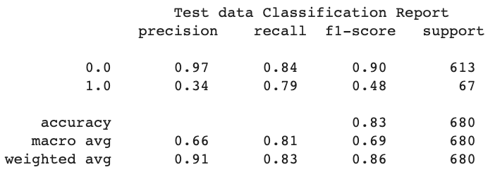

Table 1.41 Logistic Regression Optimal Cutoff Classification report

**Confusion Matrix:-**

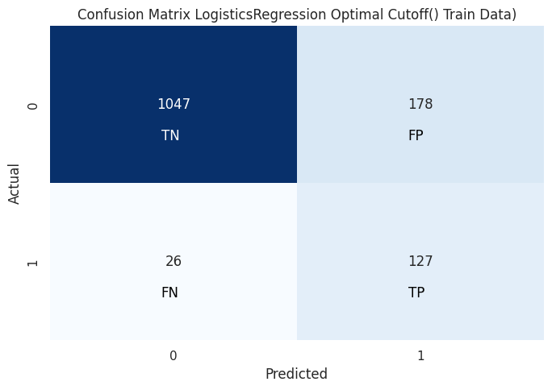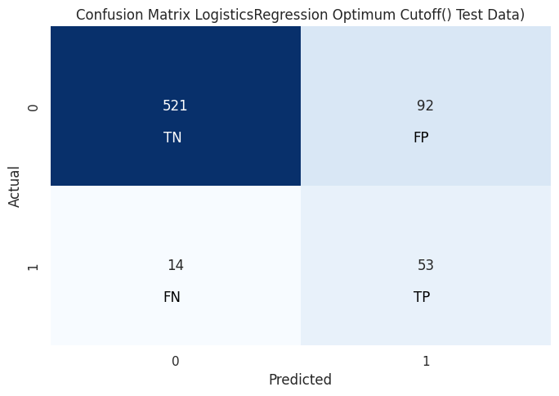

fig 1.42 Logistic Regression Optimal Cutoff Confusion Matrix

**ROC Curve**

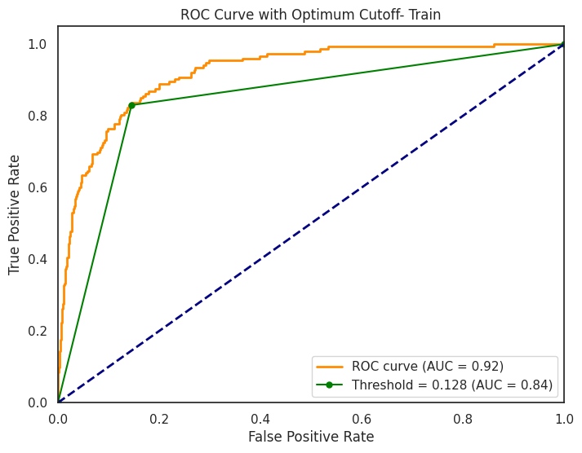 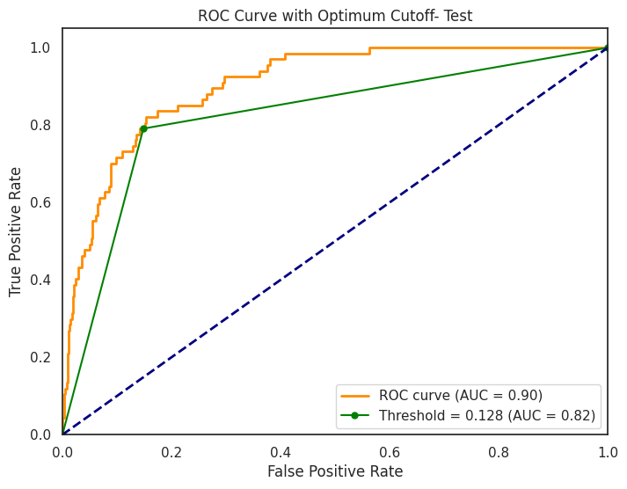

fig 1.43 Logistic Regression Optimal Cutoff ROC curve

**Logistic Regression Conclusion**

|  |  |  |
| --- | --- | --- |
| Metrics | Train | Test |
| True Negative | 1047 | 521 |
| True Positive | 127 | 53 |
| False Negative | 27 | 14 |
| False Positive | 178 | 92 |
| AUC | 84% | 82% |
| Accuracy | 85% | 83% |
| Precision | 42% | 34% |
| Recall | 83% | 79% |
| f1-score | 55% | 48% |

Table 1.42 Logistic Regression Conclusion

**Insights**

**After adjusting the optimum cutoff to 0.128, we can see significantly improved Recall score.**

* **The Precision, Recall, F1 score & Accuracy of training data for the model is in line with the testing data.**
* **The recall score for the default class has increased but the accuracy of the model has slightly decreased. Since we need better recall here, the model performs well in doing so.**
* **The Precision dropped drastically In this case along with slight decrease in AUC and F1.**

Let’s find out if we can further improve the performance using Oversampling.

**Oversampling underrepresented class using SMOTE**

**Synthetic Minority Over-sampling Technique a method used in machine learning to address class imbalance in datasets, particularly in scenarios where one class is underrepresented compared to others. Class imbalance can lead to biased models, and SMOTE helps balance the class distribution.**

**Sampling Approach: We chose sampling_strategy as= .75 which means minority class will be upsampled to have 75% as many samples as the majority class**

**Model 5 :**

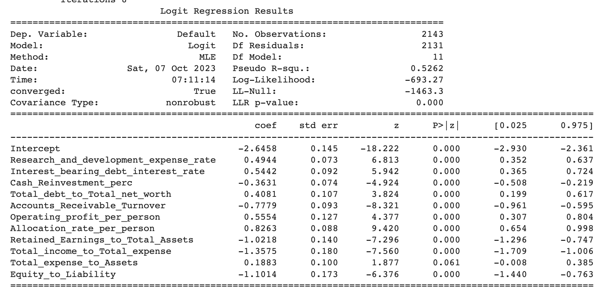

Table 1.43 Logistic Regression SMOTE Model Summary

**Model 6 : All features are not significant features, i.e. p-value<0.05. We have Total_expense_to_Assets having p-value > 0.05 i.e. 0.061. Let's drop that.**

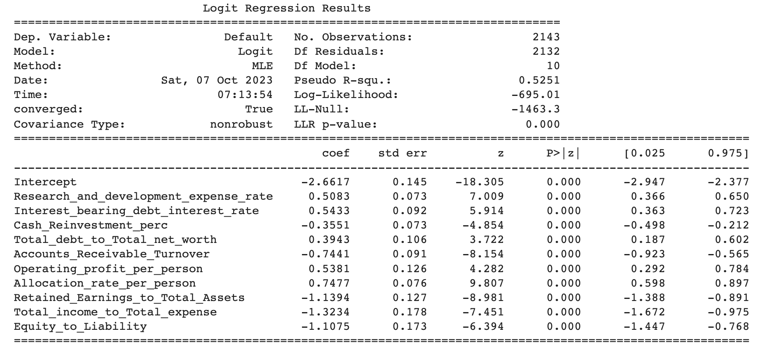

Table 1.44 Logistic Regression SMOTE Model Summary

After removing non-significant features, the **model 4** is the Optimized model with **11 features.**

**Logit Score Equation**: = -2.6617 + 0.5083 * Research_and_development_expense_rate

+ 0.5433 * Interest_bearing_debt_interest_rate - 0.3551 * Cash_Reinvestment_perc

+ 0.3943 * Total_debt_to_Total_net_worth - 0.7441 * Accounts_Receivable_Turnover

+ 0.5381 * Operating_profit_per_person + 0.7477 * Allocation_rate_per_person

- 1.1394 * Retained_Earnings_to_Total_Assets

- 1.3234 * Total_income_to_Total_expense - 1.1075 * Equity_to_Liability

The logit score equation assesses financial risk, with positive coefficients increasing Default likelihood, and negative coefficients decreasing it. For example, keeping others constant for each one-unit increase in the "Research and Development Expense Rate," the log-odds of Default increase by 0.5083 units. Conversely, for each one-unit increase in the " Accounts_Receivable_Turnover," the log-odds of Default decrease by 0.7441units.

**Model Performance Evaluation**

**Classification Report on Train & Test data:-**

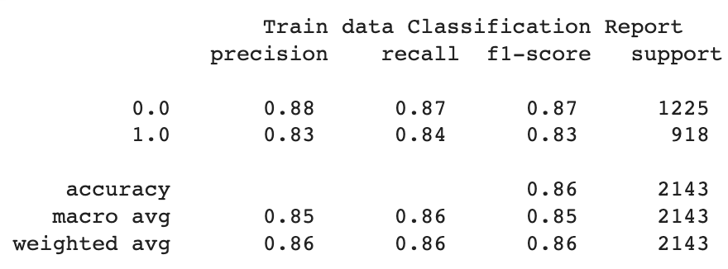 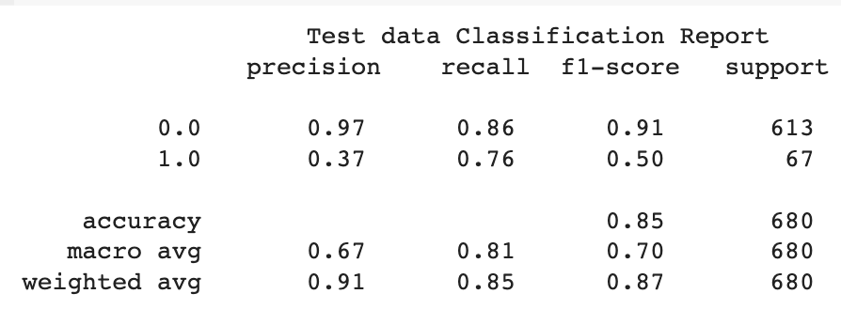

Table 1.45 Logistic Regression SMOTE Classification report

**Confusion Matrix:-**

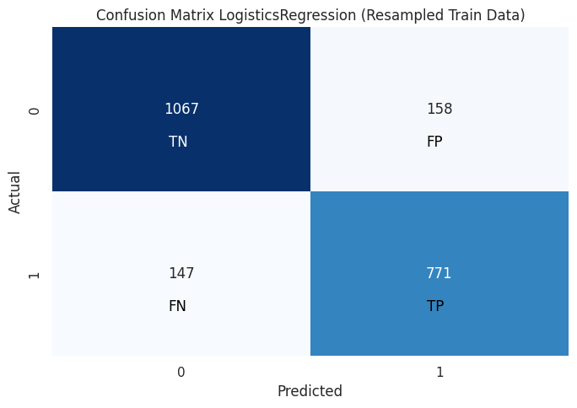 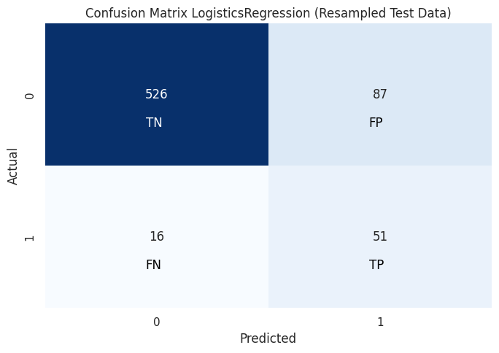

fig 1.44 Logistic Regression SMOTE Confusion Matrix

**ROC Curve**

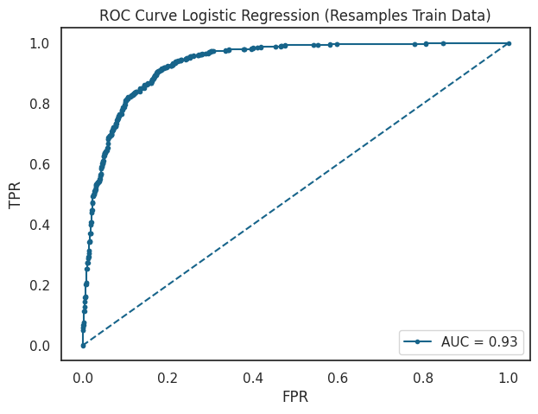 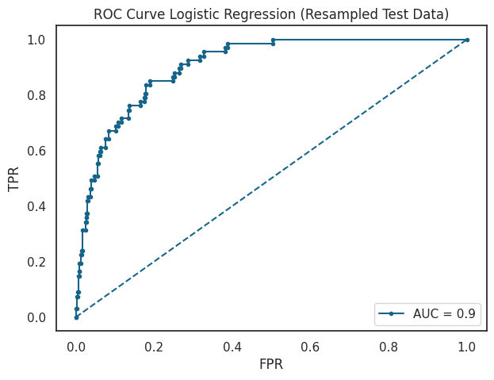

fig 1.45 Logistic Regression SMOTE ROC curve

**Logistic Regression Conclusion**

|  |  |  |
| --- | --- | --- |
| Metrics | Train | Test |
| True Negative | 1067 | 526 |
| True Positive | 771 | 51 |
| False Negative | 147 | 16 |
| False Positive | 158 | 87 |
| AUC | 93% | 90% |
| Accuracy | 86% | 85% |
| Precision | 83% | 37% |
| Recall | 84% | 76% |
| f1-score | 83% | 50% |

Table 1.46 Logistic Regression Conclusion

**Insights**

* **Applying SMOTE has led to a reduction in false negatives, improved recall, and a more balanced F1-score, indicating a better ability to detect actual default cases as compared to the Logistics Model without optimized cut off.**
* **There is a slight decrease in precision, and the AUC has also decreased, suggesting a trade-off between different aspects of model performance.**
* **However, recall is slightly lower than that of the optimized cut-off model. Let’s use optimized cut off here as well to see if any improvement.**

**Adjusting Optimum Cutoff**

**We adjust the threshold to find the optimum cut-off value that will improve the recall of the model. The optimum cut-off value comes out to be 0.367. Let’s see the evaluation Metrices:**

**Classification Report on Train & Test data:-**

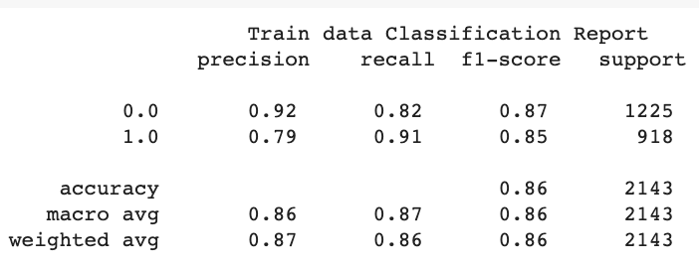 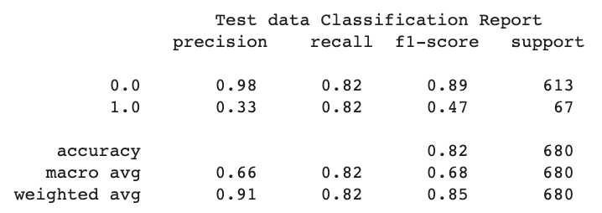

Table 1.47 Logistic Regression Optimal Cutoff Classification report

**Confusion Matrix:-**

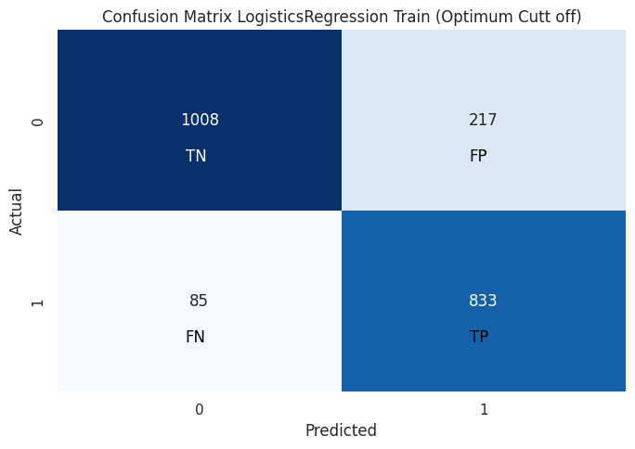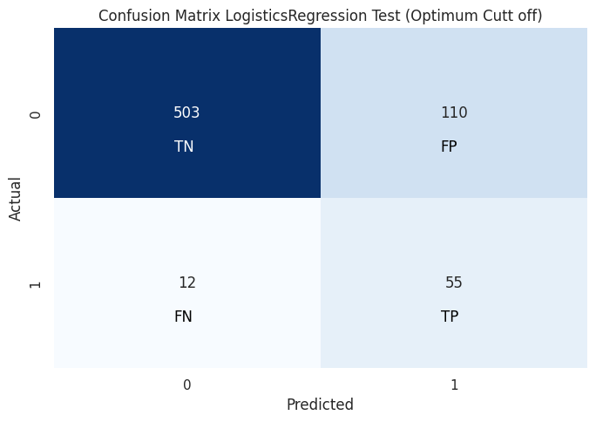

fig 1.46 Logistic Regression SMOTE Optimal Cutoff Confusion Matrix

**ROC Curve**

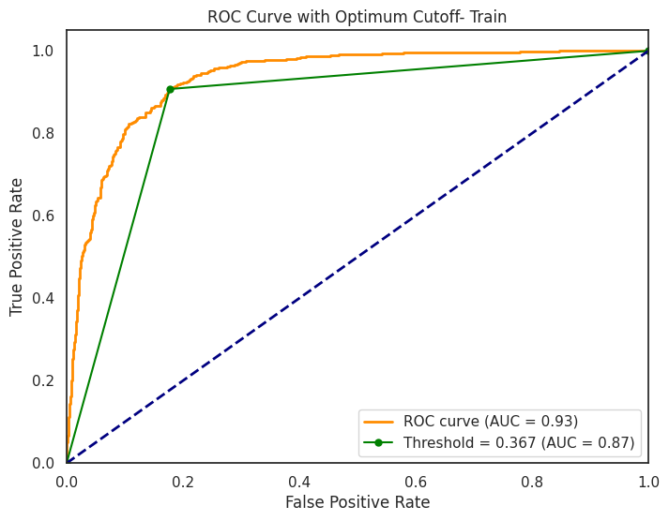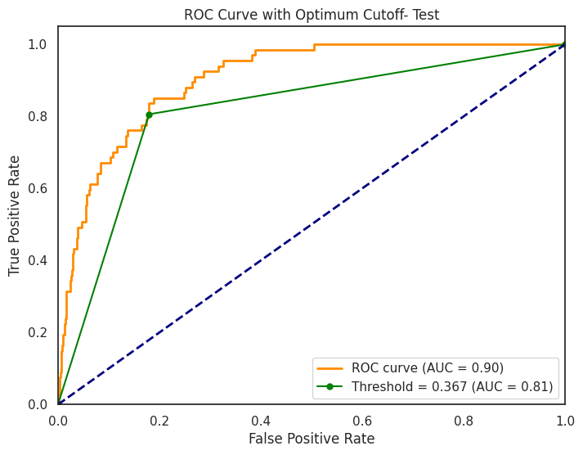

fig 1.47 Logistic Regression SMOTE Optimal ROC curve

**Logistic Regression Conclusion**

|  |  |  |
| --- | --- | --- |
| Metrics | Train | Test |
| True Negative | 1008 | 503 |
| True Positive | 833 | 55 |
| False Negative | 85 | 12 |
| False Positive | 217 | 110 |
| AUC | 87% | 81% |
| Accuracy | 86% | 82% |
| Precision | 79% | 33% |
| Recall | 91% | 82% |
| f1-score | 85% | 47% |

Table 1.48 Logistic Regression Conclusion

**Insights**

* SMOTE with optimum cut off provides excellent recall, while with default it offers a balanced trade-off between precision and recall. This model achieves a high recall of 91% in training and 82% in test, indicating excellent detection of actual default cases.
* Precision has decreased to 33% on test data due to the optimized threshold, leading to a trade-off between precision and recall.
* The F1-score and accuracy has slightly reduced. The F1 score reflecting a good balance between precision and recall.

**Model Selection for Financial Credit Default Prediction:**

|  |  |  |  |  |  |  |  |  |
| --- | --- | --- | --- | --- | --- | --- | --- | --- |
| Metrix | Logit | | Logit Optimum Cut off 0.128 | | Logit SMOTE | | Logit SMOTE Optimum Cut off 0.367 | |
| Train Data | Test Data | Train Data | Test Data | Train Data | Test Data | Train Data | Test Data |
| True Negative | 1196 | 589 | 1047 | 521 | 1067 | 526 | 1008 | 503 |
| True Positive | 71 | 31 | 127 | 53 | 771 | 51 | 833 | 55 |
| False Negative | 82 | 36 | 27 | 14 | 147 | 16 | 85 | 12 |
| False Positive | 29 | 24 | 178 | 92 | 158 | 87 | 217 | 110 |
| AUC | 92% | 90% | 84% | 82% | 92% | 90% | 87% | 81% |
| Accuracy | 92% | 91% | 85% | 83% | 86% | 85% | 86% | 82% |
| Precision | 71% | 56% | 42% | 34% | 83% | 37% | 79% | 33% |
| Recall | 46% | 46% | 83% | 79% | 84% | 76% | 91% | 82% |
| f1 | 56% | 51% | 55% | 48% | 83% | 50% | 85% | 47% |

Table 1.49 Logistic Regression Metric Comparison

The choice of the model depends on the specific goals and constraints of the credit default prediction task. Since the main objective here is to maximize the detection of actual default cases while tolerating some false positives, **SMOTE with optimized threshold** would be the **preferred choice due to its high recall on test (82%)** among all the models evaluated so far.

**Build a Random Forest Model on Train Dataset. Also showcase your model building approach. Validate the Random Forest Model on test Dataset and state the performance metrics. Also state interpretation from the model**

Random Forest is a powerful ensemble learning technique, often regarded as an extension of decision trees. It operates through the following steps:-

**1.Random Sampling**: Random Forest selects random subsets of data from the given dataset.

**2.Decision Trees**: For each of these data subsets, it constructs a decision tree, making predictions on each subset.

**3.Voting**: Random Forest then aggregates the predictions from all decision trees through a voting mechanism.

**4.Majority Rule:** The prediction result with the highest number of votes becomes the final prediction.

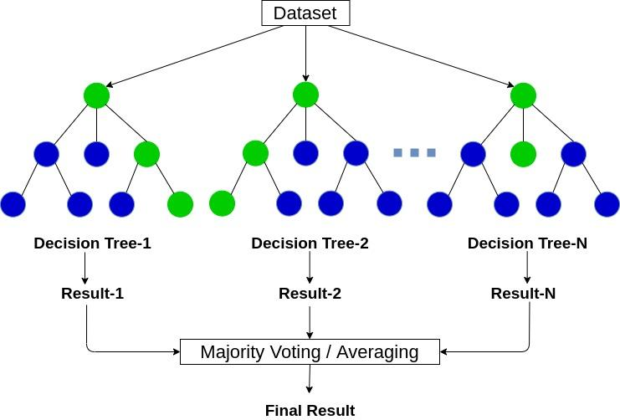

fig 1.48 Random Forrest Explanation

**Approach:-**

We build a random forest classifier & search for the best fit model, using Grid Search Cross Validation Technique with the following values:

Max depth: 5, 6, 7 => Depth of each decision tree

Max features: 3, 4 => based on √ (No. of Independent Variables)

Min samples leaf: 40, 50, 60 => based on 1 - 3 % of the records

Min samples split: 120, 150, 180 => based on 3 times min sample split

No. of estimators: 101, 301, 501 => No. of Decision Trees

Random State : 42

We obtain the best fit model with the parameters:

{'max_depth': 4, 'max_features': 2, 'min_samples_leaf': 2, 'min_samples_split': 10, 'n_estimators': 101, random_state : 42}

The best fit model parameters are then used for creating a random forest classifier model & predicting the train & test labels based on the independent variable values.

**Classification Report on Train & Test data:-**

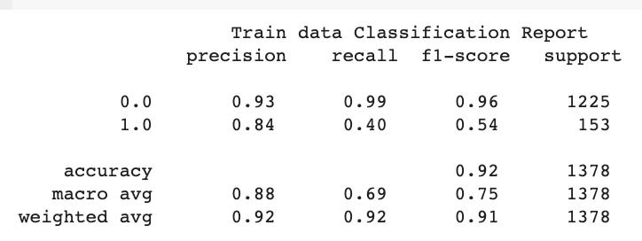 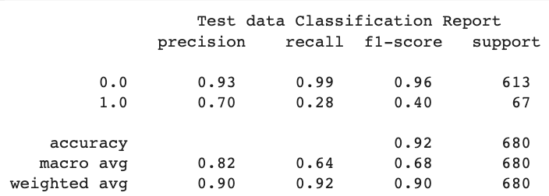

Table 1.50 Random Forest Classification report

**Confusion Matrix:-**

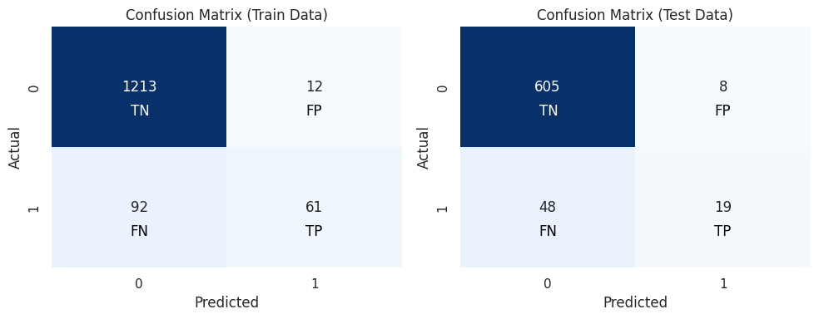

fig 1.49 RandomForest Confusion Matrix

**ROC Curve**

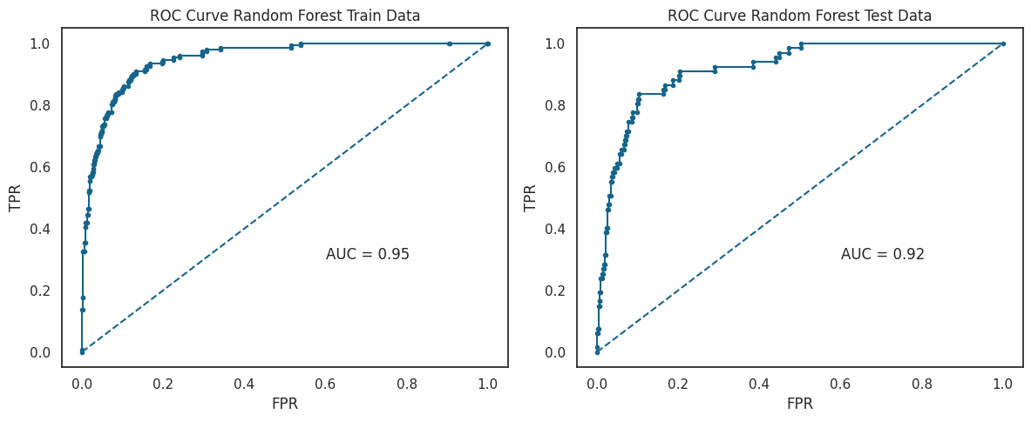

fig 1.50 RandomForest ROC curve

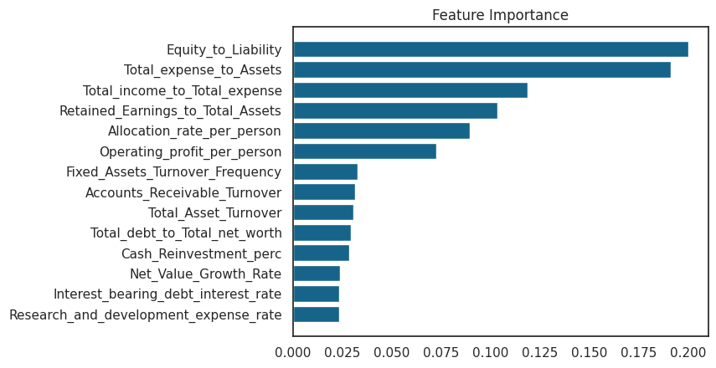

fig 1.51 RandomForest Feature Importance

**Random Forest Conclusion**

|  |  |  |
| --- | --- | --- |
| Metrics | Train | Test |
| True Negative | 1213 | 605 |
| True Positive | 61 | 19 |
| False Negative | 92 | 48 |
| False Positive | 12 | 8 |
| AUC | 95% | 92% |
| Accuracy | 92% | 92% |
| Precision | 84% | 70% |
| Recall | 40% | 28% |
| f1-score | 54% | 40% |

Table 1.51 Random Forest Conclusion

* The model shows consistent Precision, Recall, F1-score, and Accuracy scores between the training and testing data. However, it **struggles to accurately predict defaulting companies in both datasets**. The model shows higher AUC and Accuracy as compared to previous models.
* Notably, the model performs relatively **better in predicting the majority class** but **significantly worse in predicting the minority class.**
* Given its weak performance in predicting defaults but strong performance in identifying non-defaulting companies, we can **utilize this model primarily for classifying the non-default category**.
* Key features for classification include **Equity_to_Liability**, **Total_expense_to_Assests, Total_Income_to_Total_Expense.**

**Build a LDA Model on Train Dataset. Also showcase your model building approach. Validate the LDA Model on test Dataset and state the performance metrics. Also state interpretation from the model**

**Linear Discriminant Analysis** predicts the class in dependent variable using a linear combination of independent variables.

LDA projects the features in higher-dimensional space onto a lower dimensional space. LDA then searches for a linear combination of independent variables (line, plane, or hyperplane) that best separates the classes of the dependent variable.

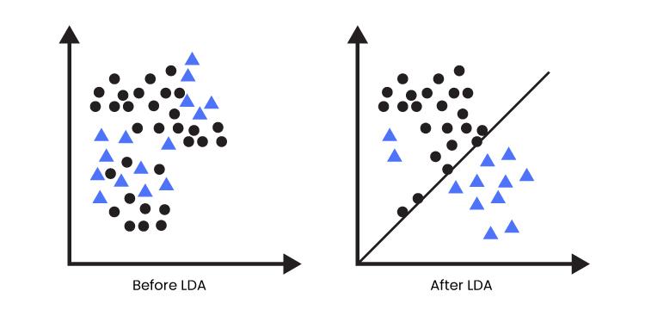

fig 1.52 LDA Explaination

**Assumptions of LDA:**

1. Each feature in the dataset is a gaussian distribution

2. Each feature has the same variance, the value of each feature varies around the mean with the same amount on average.

3. Each feature is assumed to be randomly sampled.

4. Lack of multicollinearity in independent features. Increase in correlations between independent features and the power of prediction decreases.

**Approach:-**

We use Grid Search Cross Validation Technique to obtain the best fit LDA model

We began the search for the best fit model with the following values:

Solver: svd, lsqr, eigen

Tolerance (learning rate): 0.001, 0.0001, 0.00001

We obtain the best fit model with the parameters:

Solver = lsqr

Tolerance = 0.1

The best fit model parameters are then used for creating a LDA model & predicting the train & test labels based on the independent variables

**Classification Report on Train & Test data:-**

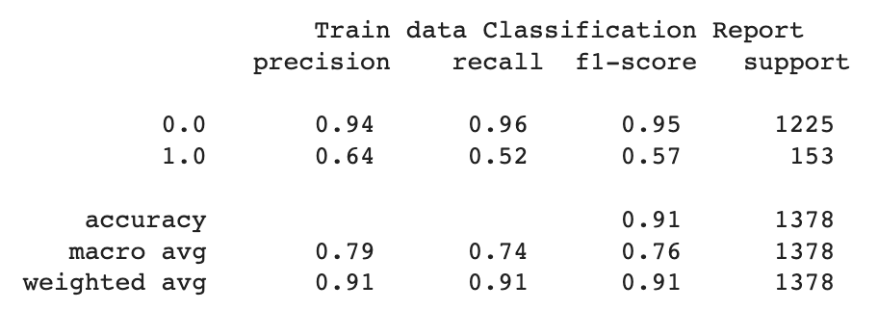 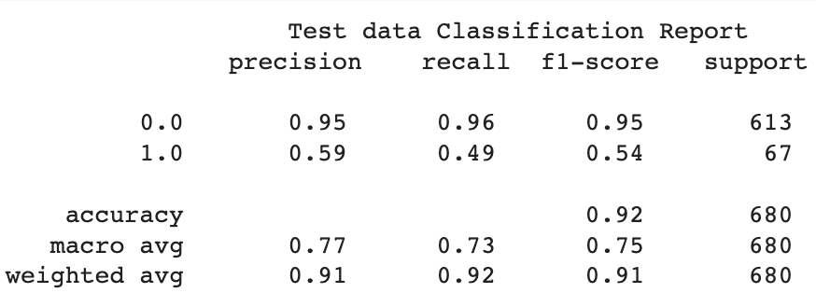

Table 1.52 LDA Classification report

**Confusion Matrix:-**

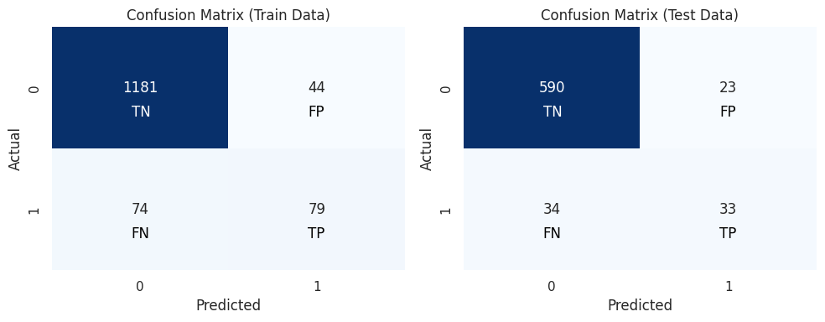

fig 1.53 LDA Confusion Matrix

**ROC Curve**

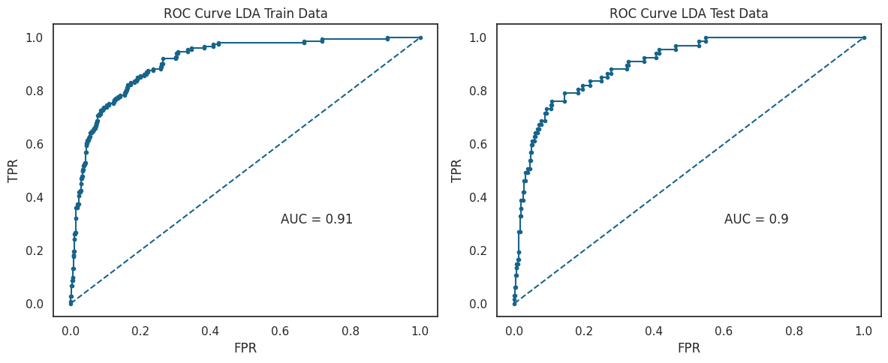

fig 1.54 LDA ROC curve

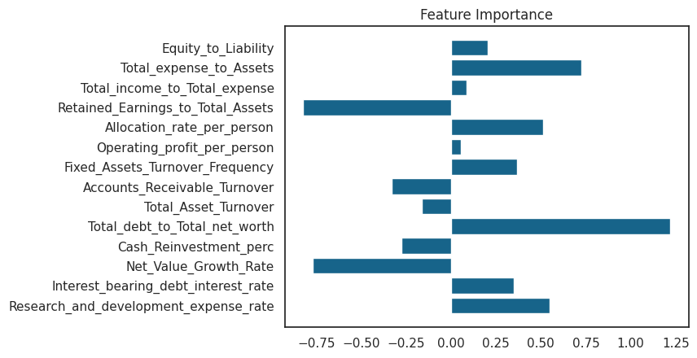

fig 1.55 LDA Feature Importance

**LDA Conclusion**

|  |  |  |
| --- | --- | --- |
| Metrics | Train | Test |
| True Negative | 1181 | 590 |
| True Positive | 79 | 33 |
| False Negative | 74 | 34 |
| False Positive | 44 | 23 |
| AUC | 91% | 90% |
| Accuracy | 91% | 92% |
| Precision | 64% | 59% |
| Recall | 52% | 49% |
| f1-score | 57% | 54% |

Table 1.53 LDA Conclusion

The Precision, Recall, F1-score, and Accuracy of the training data closely match those of the testing data. However, the model struggles to effectively identify defaulting companies in both datasets.

* Notably, the model performs relatively better in predicting the majority class (non-default) but exhibits poorer performance in predicting the minority class (default).
* The model performed slightly better than Random forest on test data. However, still not a good model to predict for minority class.
* Given its limited ability to predict defaults but relatively strong performance in identifying non-defaulting companies, it's advisable to employ this model primarily for classifying the non-default category.
* Key metrics such as Precision, Recall, F1-score, and Accuracy are reasonably consistent between training and testing data, suggesting that the model's performance generalizes well to unseen data.
* Key features for classification include **Total_Debit_to_Total_Net_worth, Net_Value_Growth_Rate, Retained_Earnings_to_Total_Earning**

**Compare the performances of Logistic Regression, Random Forest, and LDA models (include ROC curve)**

**Metric Comparison**

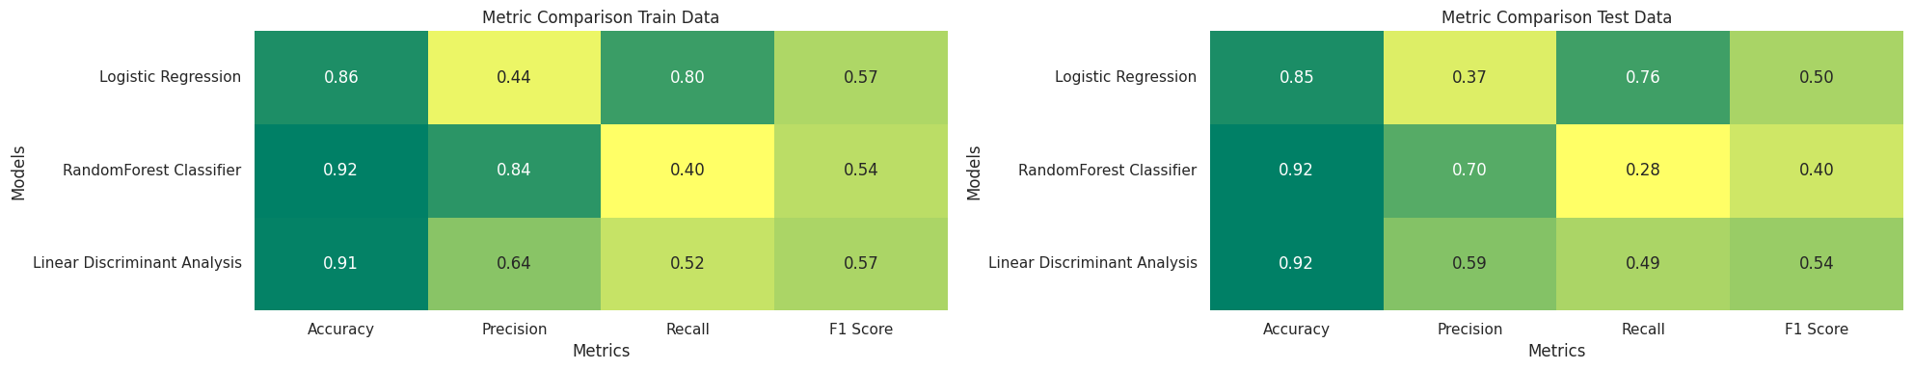

fig 1.56 All Model Comparison Metrics

* **Logistic Regression with SMOTE and Optimum Cut-off 0.367** has the **highest and recall** both in test & train data, indicating that it performs well in identifying Default 1 correctly and has a balanced trade-off between precision and recall.
* RandomForest has the highest accuracy in the test data, but its precision and recall are lower, indicating that it has a higher number of false positives and false negatives. it's advisable to employ this model primarily for classifying the non-default category.
* LDA performs consistently well in both train and test data with balanced precision and recall. However, is not upto the mark in identifying the defaults.

**Confusion Matrix on Train and Test Data**

(Note: Upper part is Train, lower one is Test)

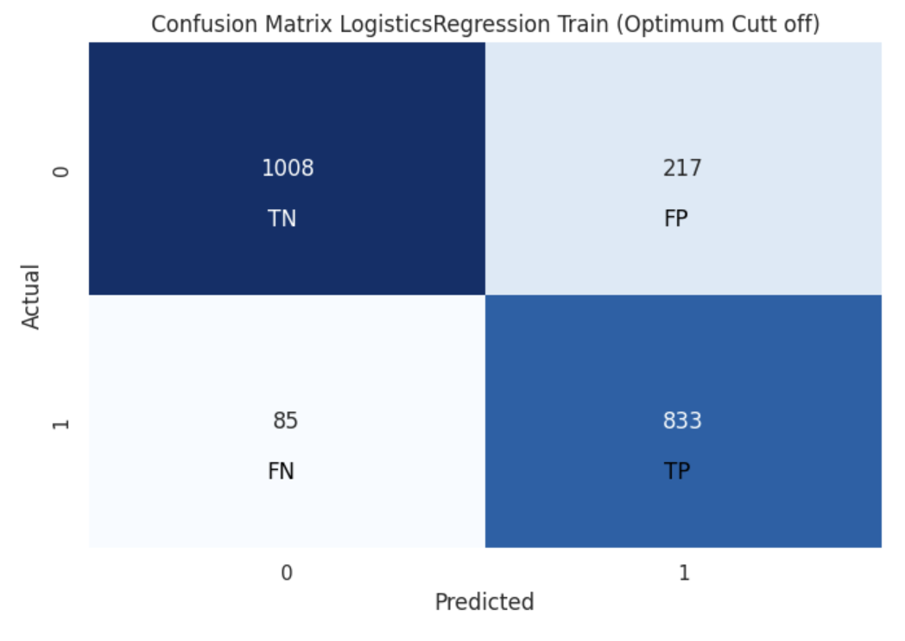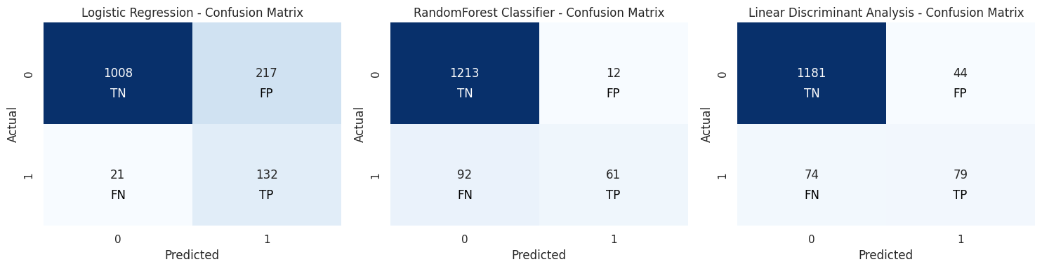

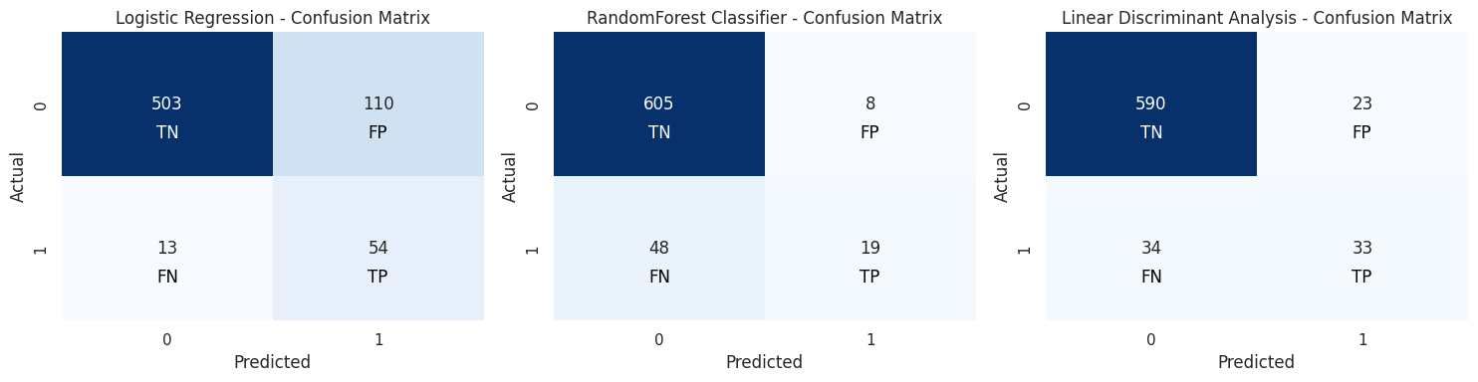

fig 1.57 All Model Comparison Confusion Matrix

* Among the three models, **Logistic Regression with SMOTE and Optimum Cut-off 0.367** performs the best in correctly **identifying Default 1 in both the train and test data, with 833 and 55 true positives**, respectively.
* RandomForest performs better in the train data compared to the test data, indicating that it may be overfitting the training data.
* LDA also performs better in the train data compared to the test data, but it is the second-best model in terms of identifying Default 1 in both datasets.

**ROC Curve**

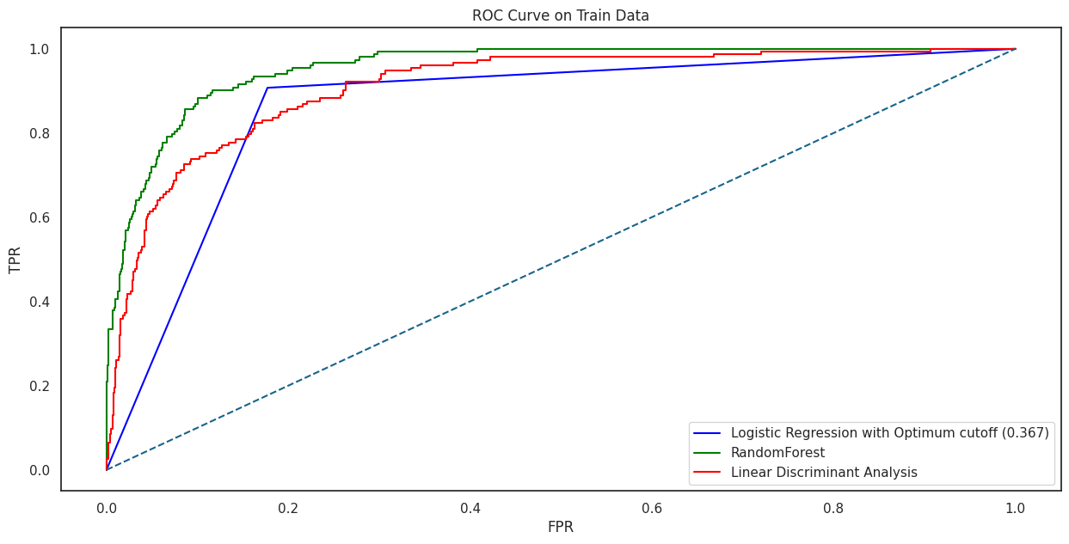

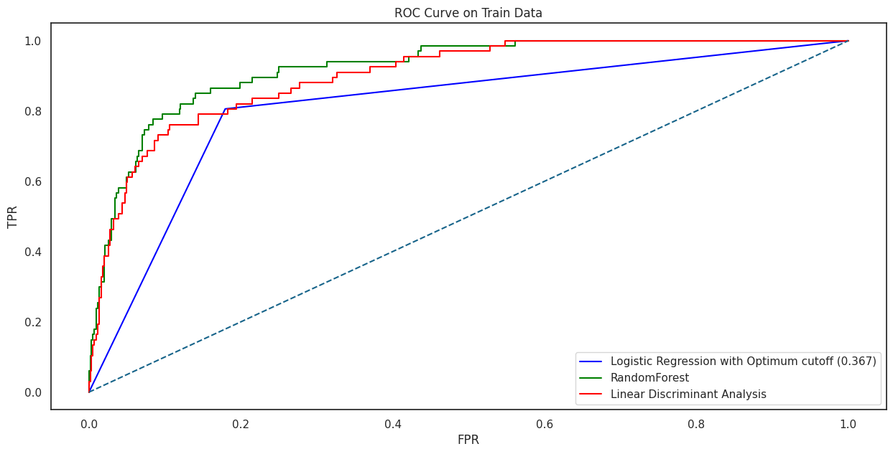

fig 1.58 All Model Comparison ROC curve

* RandomForest has the highest AUC in both train and test data, indicating that it has the best overall discriminatory power for distinguishing between the positive and negative classes.
* Logistic Regression with SMOTE and Optimum Cut-off 0.367 has a lower AUC but still performs reasonably well in distinguishing between the classes.
* LDA has a similar AUC to Logistic Regression with SMOTE but slightly lower performance in test data.

**Conclusions and Recommendations**

* All the models have approximately similar performance metrics. The models do not perform exceptionally well in predicting which companies will default for both train & test data.
* The models predicts better for the majority class and has a pretty inferior performance for the minority class.
* Since, the performance of the model is too low for the default class but it has a good performance when it comes to predicting the not going to default class. Hence, we can use this model to predict the not going to default class instead of predicting the default class.
* **Logistic Regression with SMOTE and Optimal Cut-off 0.367** stands out as the most effective model for correctly identifying Default 1. It consistently achieves the highest number of true positives in both the training and test datasets, indicating its superior ability to detect actual defaults.
* **RandomForest** demonstrates competitive performance, particularly in terms of AUC, accuracy, and precision. While it excels in true negative predictions, it lags slightly behind Logistic Regression with SMOTE in true positive identifications
* **Linear Discriminant Analysis (LDA),** while still performing reasonably well, falls short of the other two models in several metrics, including precision, recall, and F1-score.

**Recommendations**

* Since, the performance of the models are low for the defaulting class but it has a good performance when it comes to predicting the non-defaulting class. Hence, we can use this model to predict the non-defaulting class instead of predicting the defaulting class.
* **Prioritize Logistic Regression with SMOTE & Optimal cutoff:** Given its performance in identifying Default 1 with the highest number of true positives, Logistic Regression with SMOTE and Optimum Cut-off 0.367 should be the preferred model for predicting defaults. It offers the best balance between precision and recall.
* **Consider RandomForest:** RandomForest can serve as an alternative when diversity in modeling is needed. It excels in true negative predictions and maintains competitive performance in identifying Default 1. Given its strong performance in identifying non-defaulting companies, we can utilize this model primarily for classifying the non-default category.
* **Data Quality :** There is presence of missing values & outliers in the dataset which was dealt with imputation & capping respectively, which may have affected the model performance. Hence, a better-quality data may have significantly improved the model performance. There also exists high multicollinearity among the variables, meaning they are explaining the same thing. More features need to be added that explain different aspects of accounting as well.

**PART B: Market Risk**

**Problem Statement:**

The dataset contains 6 years of information(weekly stock information) on the stock prices of 10 different Indian Stocks. Calculate the mean and standard deviation on the stock returns and share insights.

The Objective is to explore a dataset containing 314 entries, including 10 stock names and a date variable.

**About the Dataset**

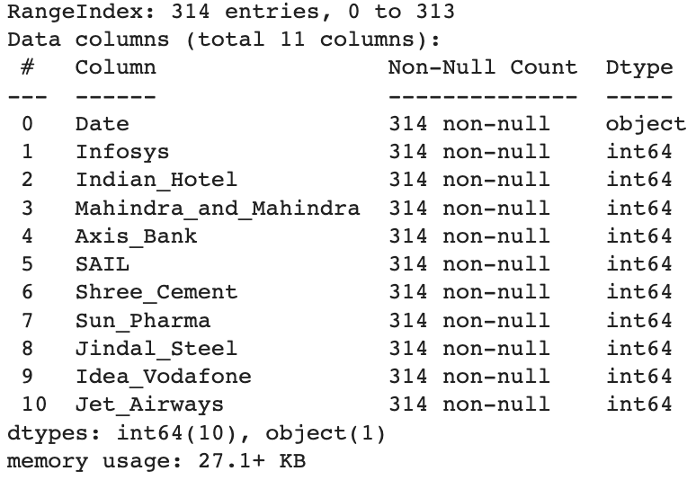

Table 2.1 Dataset Information

* The dataset consists of 11 columns.
* There are a total of 314 non-null entries in each of the stock price columns, indicating no missing data in these columns.
* All stock price columns contain integer values.
* There are no duplicate values found.

**Sample of dataset**

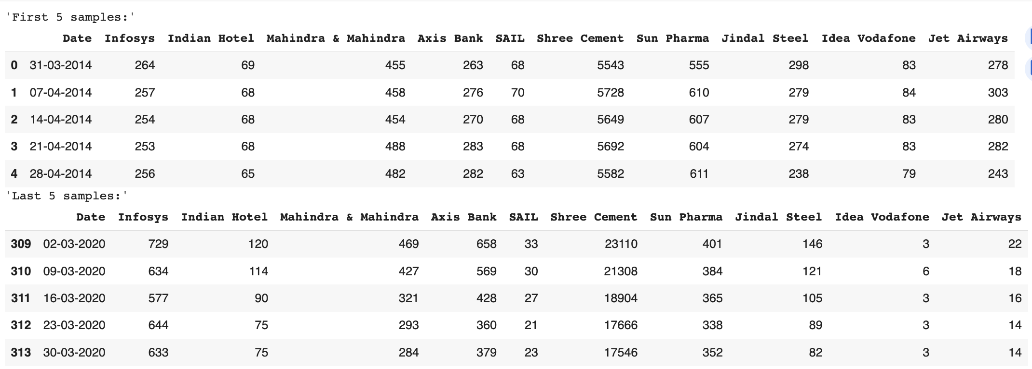

Table 2.2 Sample of the Dataset

**Descriptive Statistics**

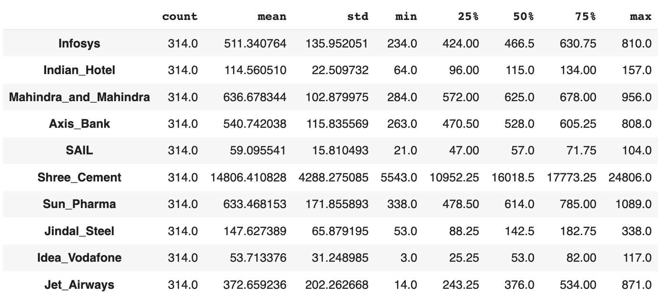

Table 2.3 Descriptive Statistics

* Shree Cement and Jet Airways have the widest price ranges, indicating significant price fluctuations over the years.
* Sun Pharma, Axis Bank, and Infosys also show substantial price volatility.
* Indian Hotel and Jindal Steel have relatively stable price movements compared to other stocks.
* Stocks like Idea_Vodafone and SAIL have moderate volatility with a relatively narrow price range.
* Shree Cement has the highest average stock price, while Idea-Vodafone has the lowest average stock price among the analyzed stocks.

**Draw Stock Price Graph(Stock Price vs Time) for any 2 given stocks with inference**

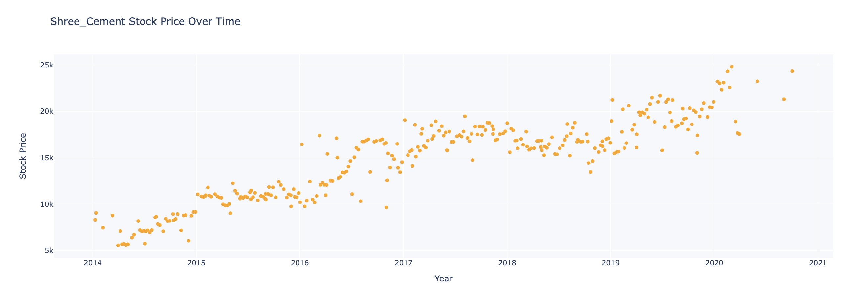

Fig 2.1 Stock Price vs Time Graph for Shree Cement

* The Prices of Shree Cement has shown an increasing Trend over the past 6 years
* Lowest Price recorded in the 6 years was 5543 on 31-03-2014
* Highest Price of Shree_Cement was 24806 on 03-02-2020
* This stock has the highest average stock price of 14806.41

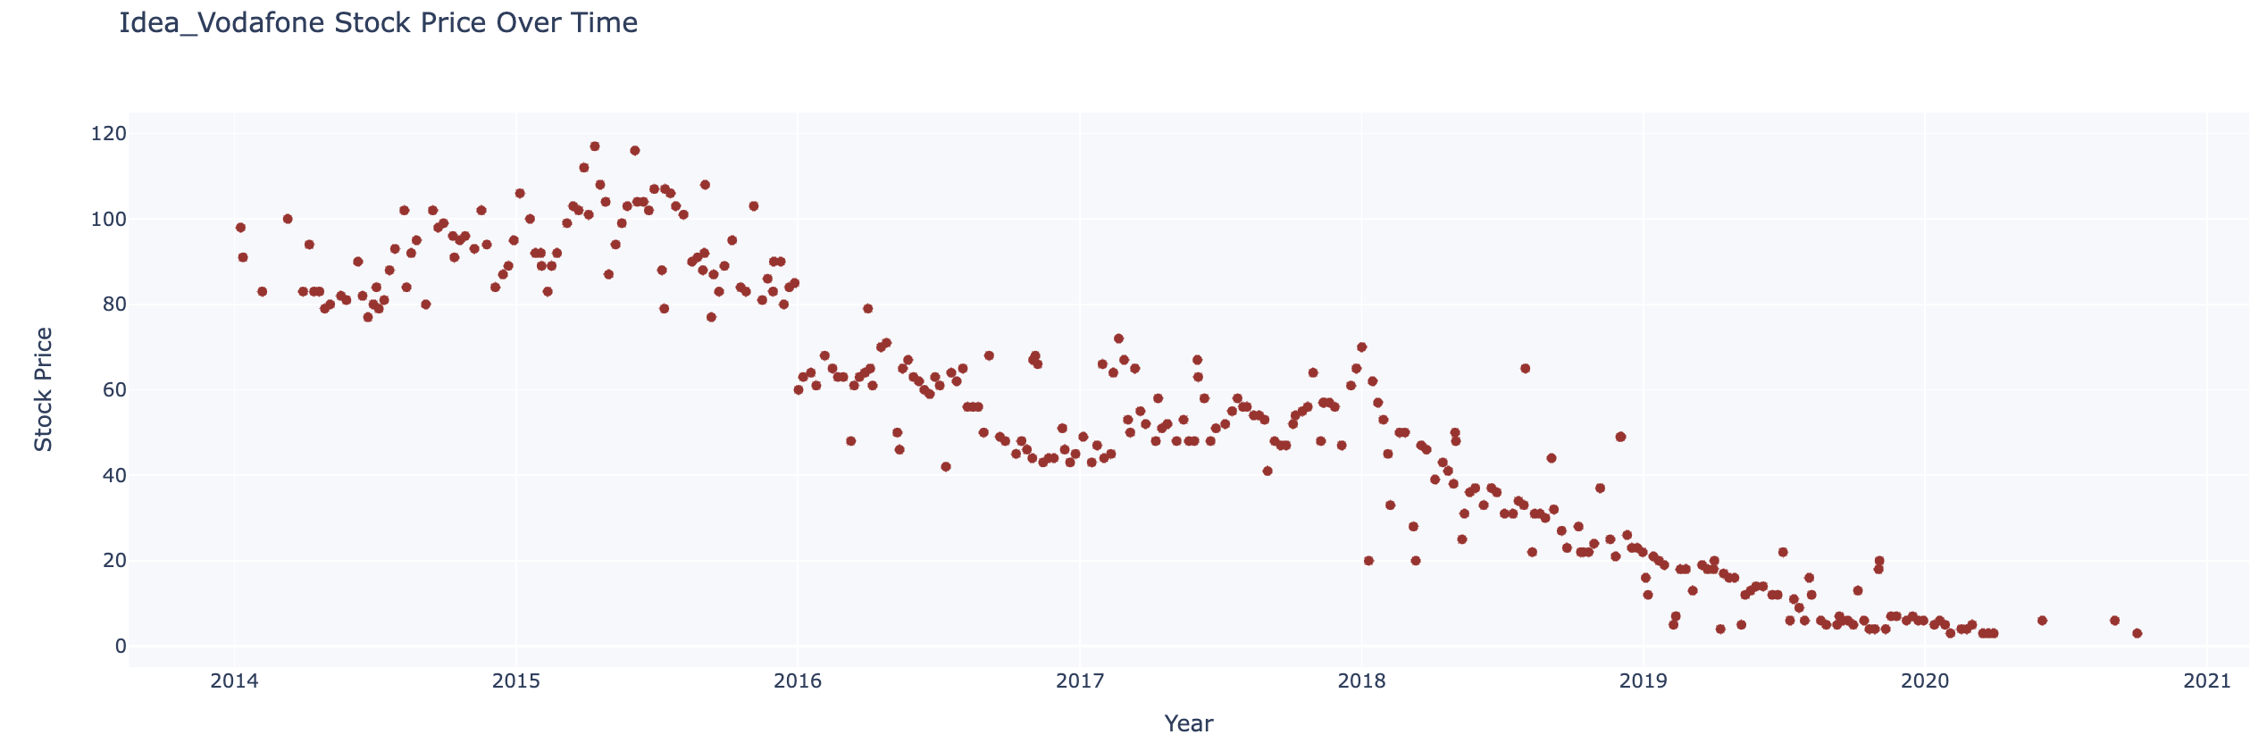

Fig 2.2 Stock Price vs Time Graph for Idea-Vodafone

* The Prices of Idea-Vodafone has shown an decreasing Trend over the past 6 years
* Lowest Price recorded in the 6 years was 3 on 10-02-2020
* Highest Price of Shree_Cement was 117 on 13-04-2015
* Idea_Vodafone has the lowest average stock price of 53.71 among the analyzed stocks

**Calculate Returns for all stocks with inference**

To calculate the returns form price, we have taken Logarithms and their differences. Returns is the difference between two consecutive week prices for the stock

Note: We have dropped the date column, hence the updated dataset with Stock Returns contains only 10 columns with Stock Names as header and 314 rows.

The negative value refers to decrease in price compared to previous week and vice versa.

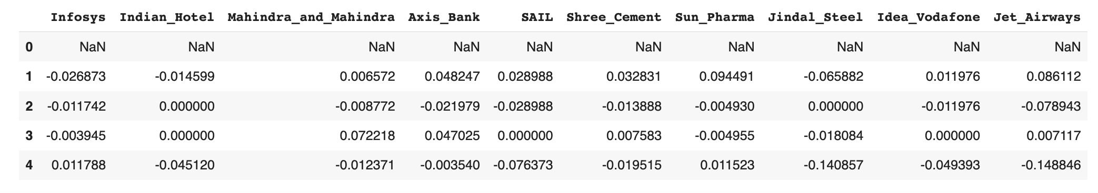

Table 2.4 Sample of the Stock Returns

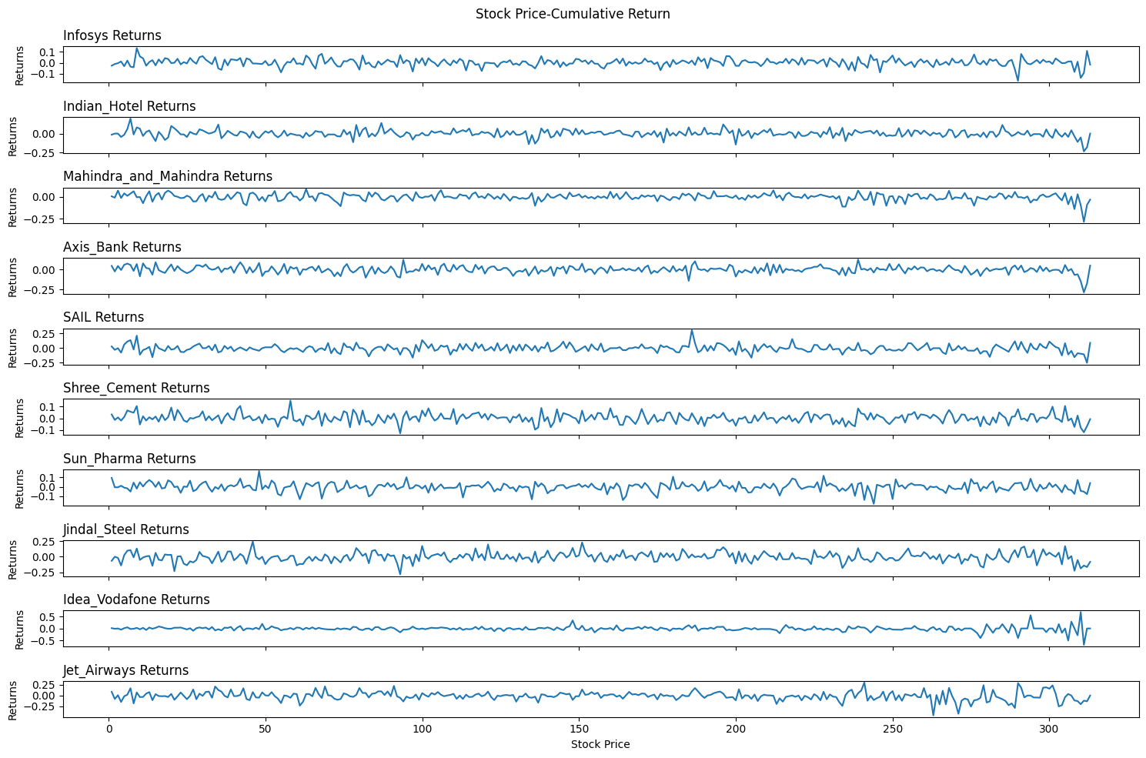

Fig 2.3 Stock Returns & Price Trend

**Descriptive Statistics of Stock Returns**

Note: The prices are not rounded off due to low values in decimals..

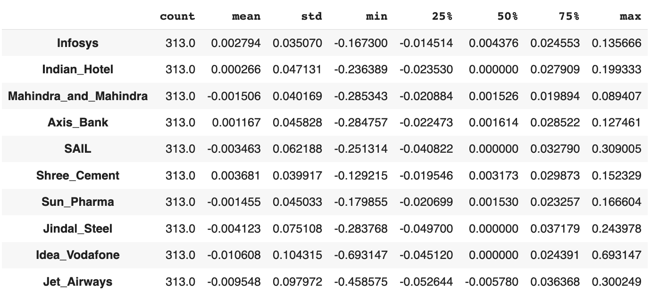

Table 2.5 Sample of the Stock Returns

* The above stock returns covers the weekly returns of different stocks over a period of time.
* Each stock displays varying levels of average returns, volatility, and ranges of returns.
* Stocks like **Shree Cement and Axis Bank** have relatively **favourable average returns**.
* **Idea Vodafone** and **Jet Airways** might have faced significant challenges, resulting in **substantial negative returns.**

**Calculate Stock Means and Standard Deviation for all stocks with inference**

**Stock Means:** Stock Means represent the average returns a stock generates on a week-to-week basis

**Stock Standard Deviation:** serves as a gauge of volatility. In essence, the higher the deviation of a stock's returns from its average return, the greater its level of volatility

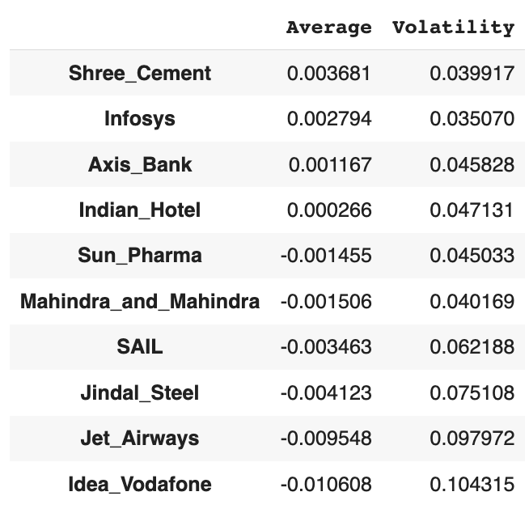

Table 2.6 Stock Mean and Volatility

* **Shree Cement** has the **highest average stock** **price**, while **Idea-Vodafone has the lowest average** **stock price** among the analyzed stocks.
* **Idea_Vodafonehas** the **highest volatility** while **Infosys has the lowest**

**Draw a plot of Stock Means vs Standard Deviation and state your inference**

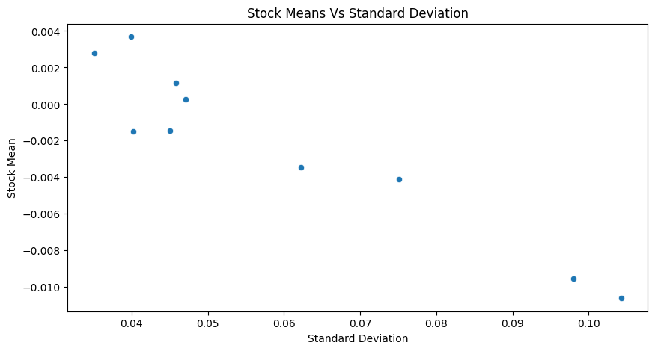

Fig 2.4 Stock Means vs Standard Deviation

Labelling each of the datapoints to identify the stocks

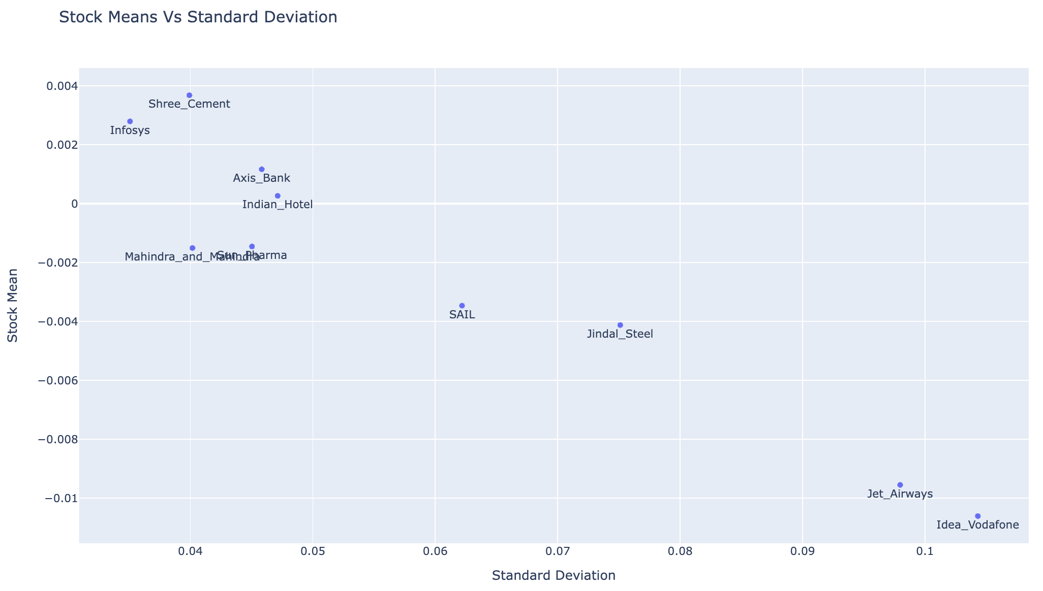

Fig 2.5 Stock Means vs Standard Deviation with Stock Names

**Idea Vodafone:** This stock has the **highest negative average return (-1.06%)** among the listed stocks. It also exhibits the **highest volatility (10.43%),** indicating **substantial price fluctuations**. The negative average suggests a **consistent downward trend.**

**Jet Airways:** While having a **negative average return (-0.95%),** Jet Airways shows **slightly lower volatility (9.80%) compared to Idea Vodafone**. This implies that although the stock is declining, it **experiences relatively smaller price swings**.

**Jindal Steel:** Jindal Steel also has a **negative average return (-0.41%)** but with **higher volatility (7.51%).** This suggests that the **stock has fluctuations**, but the downward trend is not as pronounced as Idea Vodafone or Jet Airways.

**SAIL:** Steel Authority of India Limited (SAIL) has a **negative average return (-0.35%)** and moderate **volatility (6.22%).** While it **exhibits some price fluctuations**, they are relatively milder compared to highly volatile stocks.

**Indian Hotel:** Indian Hotel demonstrates a slightly **positive average return (0.03%)** with **moderate volatility (4.71%)**. This indicates that the stock has **relatively stable performance**, with minor price swings.

**Axis Bank:** Axis Bank showcases a **positive average return (0.12%)** and relatively **moderate volatility (4.58%).** This suggests that the stock has a **positive trend with limited price fluctuations**.

**Sun Pharma:** Sun Pharma has a **negative average return (-0.15%)** with **moderate volatility (4.50%).** It indicates a **declining trend with relatively stable price movements**.

**Mahindra and Mahindra:** This stock has a **negative average return (-0.15%)** and **with relatively low (4.02%) than previous stocks.** It suggests that the stock **experiences price fluctuations, but the overall trend is negative**.

**Shree Cement:** Shree Cement has a **positive average return (0.37%) with relatively low volatility (3.99%) than previous stocks.** It shows a **positive trend with relatively stable price movements**.

**Infosys:** Infosys has a positive **average return (0.28%) and the lowest volatility (3.51%)** among the listed stocks. This indicates a **consistent positive trend with minimal price fluctuations**.

**Conclusion:**

The stocks with **negative average returns** (**Idea Vodafone, Jet Airways, Jindal Steel, SAIL, Mahindra and Mahindra**) generally have **higher volatility**, suggesting a **downward trend with significant price swings.**

On the other hand, **stocks with positive average returns** (**Axis Bank, Indian Hotel, Shree Cement, Infosys**) tend to have **lower volatility**, indicating **more stable and positive trends**.

**Recommendation**

Among the listed stocks, **Infosys and Shree Cement** exhibit the **most favourable combination of high average returns and low volatility**. Hence, stocks with **higher returns relative to their risk level are considered better among the available options.**

For investors seeking a **balance between returns and risk**, we recommend considering stocks from the mid-range performers, such as **Axis Bank, Indian Hotel, Sun Pharma, and Mahindra and Mahindra**. These stocks exhibit **moderate returns with relatively stable price movements.**

On the contrary, it's essential to exercise caution with stocks like **Jet Airways and Idea Vodafone**, which have the **highest losses and significant price** **fluctuations**. These stocks **may not be suitable for conservative investors**.

Diversifying investments across various stocks can also help spread risk and optimize returns.